PENNSYLVANIA

PUBLIC UTILITY COMMISSION

Harrisburg, PA 17105-3265

Public Meeting held August 23, 2018

Commissioners Present:

Gladys M. Brown, Chairman
Andrew G. Place, Vice Chairman
Norman J. Kennard
David W. Sweet
John F. Coleman, Jr.

Periodic Review of PECO Energy Company’s Long-Term Infrastructure Improvement Plan | M-2018-3000950

OPINION AND ORDER

BY THE COMMISSION:

On April 10, 2018, via Secretarial Letter, the Commission initiated the periodic review of PECO Energy Company’s (PECO) electric Long-Term Infrastructure Improvement Plan (LTIIP) as required by the Public Utility Code. 52 Pa. Code § 121.7(a). Unless otherwise directed, the periodic review shall begin at the midpoint of the term of the current LTIIP. PECO’s current electric LTIIP began with calendar year 2016, and thus the midpoint is approximately July 1, 2018.

For the purposes of the periodic review, the Commission established a thirty (30) day comment period and a twenty (20) day reply comment period.

PECO filed comments on May 10, 2018. No other comments were received.

BACKGROUND

On February 14, 2012, Governor Thomas Corbett signed into law Act 11 of 2012 (Act 11), which amends Chapters 3, 13 and 33 of Title 66. Act 11, inter alia, provides utilities with the ability to implement a Distribution System Improvement Charge (DSIC) to recover reasonable and prudent costs incurred to repair, improve or replace certain eligible distribution property that is part of the utility’s distribution system. The eligible property for the utilities is defined in 66 Pa. C.S. §1351. Act 11 states that as a precondition to the implementation of a DSIC, a utility must file an LTIIP with the Commission that is consistent with 66 Pa. C.S. §1352.

The Commission promulgated regulations relating to LTIIPs at 52 Pa. Code §§ 121.1 – 121.8 that became effective December 20, 2014. In accordance with the regulations a periodic review will determine:

- If the utility has adhered to its LTIIP.
- If changes to the LTIIP are necessary to maintain and improve the efficiency, safety, adequacy and reliability of the utility’s existing distribution infrastructure.

In accordance with the Code, if the Commission determines during the periodic review that a utility’s LTIIP is found to be no longer adequate to ensure and maintain the efficiency, safety, adequacy and reliability of the utility’s existing distribution infrastructure, the Commission would direct the utility to revise, update or resubmit its LTIIP as appropriate. If the utility chooses not to abide by the Commission’s direction in this regard, the utility may elect to withdraw its LTIIP and forfeit its right to recover expenses through a DSIC.

PERIODIC REVIEW OF PECO’s LTIIP

PECO’s LTIIP covers the five calendar years 2016 through 2020. The stated long-term goal of PECO’s improvement plan is to enhance system resilience, reliability, and facility relocation and to recover reasonable and prudent costs incurred to repair, improve or replace certain eligible distribution property that is part of PECO’s distribution system as permitted by 66 Pa. C.S. §1351. PECO’s total projected expenditures in its Commission-approved LTIIP were $324.3 million. PECO in its comments noted that at mid-term it is projected that the total LTIIP expenditures will be approximately $336.2 million, which is a variance of only 3.5%.

Table 1, below, details PECO’s actual and planned expenditures for the entire LTIIP period by LTIIP project category.

Table 1: Actual and Planned LTIIP Expenditures

PECO’s actual LTIIP expenditures exceeded the Commission approved plan by approximately $11.9 million, or 3.5%. However, this was primarily due to an excess in projected expenditures for unreimbursed facility relocations of approximately $9.2 million. PECO noted that it is difficult to accurately project such costs because facility relocation projects are dependent on PennDOT and Local Municipality work scheduling and coordination. If unreimbursed facility relocation projects are excluded, it can be seen that PECO’s projected expenditures have been fairly accurate and that it appears the current PECO LTIIP is on track to meet or exceed plan goals in a reasonable and cost-effective manner.

Table 2, below, details PECO’s actual and planned infrastructure improvements for the entire LTIIP period by LTIIP project category.

Table 2: Actual and Planned Infrastructure Improvements

PECO’s infrastructure replacements and completed projects have either met or exceeded their original plan for 2016 and 2017. For 2016 and 2017, PECO exceeded planned material replacements for CEMI projects by 3 projects, Main Stem Cable replacement by 3.9 miles, and URD Cable replacement by 4.6 miles.

In its comments, PECO provided information on metrics related to the LTIIP project work. Table 3, below, details PECO’s CEMI reliability data from 2013 through 2017. PECO’s 2017 CEMI data for customers experiencing up to 7 interruptions per year appears to be trending in a positive direction that shows reliability has improved.

Table 3: PECO CEMI Data 2013 through 2017

Table 4, below, details PECO’s Annual Main Stem Cable Fault data from 2009 through 2017. PECO’s Main Stem Cable Fault data for 2016 and 2017 appears to be trending in a positive direction that shows reliability has improved.

Table 4: PECO Annual Main Stem Cable Faults

Table 5, below, details PECO’s Underground Residential Development (URD) cable Faults data from 2008 through 2017. PECO’s URD Cable Fault data appears to be trending higher. However, PECO noted that for 2017, URD cable faults have decreased from the previous year, which may be the start of a positive trend direction showing reliability will continue to improve.

Table 5: URD Cable Faults

Table 6, below, details PECO’s data regarding its SAIFI metric, which measures the average number of sustained service interruptions experienced by a customer in a rolling 12-month period. As can be seen, PECO’s reliability has been improving since 2016 and has maintained benchmark performance.

Table 6: PECO SAIFI from 2004 through 2017
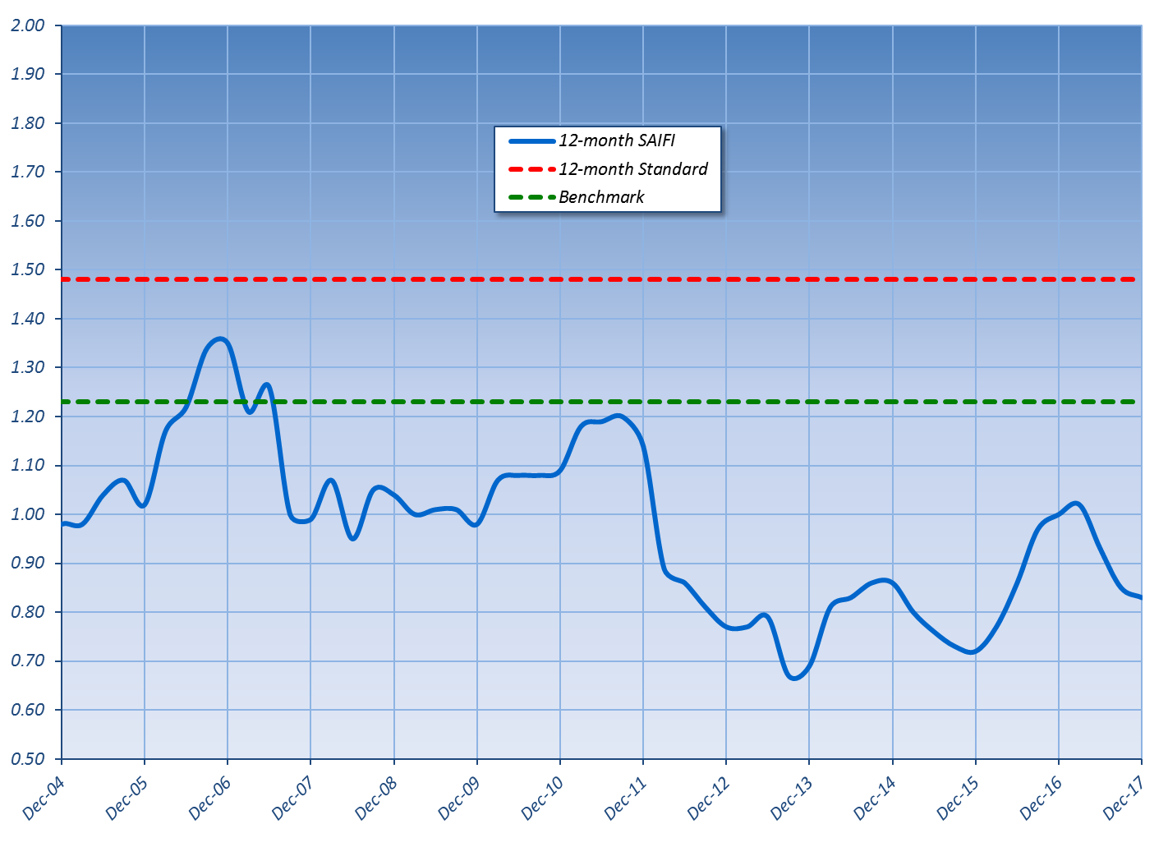

RECOMMENDATION REGARDING UTILITY'S LTIIP

Based on the analysis above, it appears that PECO is in compliance with its approved LTIIP expenditure obligations. Additionally, PECO appears to be meeting its LTIIP goals for infrastructure replacement, and resilience and reliability improvements.

CONCLUSION

The Commission finds that the Long-Term Infrastructure Improvement Plan of PECO is designed adequately to ensure and maintain safe, adequate and reliable service and that PECO has substantially adhered to its plan; THEREFORE,

IT IS ORDERED:

1. That the Long-Term Infrastructure Improvement Plan of PECO Energy Company is designed adequately to ensure and maintain safe, adequate and reliable service and that PECO Energy Company has substantially adhered to its plan.

2. That the proceeding at Docket No. M-2018-3000950 be closed.


BY THE COMMISSION,

Rosemary Chiavetta
Secretary

(SEAL)

ORDER ADOPTED: August 23, 2018

ORDER ENTERED: August 23, 2018

See Petition of PECO Energy Company for Approval of their Electric Long-Term Infrastructure Improvement Plan, Order entered on Oct. 22, 2015, at Docket No. P-2015-2471423.
http://www.legis.state.pa.us/WU01/LI/LI/US/HTM/2012/0/0011..HTM
See 52 Pa. Code § 121.7(b).
See 52 Pa. Code § 121.7(d).
The Commission reliability performance metrics are: Customer Average Interruption Duration Index (CAIDI), System Average Interruption Frequency Index (SAIFI), and System Average Interruption Duration Index (SAIDI). Electric Distribution Utilities’ 12-month rolling reliability metrics are expected to be at or below the determined performance benchmarks and are required to be at or below the determined performance standards. See Docket No. M-00991220.

