COMMONWEALTH OF PENNSYLVANIA
PENNSYLVANIA PUBLIC UTILITY COMMISSION
400 NORTH STREET, HARRISBURG PA 17120
Formal Complaint
Docket #: C-2018-3004912
Date Served: September 26, 2018

RENEE MARQUIS, MANAGER
AQUA PENNSYLVANIA, INC.
762 WEST LANCASTER AVENUE
BRYN MAWR, PA 19010

RE: PA PUC vs AQUA PENNSYLVANIA INC.
Rate Case Docket #: R-2018- 3003558

Dear Renee Marquis:

A Formal Complaint has been filed against you in the above-captioned matter before the Pennsylvania Public Utility Commission by The Links at Gettysburg Master Association c/o Coyd Vance.

This true and correct copy of the complaint has been filed of record with the Pennsylvania Public Utility Commission. Both the Pennsylvania Public Utility Code, 66 Pa. C.S. and the Commission’s regulations at 52 Pa. Code Section 1.53, requires the Commission to serve on each party named in a Formal Complaint a copy of the complaint.

Within ten (10) days from the above date of service, you may either satisfy or answer this complaint in accordance with the provisions of 52 Pa Code, §5.61(d).

When filing your answer to the Formal Complaint, please reference the “Formal Complaint Docket Number” located in the upper-right hand corner of this Notice.

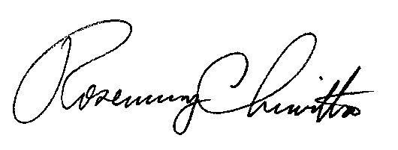
Very Truly Yours,

Rosemary Chiavetta
Secretary

RC:Jbs

(SEAL)

Certified Mail
Return Receipt Requested

