BEFORE THE
PENNSYLVANIA PUBLIC UTILITY COMMISSION

Deborah and Mark Matasich :
:
v. : C-2018-3004055
:
Pittsburgh Water and Sewer Authority :

FIRST INTERIM ORDER
CONFIRMING THE GRANTING OF COMPLAINANT’S
REQUEST FOR A HEARING CONTINUANCE

An initial telephonic hearing in this case was scheduled for Friday, October 19, 2018, at 10:00 a.m. By electronic mail dated October 12, 2018, Kristine E. Marsilio, Esquire, counsel for Respondent Pittsburgh Water and Sewer Authority (PWSA), represented that Complainant Mark Matasich was seeking a continuance of the hearing. Attorney Marsilio further represented that PWSA did not object to the continuance request and noted the parties were attempting settlement of the matter.

Pursuant to Section 1.15(b) of the Pennsylvania Public Utility Commission’s (Commission) regulations, 52 Pa. Code §1.15(b), a request for a change of the scheduled hearing date may be submitted by motion in writing and filed no later than five (5) days prior to the hearing with the Commission. The motion must state the facts upon which the request rests. Only for good cause shown will requests for continuance be considered. Id.

After due consideration, I treated the electronic mail requesting a continuance of the hearing as a motion, found that the motion stated good cause to warrant a continuance, and so informed the parties by electronic mail on October 12, 2018. This interim order confirms the granting of the continuance request. A notice rescheduling the telephonic hearing will be issued to the parties.

The parties are encouraged to talk with each other to resolve this matter or some
portion thereof. It is the Commission’s policy to encourage settlements. 52 Pa. Code §5.231.

THEREFORE,

IT IS ORDERED:

- That the motion of Complainant Mark Matasich for a continuance of the October 19, 2018, Initial Call-In Telephonic Hearing scheduled in the case of Deborah and Mark Matasich v. Pittsburgh Water and Sewer Authority at Docket No. C-2018-3004055 is granted.

- That the Scheduling Staff of the Office of Administrative Law Judge shall reschedule the Initial Call-In Telephonic Hearing in the case of Deborah and Mark Matasich v. Pittsburgh Water and Sewer Authority at Docket No. C-2018-3004055 and so notify the parties in writing.

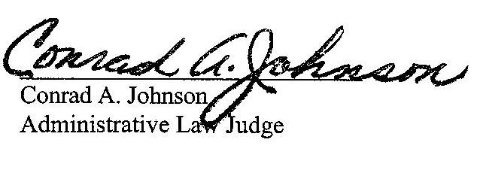

Date: October 16, 2018

C-2018-3004055 - DEBORAH & MARK MATASICH v. PITTSBURGH WATER AND SEWER AUTHORITY
(Revised 9/10/18)
DEBORAH & MARK MATASICH
4231 STANTON AVE
PITTSBURGH PA 15201
412.781.2433
*DEANNE M O'DELL ESQUIRE
KRISTINE MARSILIO ESQUIRE
ECKERT SEAMANS CHERIN & MELLOTT LLC
213 MARKET STREET 8TH FLOOR
HARRISBURG PA 17101
717.255.3744
717.237.6000
*Accepts E-Service

