BEFORE THE
PENNSYLVANIA PUBLIC UTILITY COMMISSION

Carla Matrunics :
:
v. : C-2017-2617235 :
West Penn Power Company :

INTERIM ORDER
CLOSING THE HEARING RECORD

AND NOW, the transcript of the September 5, 2018, initial hearing in this case having been filed with the Commission’s Secretary’s Bureau in Harrisburg on November 8, 2018; and a copy of the transcript having been received by the undersigned in Pittsburgh on November 19, 2018; and no further hearings in this matter are to be scheduled or held,

THEREFORE,

IT IS ORDERED:

- That the hearing record at Docket No. C-2017-2617235 is closed.

2. That the Initial Decision in this case shall be prepared and issued.
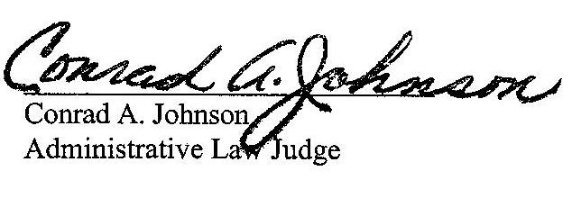

Dated: November 20, 2018

C-2017-2617235 - CARLA MATRUNICS v. WEST PENN POWER COMPANY

DAVID A COLECCHIA ESQUIRE
324 SOUTH MAPLE AVENUE
GREENSBURG PA 15601
724.837.2320
Accepts Eservice

CARLA MATRUNICS
105 10th street
bradenville pa 15601
724.875.2574

JOHN L MUNSCH ESQUIRE
WEST PENN POWER COMPANY
800 CABIN HILL DRIVE
GREENSBURG PA 15601
724.838.6210

