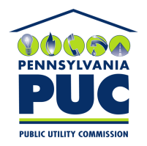 | COMMONWEALTH OF PENNSYLVANIA  PENNSYLVANIA PUBLIC UTILITY COMMISSION  400 NORTH STREET, HARRISBURG, PA 17120 | IN REPLY PLEASE REFER TO OUR FILE
December 3, 2018

JOHN ZBIHLEY, SENIOR DIRECTOR OF BUSINESS SOLUTIONS
KINECT ENERGY, INC.
500 CHERRINGTON PARKWAY, SUITE 400
MOON TOWNSHIP, PA 15108

Dear Mr. Zbihley:

On November 28, 2018, the Commission received the Application of Kinect Energy, Inc., for approval to supply natural gas services to the public in the Commonwealth of PA. Upon initial review, the Application has been determined to be missing information for the following reason:

- No Original Signature on Cover Page

Pursuant to 52 Pa. Code §1.4, you are being advised of this missing information and are required to file a correction. Failure to correct the foregoing missing information within 20 days of the date of this letter will result in the Application being returned unfiled.
Please return your item to the above listed address and address to the attention of the Office of the Secretary.
If you have any question in regards to this letter, please contact our bureau at (717) 772-7777. Thank you
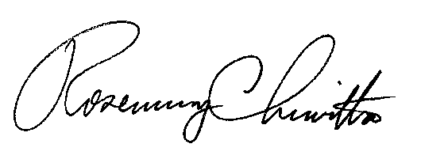
Sincerely,

Rosemary Chiavetta
Secretary

Enclosure

RC:AEL

