PENNSYLVANIA
PUBLIC UTILITY COMMISSION
Harrisburg, PA 17105-3265

Public Meeting held December 20, 2018

Commissioners Present:

Gladys M. Brown, Chairman
Andrew G. Place, Vice Chairman
Norman J. Kennard
David W. Sweet
John F. Coleman, Jr.

Pennsylvania Public Utility Commission,  Bureau of Investigation and Enforcement  v.  PECO Energy Company |  | M-2018-2531404

Opinion and Order

BY THE COMMISSION:

Before the Pennsylvania Public Utility Commission (Commission) for consideration and disposition is a proposed Settlement Agreement (Settlement) filed on April 16, 2018, by the Commission’s Bureau of Investigation and Enforcement (I&E) and PECO Energy Company (PECO or Company) (collectively, the Parties), with respect to an informal investigation conducted by I&E. Both Parties submitted Statements in Support of the Settlement. The Parties submit that the proposed Settlement is in the public interest and is consistent with the Commission’s Policy Statement at 52 Pa. Code § 69.1201, Factors and standards for evaluating litigated and settled proceedings involving violations of the Public Utility Code and Commission regulations—statement of policy. Settlement at 10. We will issue the Settlement for comment.

History of the Proceeding

This matter concerns allegations by various low income customers of unlawful termination during the moratorium on service termination in the winter months. In early 2016, the Commission’s Bureau of Consumer Services (BCS) received informal complaints from several customers that PECO had terminated service to low income customers during the winter months in 2015 and 2016, despite knowing that the affected customers’ incomes met or fell below the 250% of the federal poverty level threshold provided by 52 Pa. Code § 56.100(b). BCS referred the matter to I&E for further review. Thereafter, I&E determined that the allegations warranted further investigation on the issue of whether Company’s actions violated the Public Utility Code (Code) or Commission Regulations and orders. By letter dated July 15, 2016, I&E submitted data requests to PECO related to the allegations and the Company complied with the requests.

As part of the investigation, the Parties entered into negotiations and agreed to resolve the matter in accordance with the Commission’s policy to promote settlements at 52 Pa. Code § 5.231. As a result of those negotiations, the Parties filed the instant Settlement on April 16, 2018.

Background

BCS received nearly three dozen informal complaints from residential customers of PECO alleging that their electric service had been terminated during the winter months. In the informal complaints, the customers alleged that they qualified for low-income protection during the winter months and that the Company nonetheless terminated their service due to non-payment of bills. Finding the terminations to be improper, BCS informally directed service to be restored. No appeals were taken from any written informal decisions issued by BCS. Thereafter, BCS referred the matter to I&E for further review. Settlement at 4.

Pursuant to the investigation, it was determined that approximately eight customers were improperly terminated during the winter months allegedly due to a faulty computer program that failed to identify the customers as qualifying for the winter months protections. Settlement at 5. Additionally, I&E found that approximately thirty more customers may have suffered service terminations due to PECO’s inadequate income verification and winter service procedures. Specifically, I&E found that the income verification information of various customers had expired and PECO terminated their service due to the lack of income information. I&E Statement in Support at 2-3.

I&E’s investigation revealed that PECO restored service in a timely manner upon learning about the customers whose service was terminated due to the alleged computer programming error. Additionally, I&E indicated that due to BCS’s informal decisions ordering service restoration, many, if not all, of the additional customers whose service may have been improperly terminated had their service restored. I&E Statement in Support at 8.

PECO’s winter termination procedure is governed by PECO’s tariff which provides that “the customer is subject to collection action, including termination of service (in accordance with the Pennsylvania Public Utility Code or the Commission’s regulations[)].” Settlement at 5 (citing PECO Supplement No. 34 to Tariff Electric Pa. P.U.C. No. 4, at 25, § 18.1 (Tariff Supplement No. 34)). In addition, the Company has implemented internal policies and procedures regarding income verification and winter termination that govern how PECO proceeds with income verification and termination of customers during the winter months. Settlement at 6.

In its review of the matter, I&E determined that PECO’s tariff and its policies and procedures regarding winter termination of low-income customers and income verification are insufficient to fully inform customers of PECO’s policies and procedures for winter month termination and income verification. Settlement at 6.

As a result of its informal investigation, I&E concluded that there was sufficient data to substantiate allegations of violations of the Code and our Regulations. Specifically, I&E was prepared to allege in a formal complaint that PECO, pursuant to its policy regarding winter termination of customers without verified income information, wrongfully terminated customers who qualified for protection from termination during the statutory winter months period. If proven, I&E contends that this would have violated 66 Pa. C.S. § 1406(e). Settlement at 6.

Additionally, I&E would have alleged that PECO terminated service to approximately eight customers due to a computer logic error that failed to properly identify customers who qualified for protection from termination during the winter months. I&E asserts that, if proven, this would have violated 66 Pa. C.S. § 1406(e) and 52 Pa. Code §§ 56.100(b) and 56.100(e). Settlement at 6.

Further, I&E would have alleged that PECO’s policies and procedures for winter termination and income verification are in adequate to ensure the proper implementation of the requirements of the Code and the Commission’s Regulations and orders. I&E submits that, if proven, this would have violated 66 Pa. C.S. § 1406(e) and 52 Pa. Code §§ 56.100(b) and 56.100(e). Settlement at 6-7.

I&E acknowledges that PECO fully cooperated with I&E’s investigation and promptly complied with I&E’s requests for information and documentation and provided I&E with records, correspondences, and other documents as requested by I&E. Moreover, throughout the entire investigatory process, PECO and I&E remained active in communications and informal discovery and continued to explore the possibility of resolving this investigation. Settlement at 7.

Although PECO disputes or disagrees with the allegations, it fully acknowledges the seriousness of winter terminations and recognizes the need to prevent the reoccurrence of a similar situation. Moreover, the Parties recognize that this is a disputed claim, and given the inherent unpredictability of the outcome of a contested proceeding, recognize the benefits of amicably resolving the disputed issues. Settlement at 8.

The Settlement, which is attached to this Opinion and Order, has been filed by the Parties to resolve this matter without litigation. The Parties urge the Commission to approve the Settlement as being in the public interest.

Terms of the Settlement
Pursuant to the proposed Settlement, PECO will pay a civil penalty of $10,000. According to the Settlement, the civil penalty is in response to the multiple alleged unlawful terminations due to the computer error resulting in approximately eight customers being wrongfully terminated and “all other alleged improper terminations where PECO knew or reasonably should have known that the customer qualified for protection from termination during the winter months.” Settlement at 8. In addition, the Company will increase the amount available for matching contributions in its Matching Energy Assistance Fund (MEAF) by $20,000. Id.

Pursuant to the Settlement, the civil penalty would be due within thirty days after entry of a final Commission Order approving the Settlement and PECO’s increase in the amount available for matching contributions to the MEAF program would need to be completed within sixty days after a final Commission Order. Id.

The Settlement also requires PECO to submit a draft tariff supplement for approval to the Commission within sixty days after a final Commission Order. Pursuant to the Settlement, the tariff supplement will enhance the Company’s current procedure and would succeed the current tariff language in Tariff Supplement No. 34. Additionally, PECO will continue to ensure that its employees are reminded of the Commission’s Regulations regarding winter termination procedures “with an emphasis on income verification and protections for low-income customers.” Settlement at 9.

PECO agrees to provide a single point of contact to Commission staff for resolution of consumer inquiries and complaints received by BCS. The Company will also continue to respond to all consumer inquiries and complaints relating to winter termination for low income customers and to cooperate with BCS to resolve such matters. Id.

In response, I&E agrees to forbear from initiating a formal complaint relative to the allegations that are the subject of the proposed Settlement. The proposed Settlement is conditioned on the Commission’s approval without modification of any of its terms or conditions. If the Commission does not approve the proposed Settlement or makes any change or modification to the proposed Settlement, either Party may elect to withdraw from the Settlement. Id. at 11-12.

Discussion

Pursuant to our Regulations at 52 Pa. Code § 5.231, it is the Commission’s policy to promote settlements. The Commission must, however, review proposed settlements to determine whether the terms are in the public interest. Pa. PUC v. Philadelphia Gas Works, Docket No. M-00031768 (Order entered January 7, 2004).

Conclusion

Before issuing a decision on the merits of the proposed Settlement, and consistent with the requirement of 52 Pa. Code § 3.113(b)(3), we are providing an opportunity for interested parties to file comments regarding the proposed Settlement; THEREFORE,

IT IS ORDERED:

1. That this Opinion and Order, together with the attached Settlement Agreement and Statements in Support, shall be issued for comments by any interested party.

2. That a copy of this Opinion and Order, together with the attached Settlement Agreement and the Statements in Support thereof, shall be served on the Office of Consumer Advocate and the Office of Small Business Advocate.

3. That within twenty (20) days from the date of entry of this Opinion and Order, interested parties may file comments concerning the proposed Settlement Agreement. Comments to the proposed Settlement Agreement may be filed either through eFiling for those parties who have an eFiling user account with the Pennsylvania Public Utility Commission or by paper copy. Paper copies shall be filed with the Secretary’s Bureau at the following address:

Rosemary Chiavetta, Secretary
Pennsylvania Public Utility Commission
Commonwealth Keystone Building
400 North Street
Harrisburg, PA, 17120

4. That, subsequent to the Commission’s review of comments filed in this proceeding, an Opinion and Order will be issued by the Commission.


BY THE COMMISSION,

Rosemary Chiavetta
Secretary

(SEAL)

ORDER ADOPTED: December 20, 2018

ORDER ENTERED: December 20, 2018

ATTACHMENT

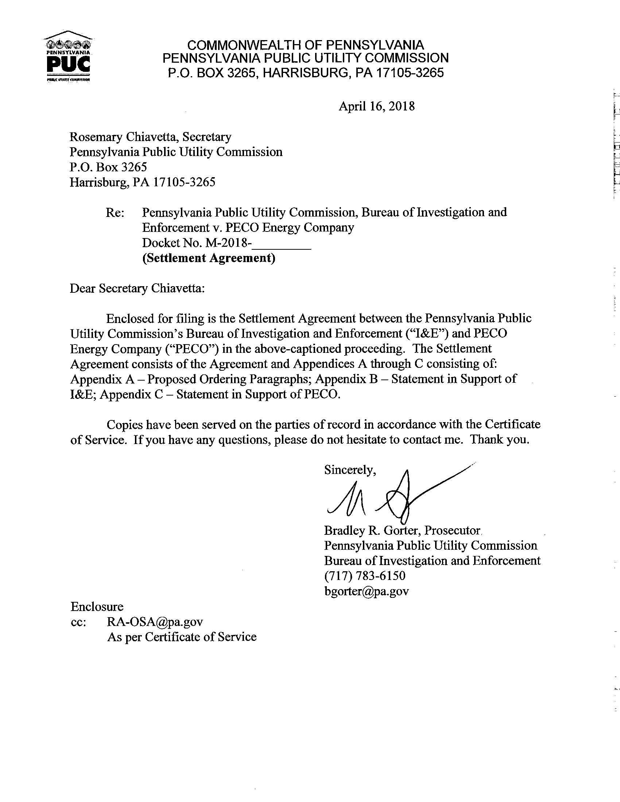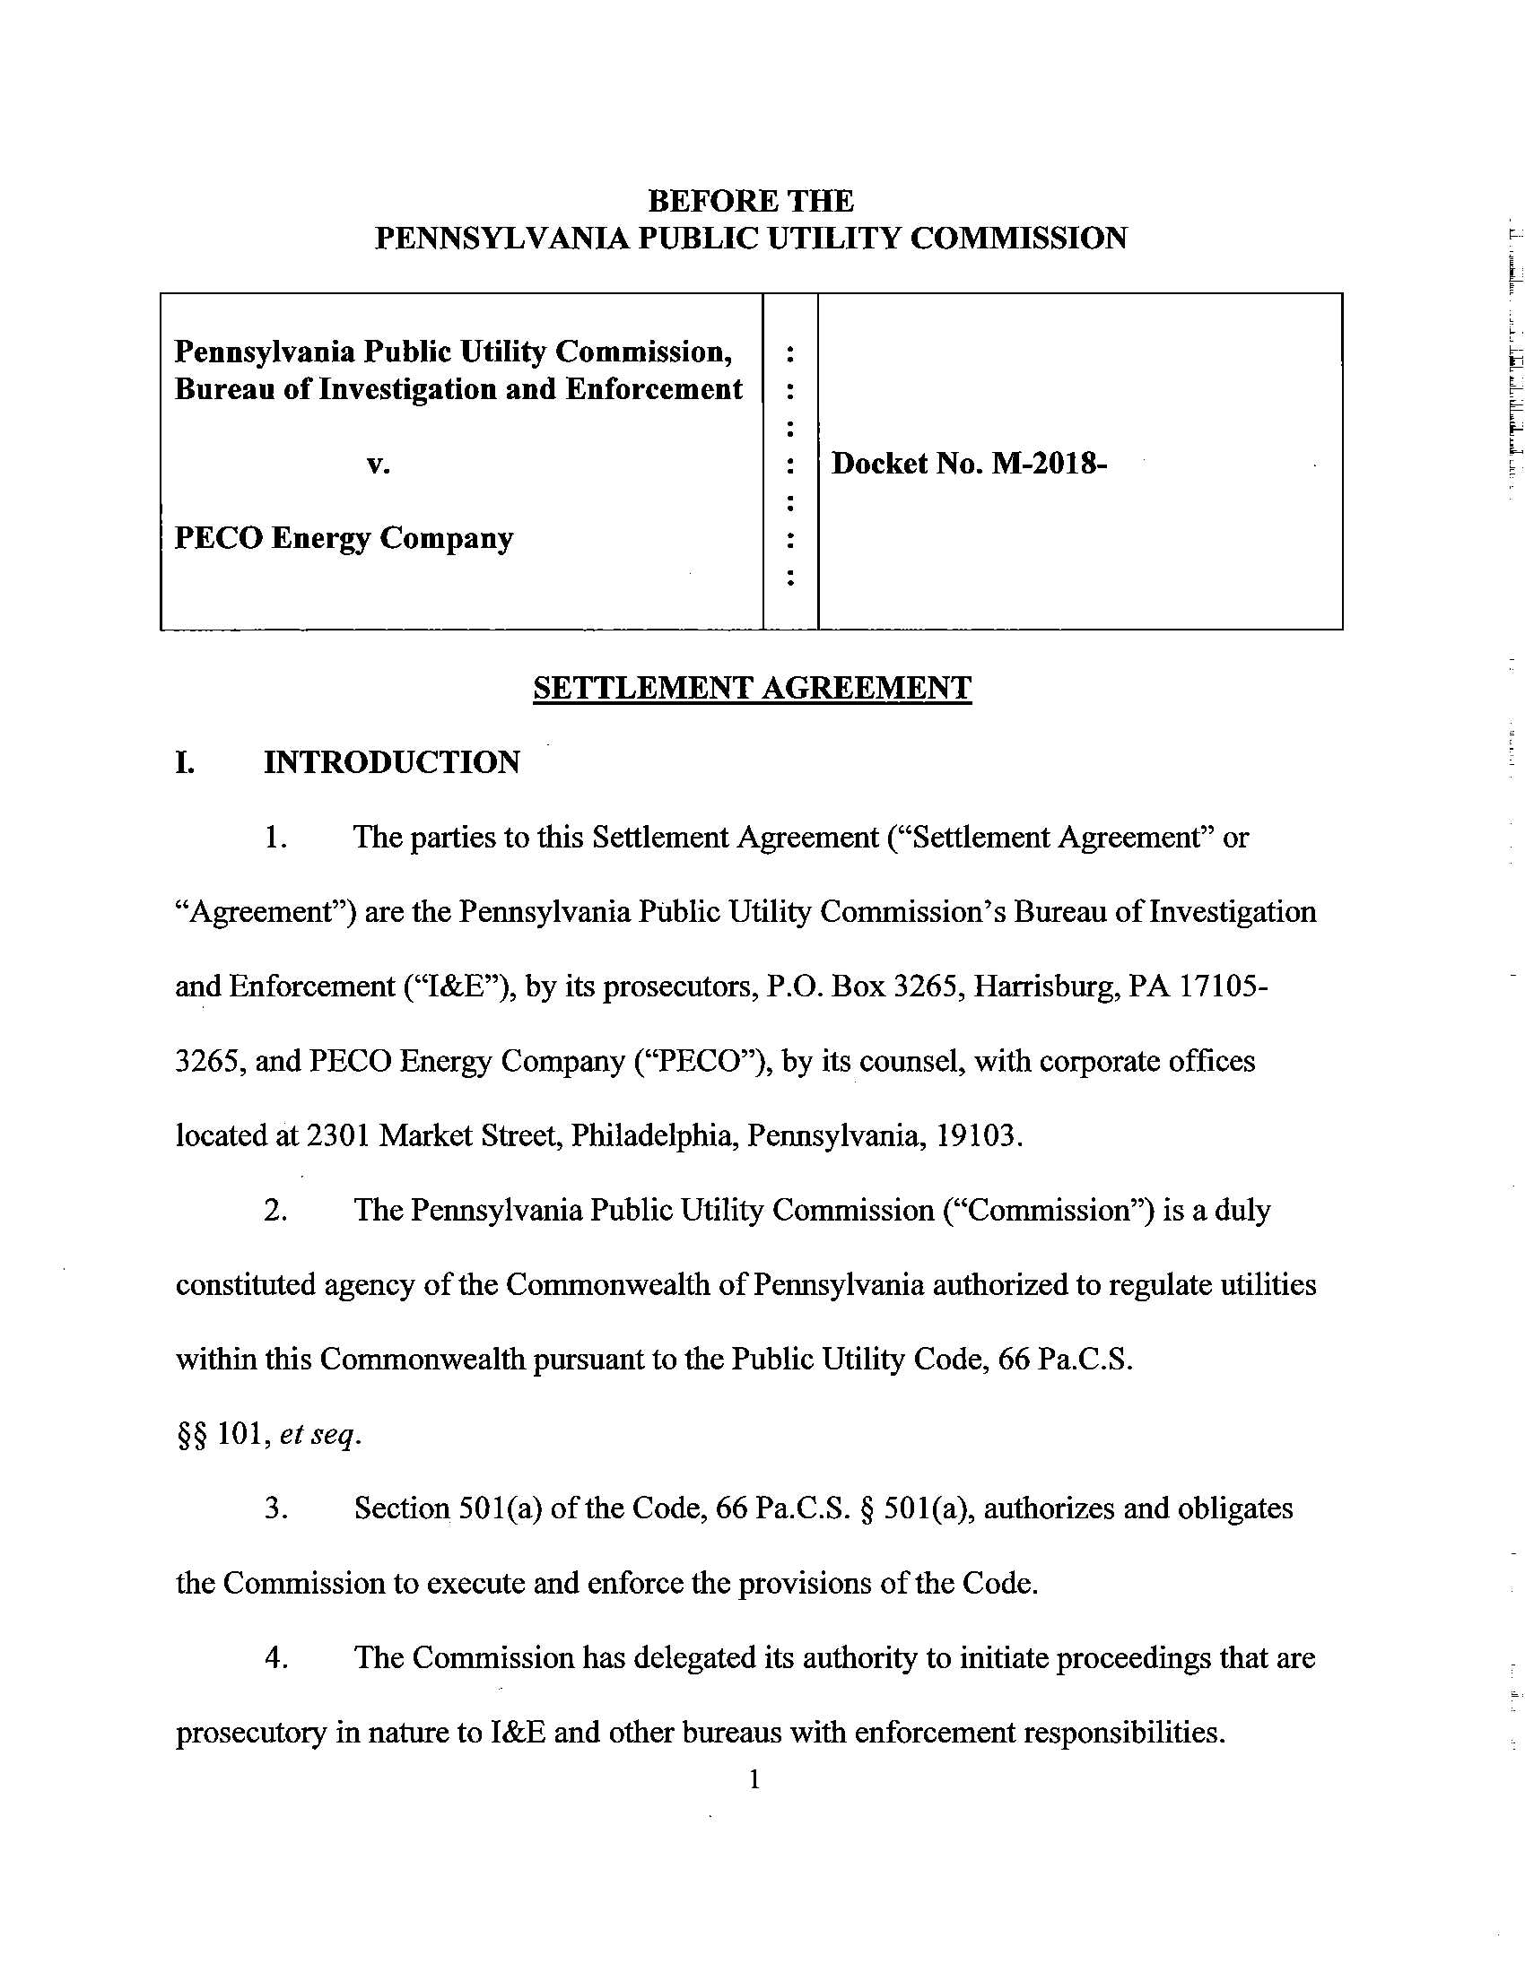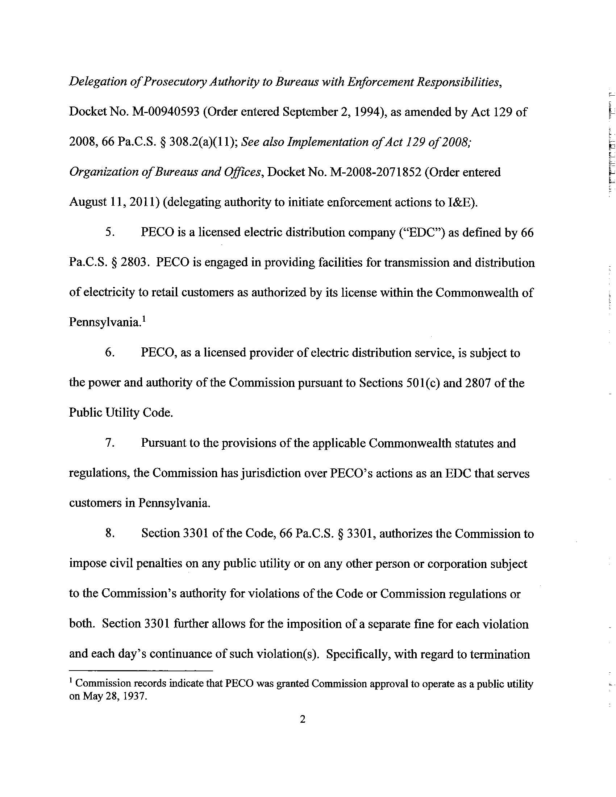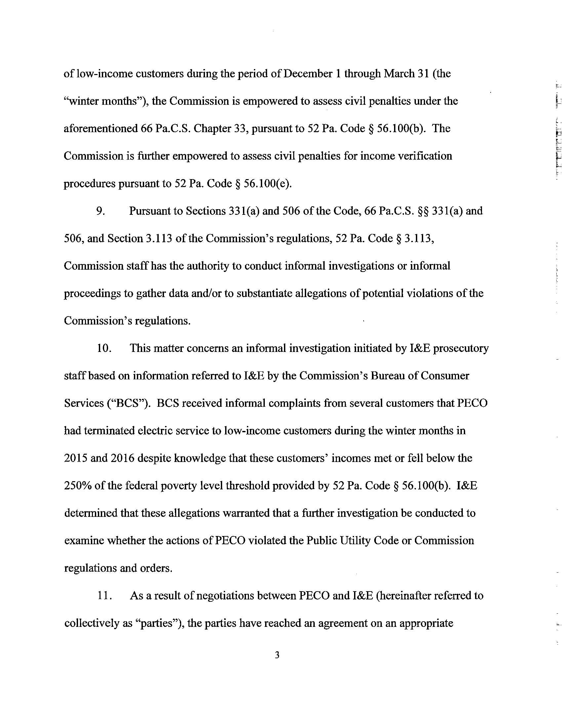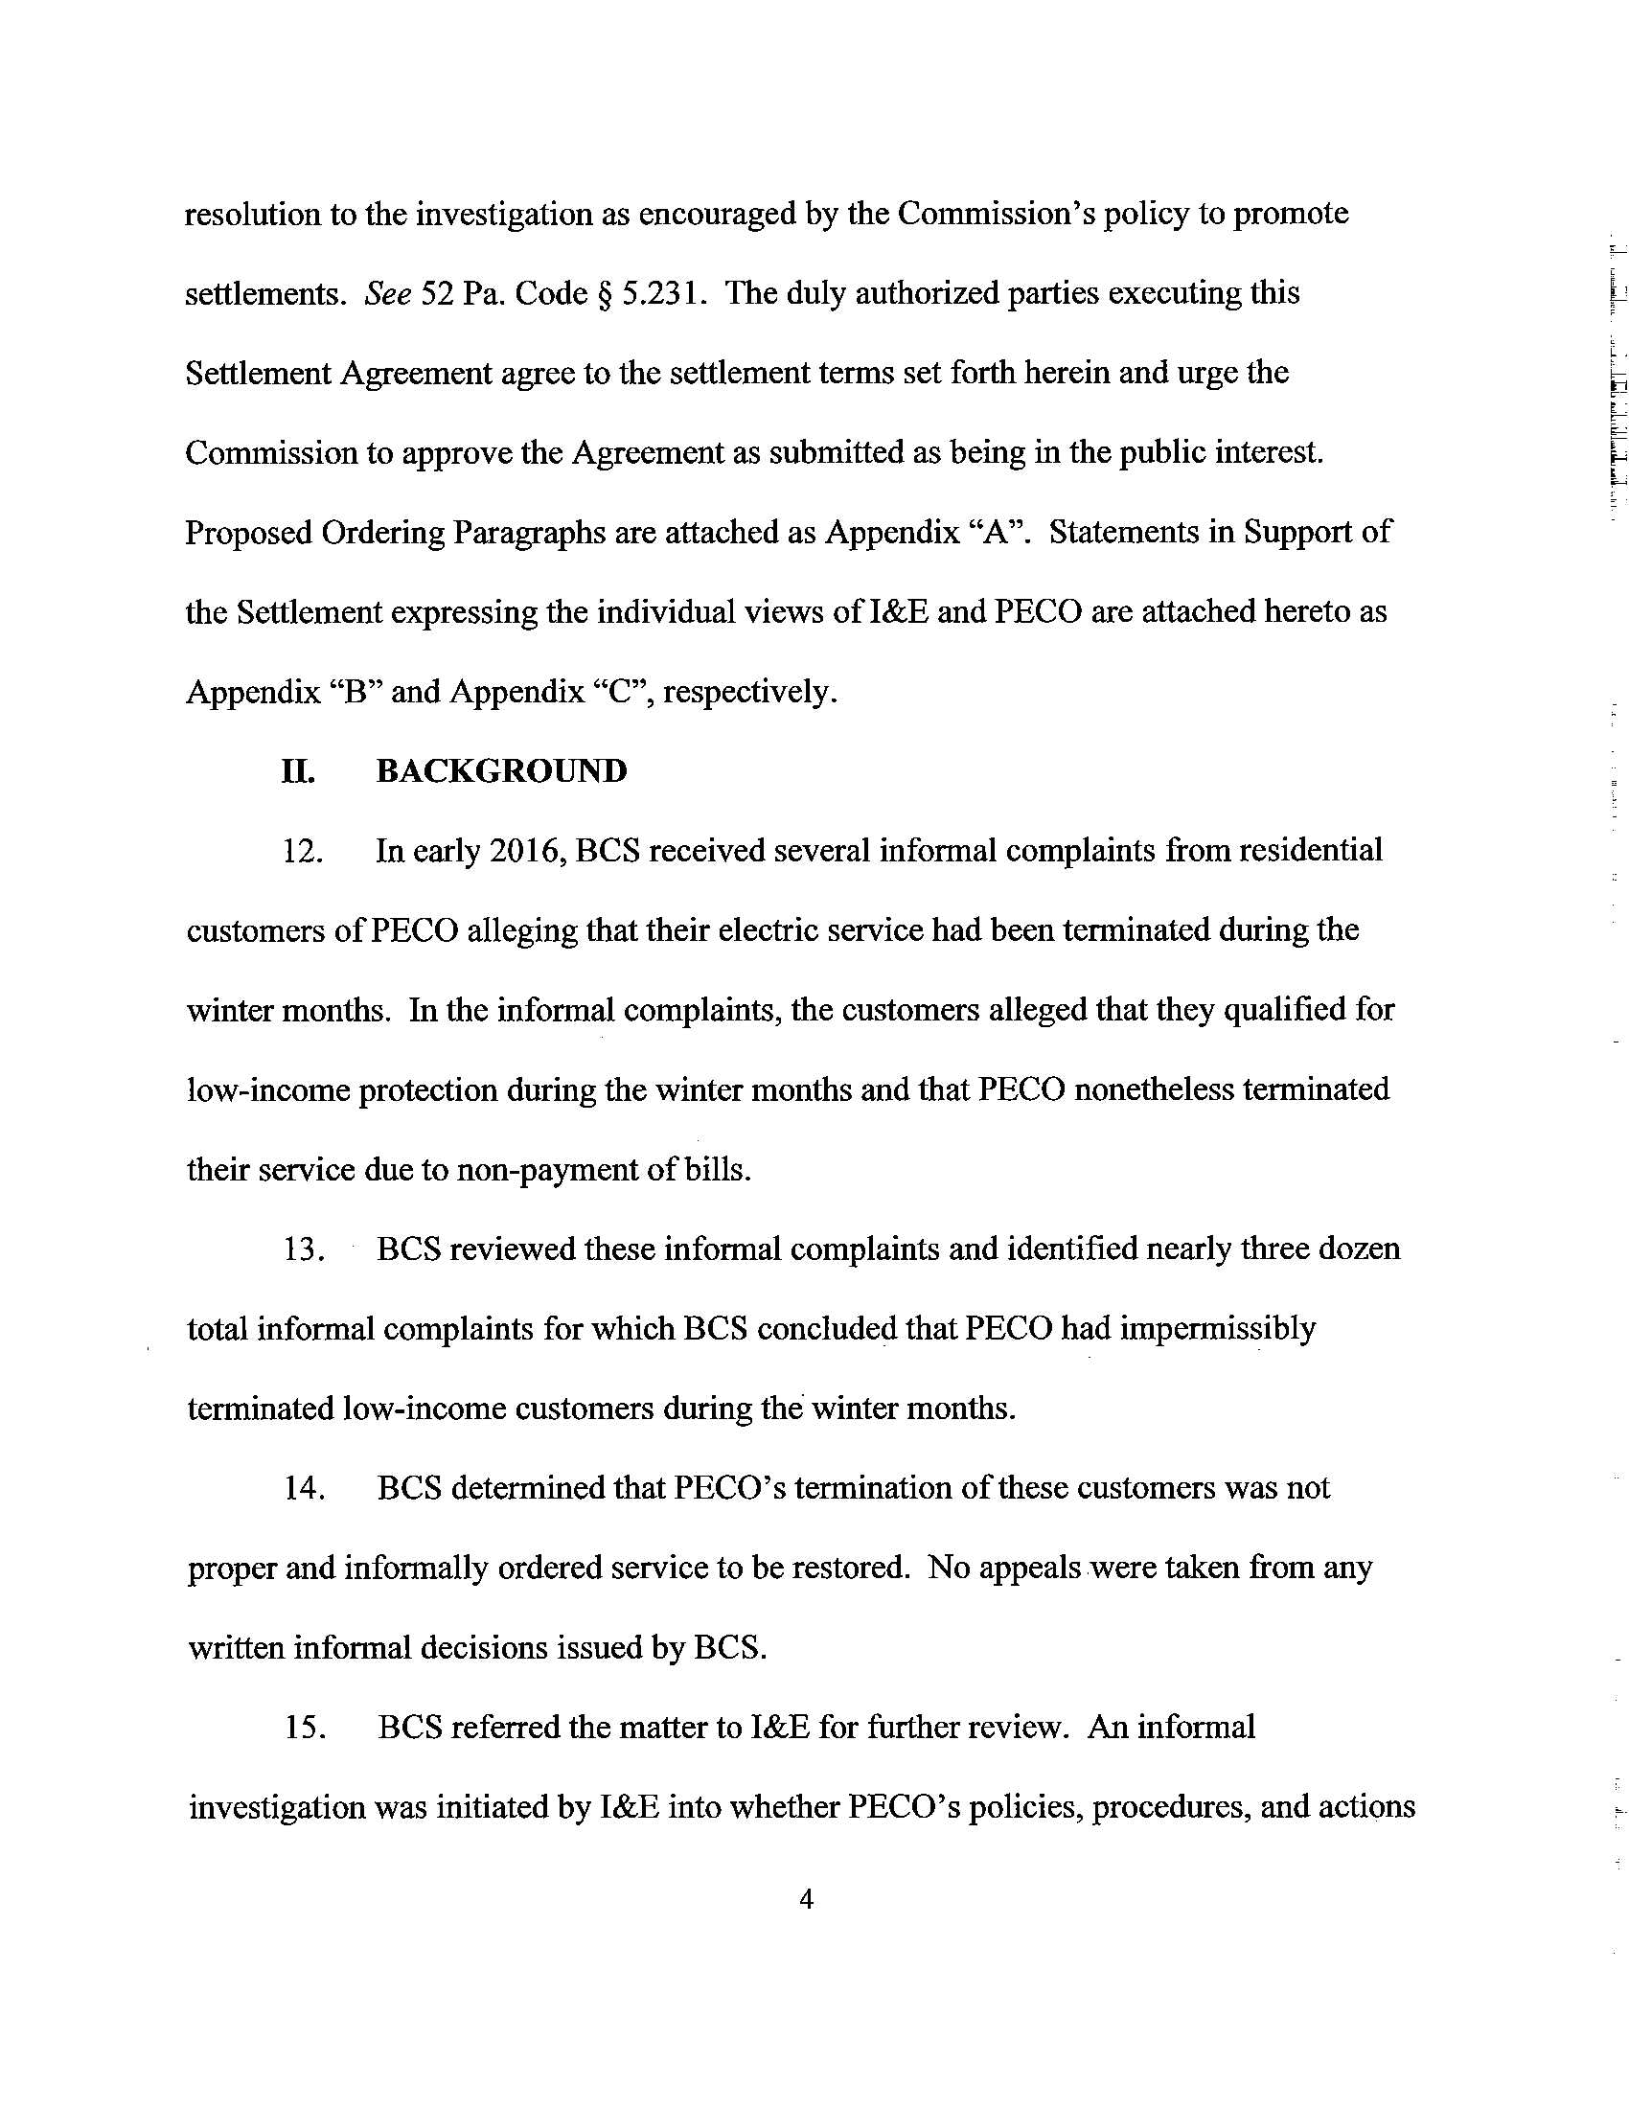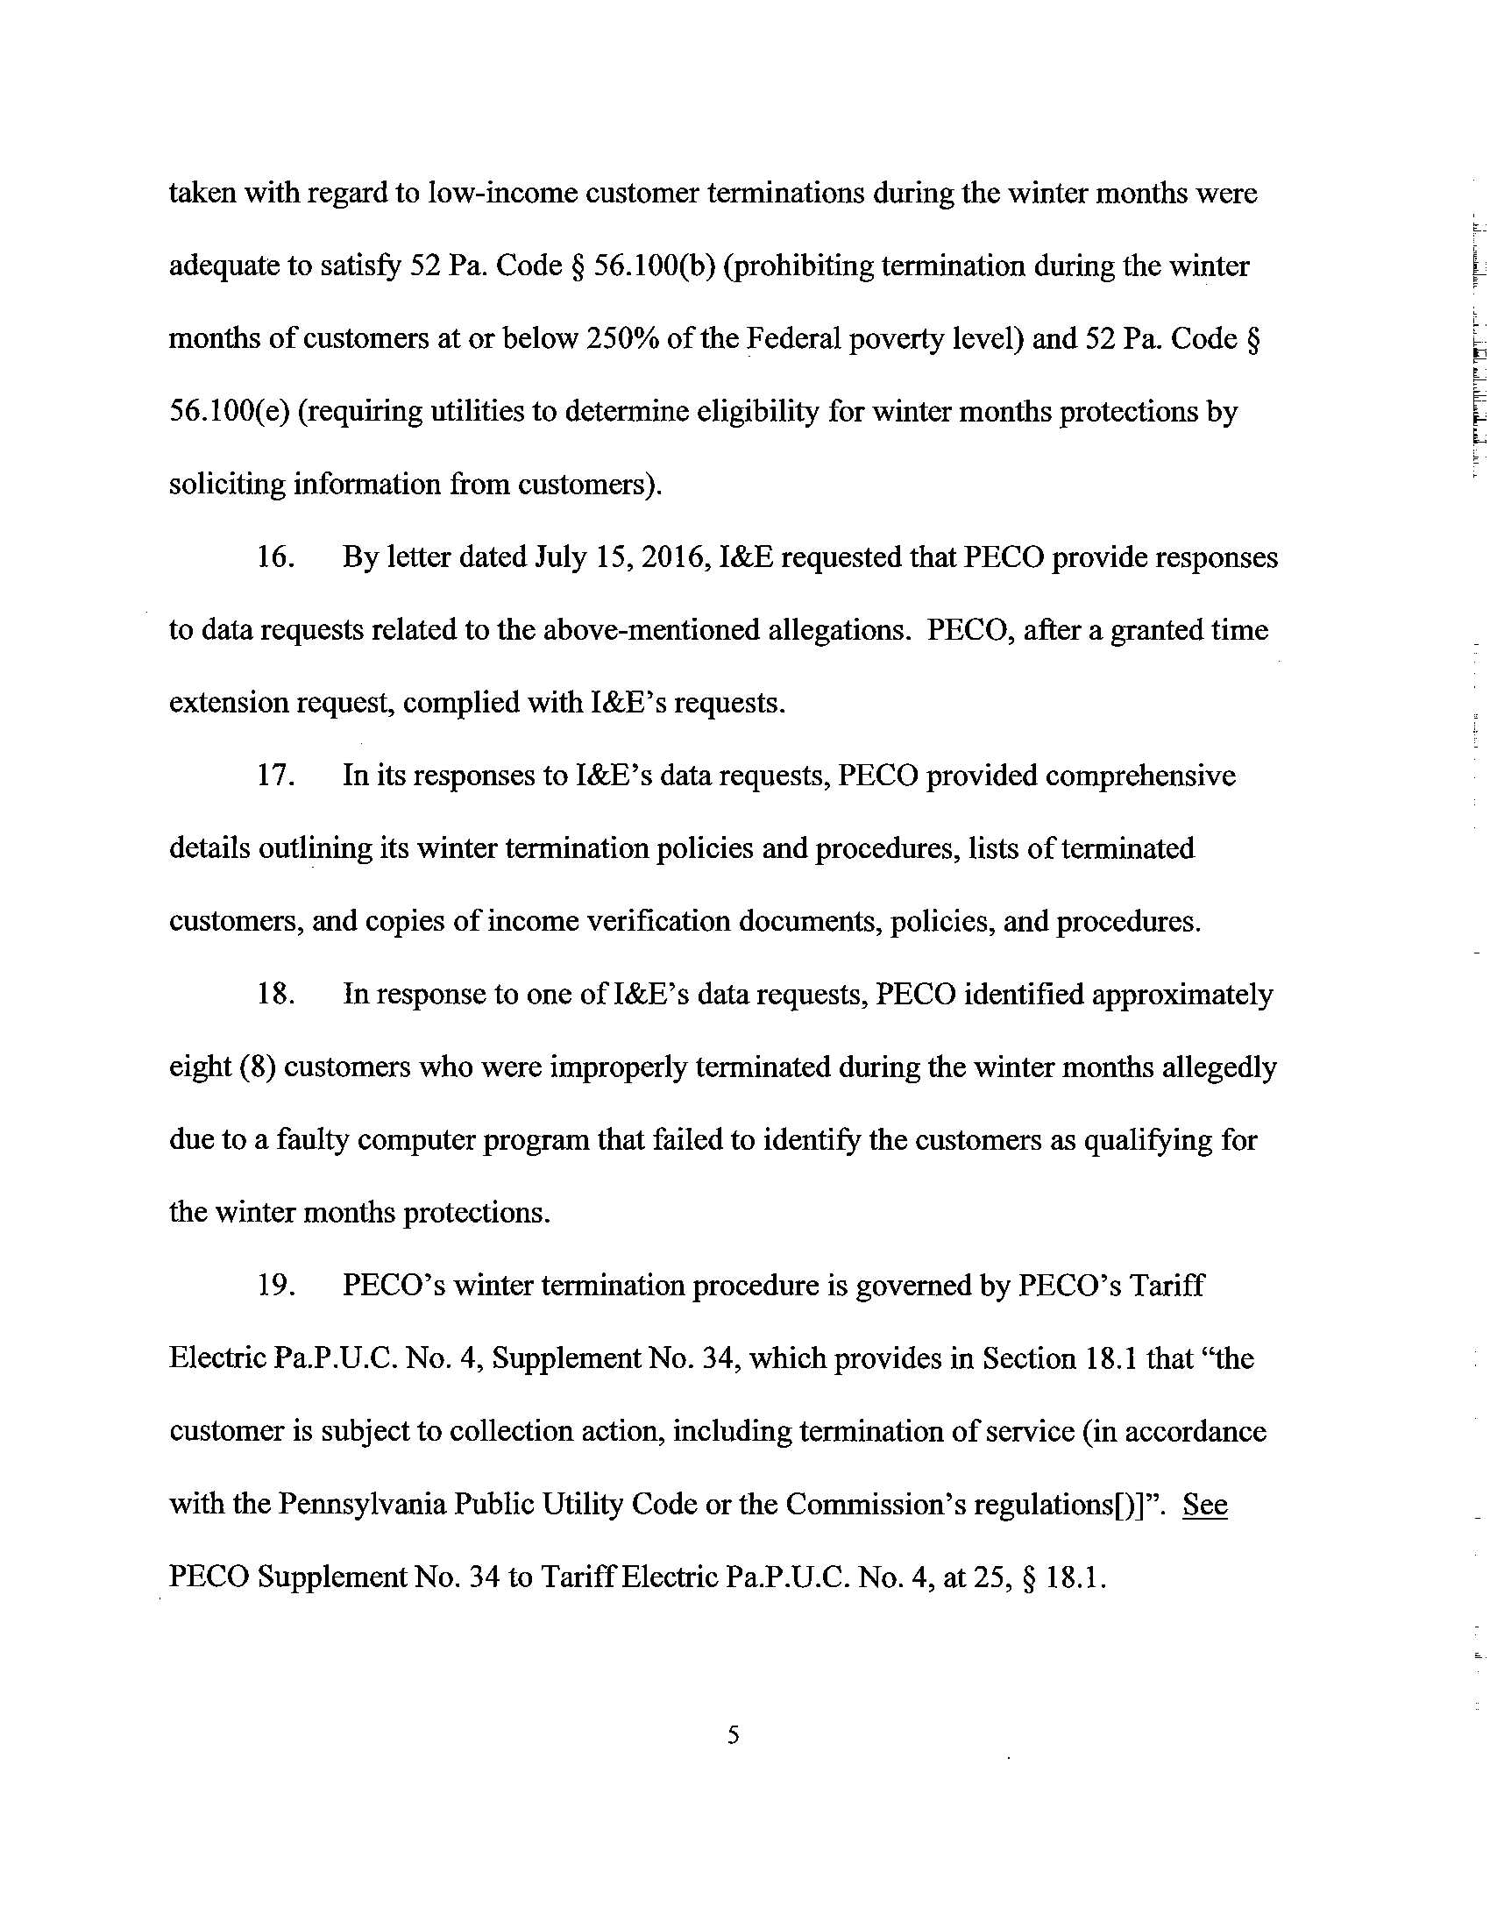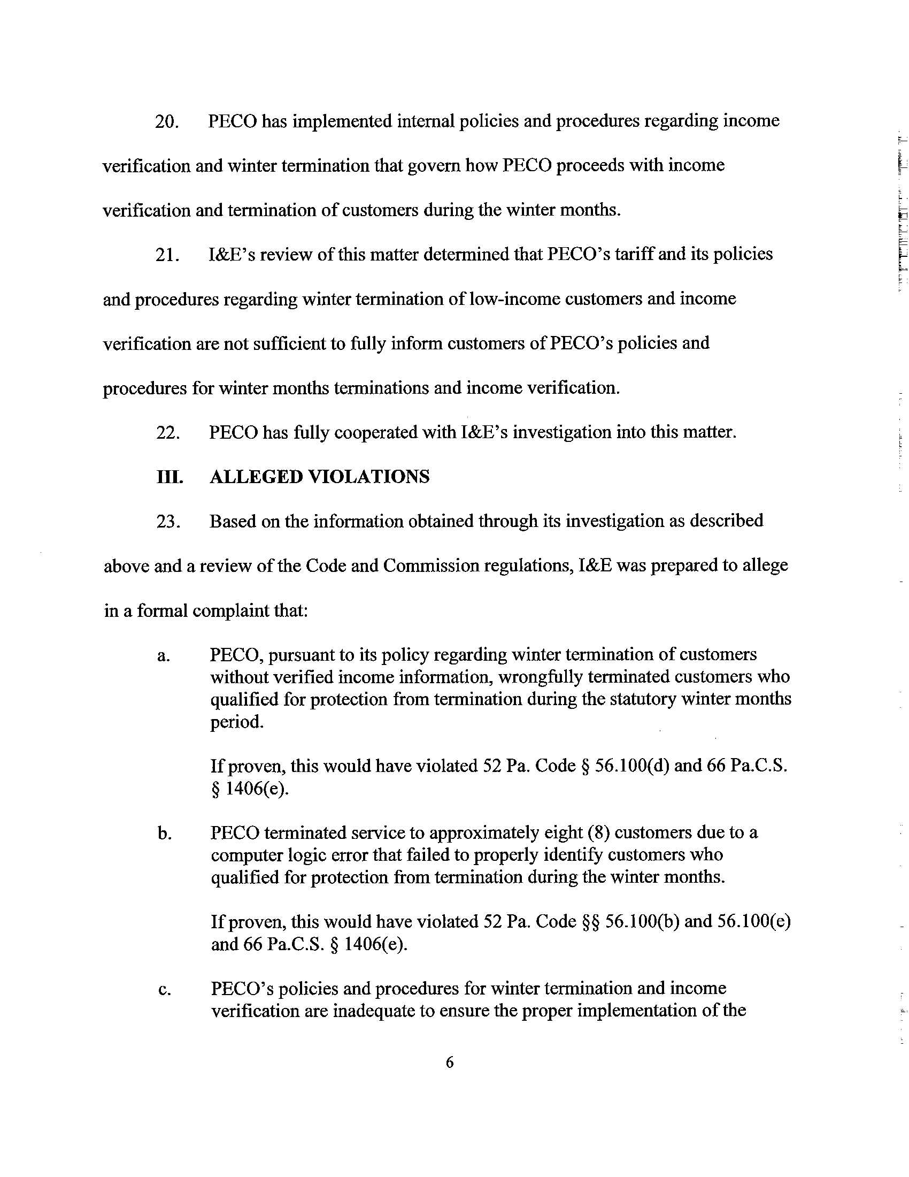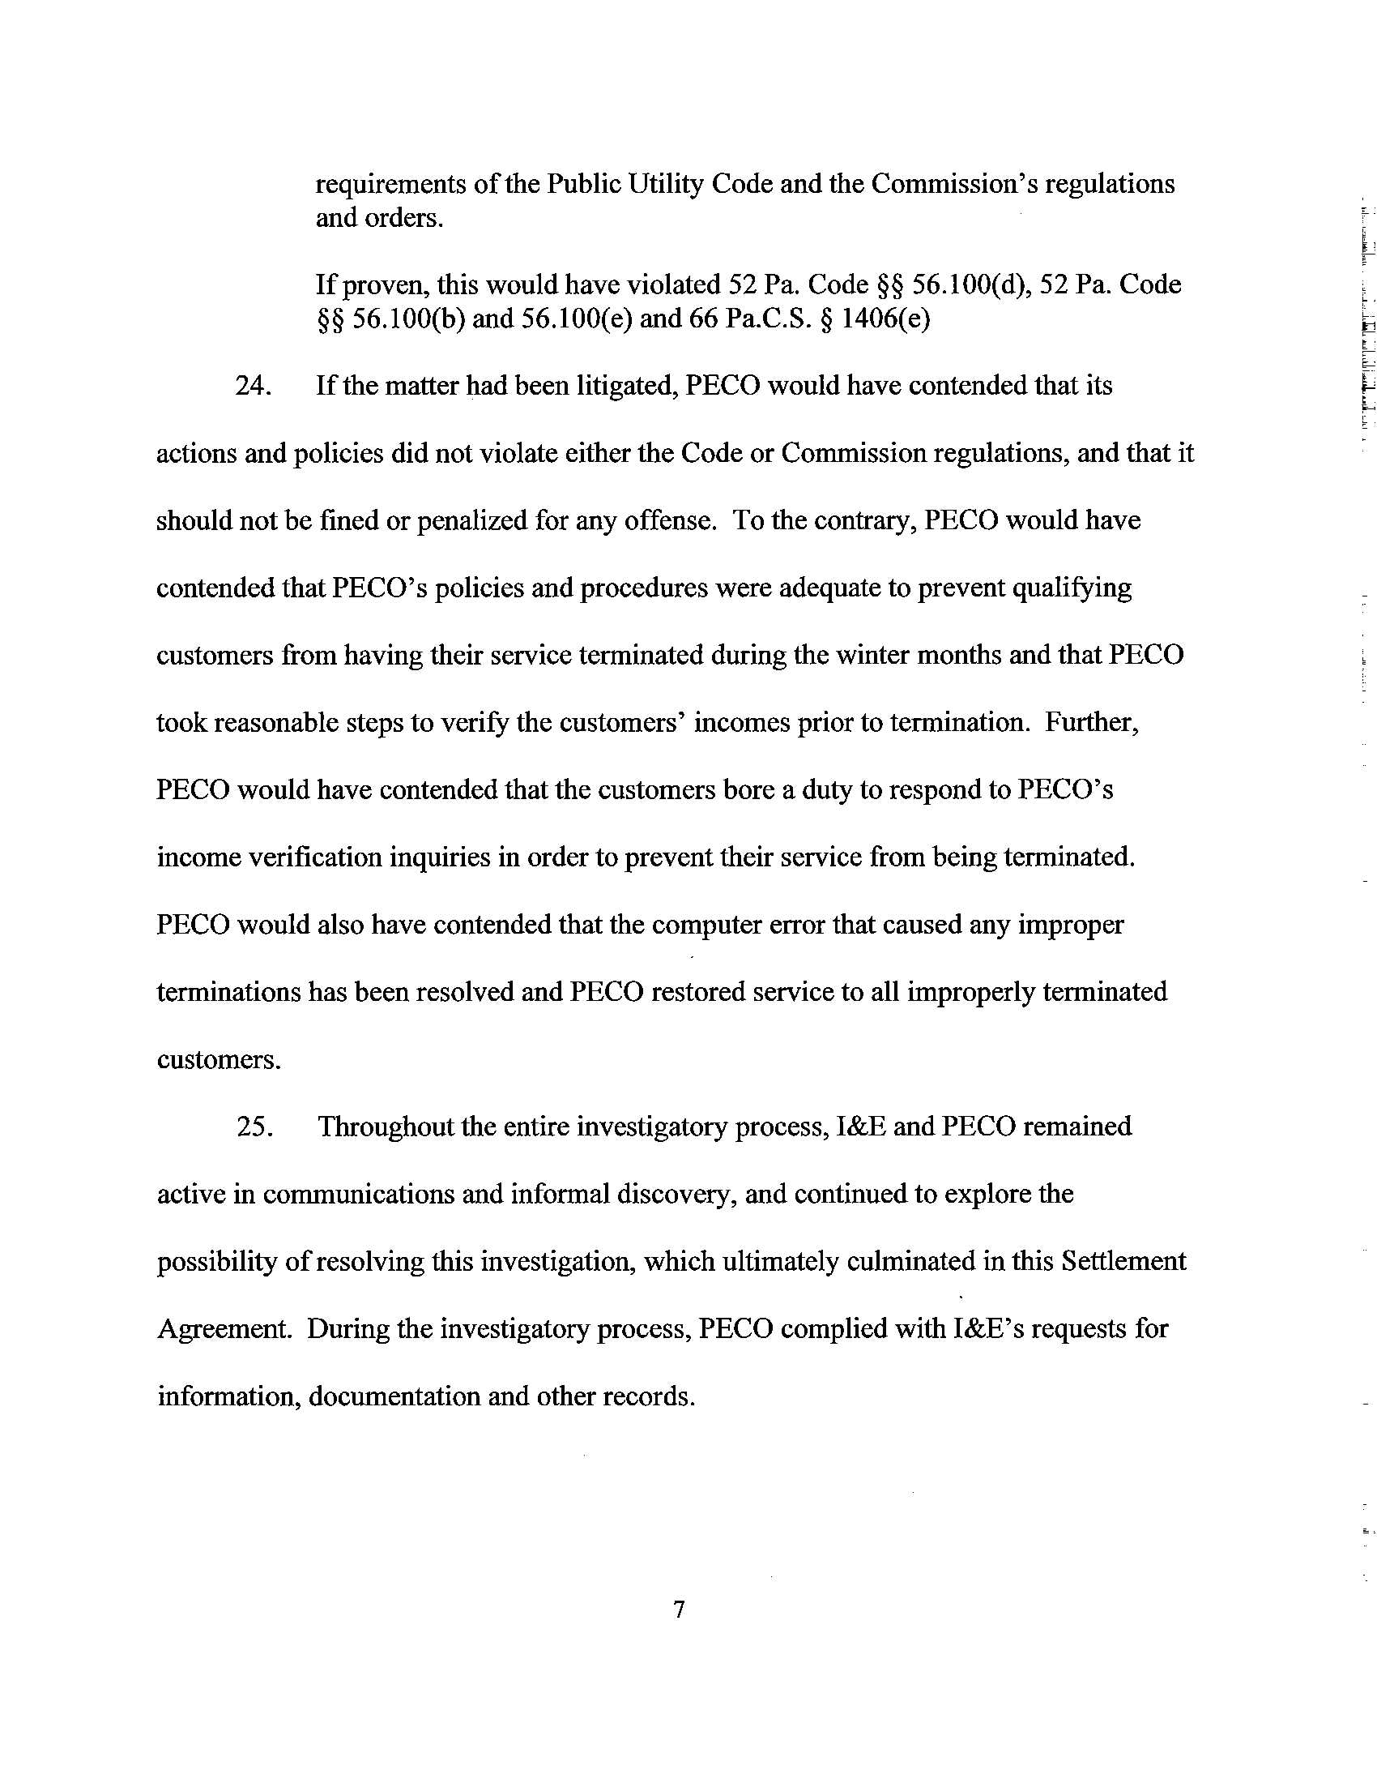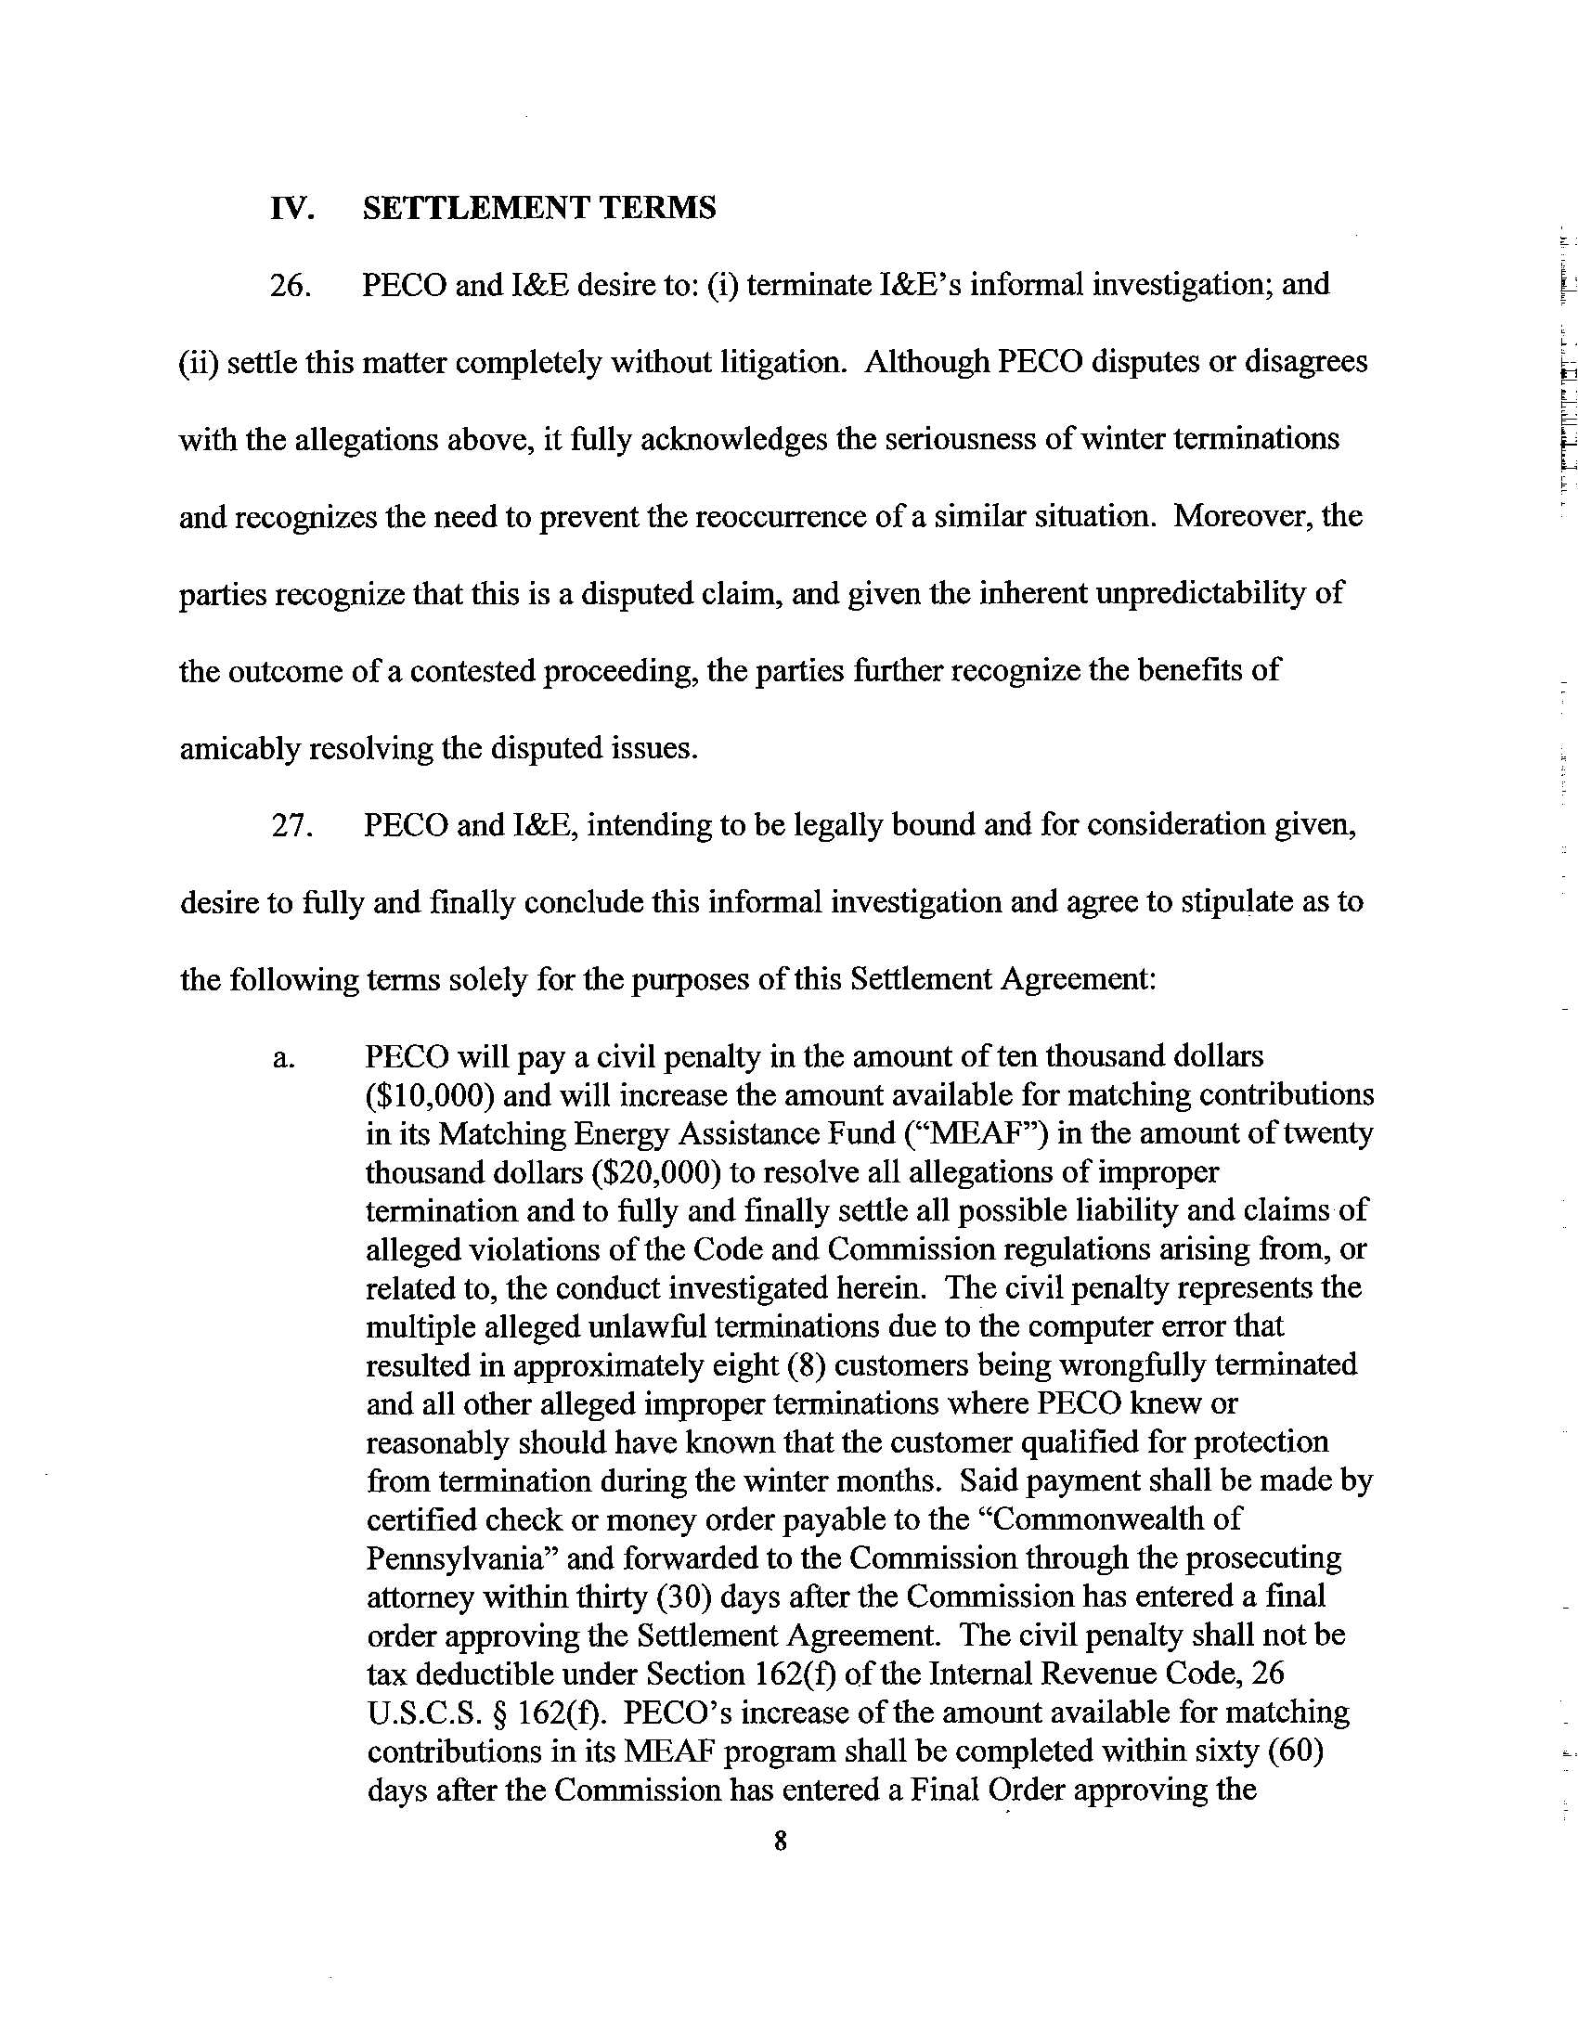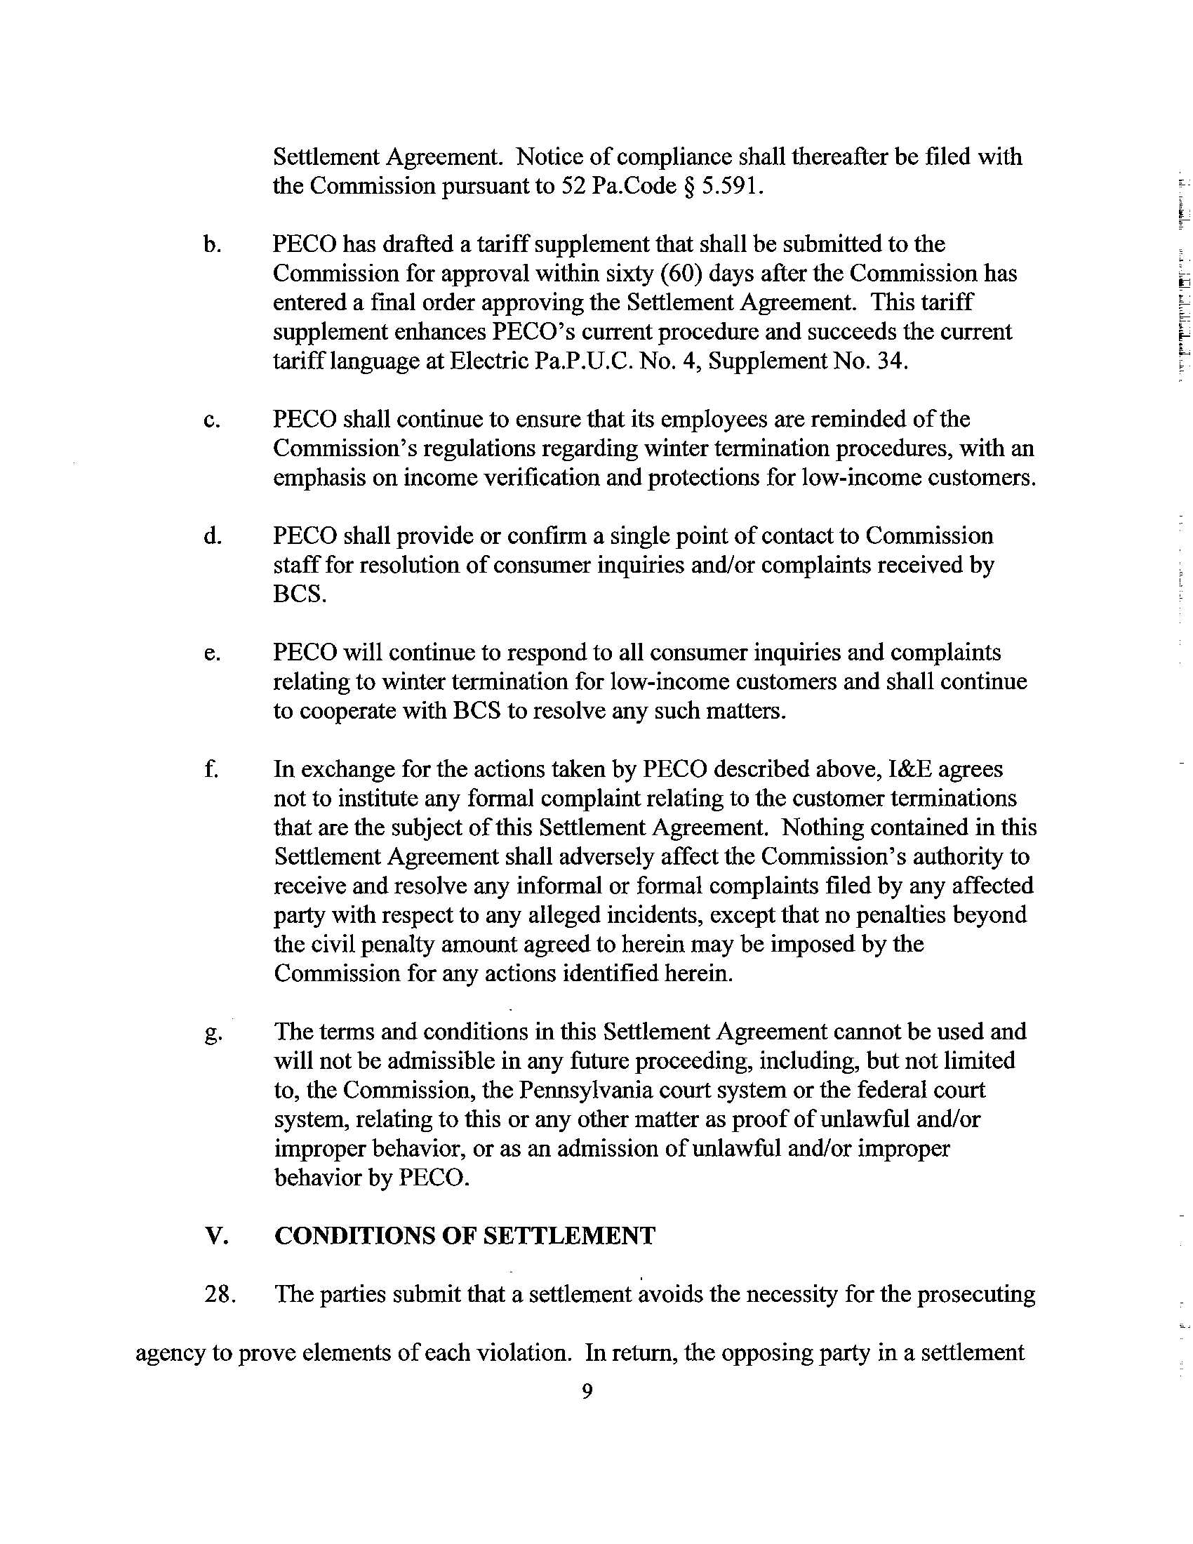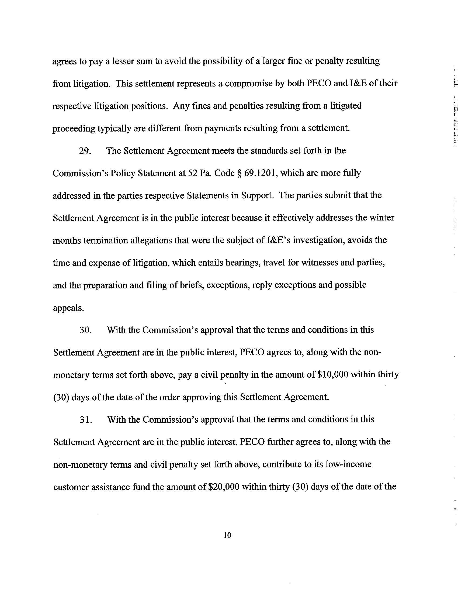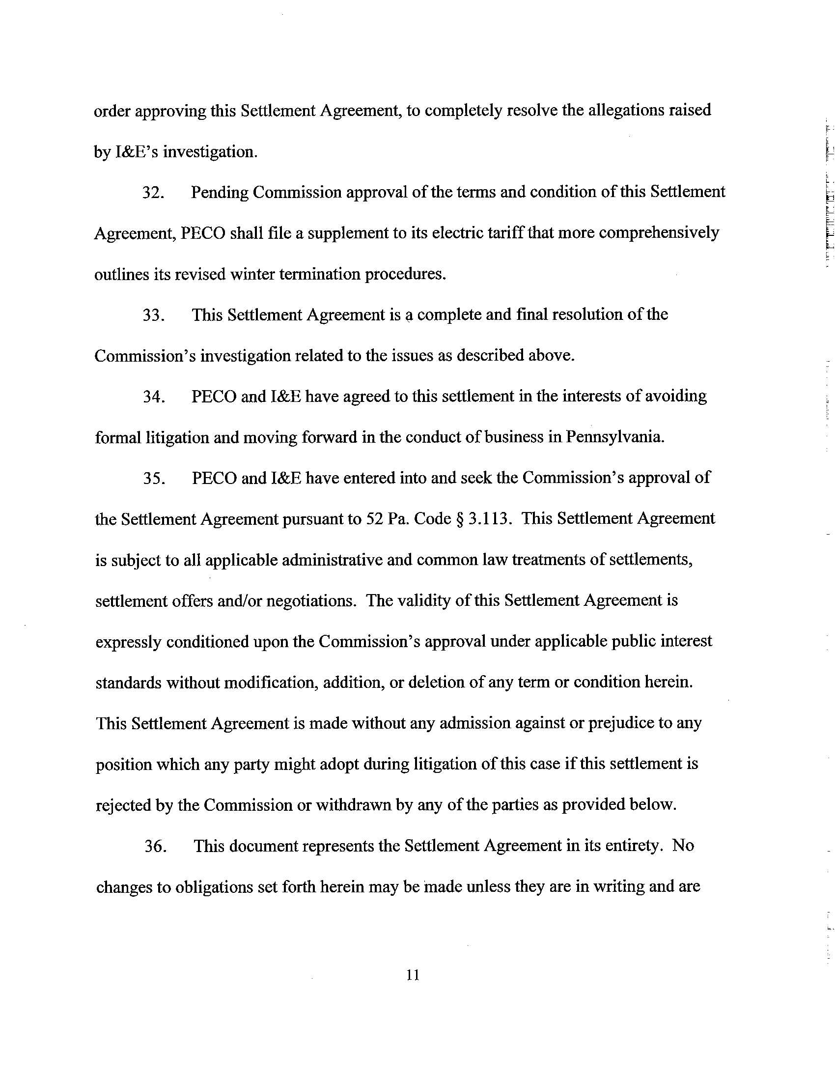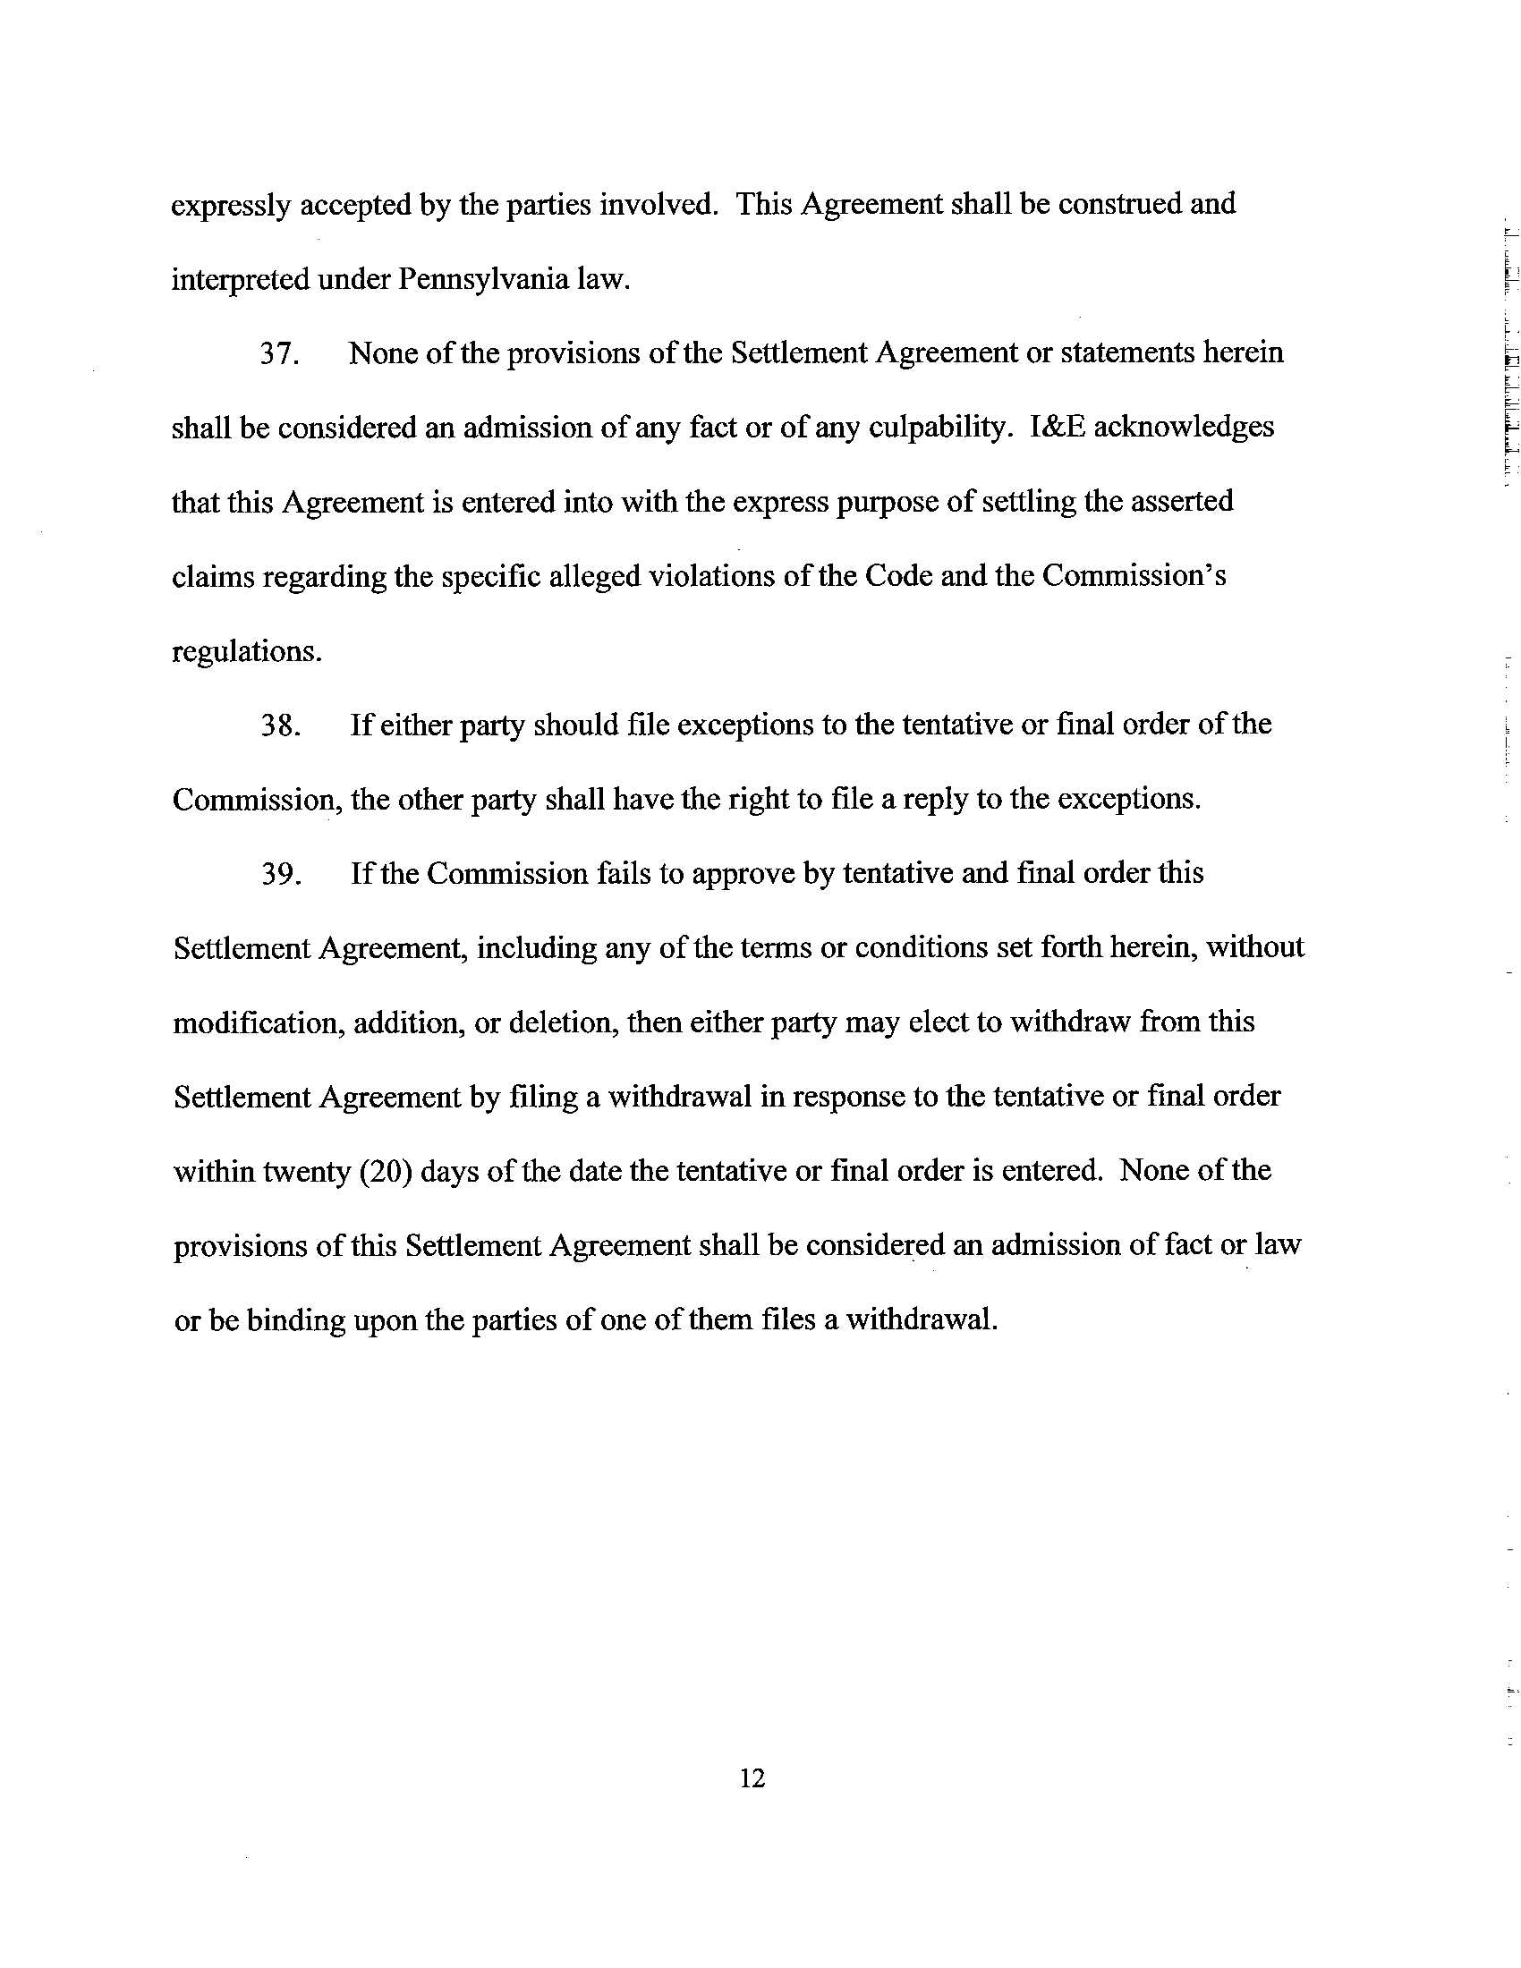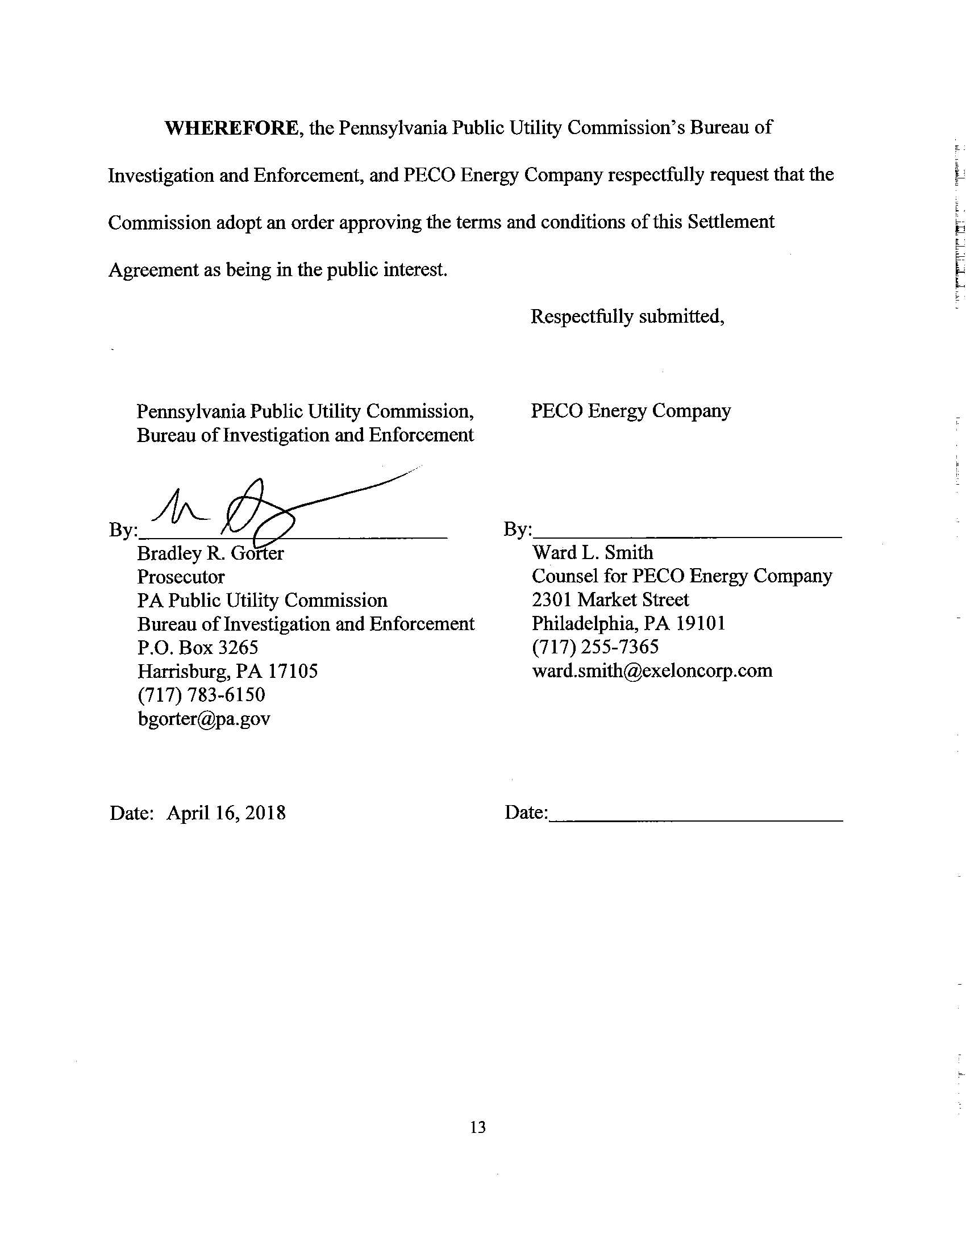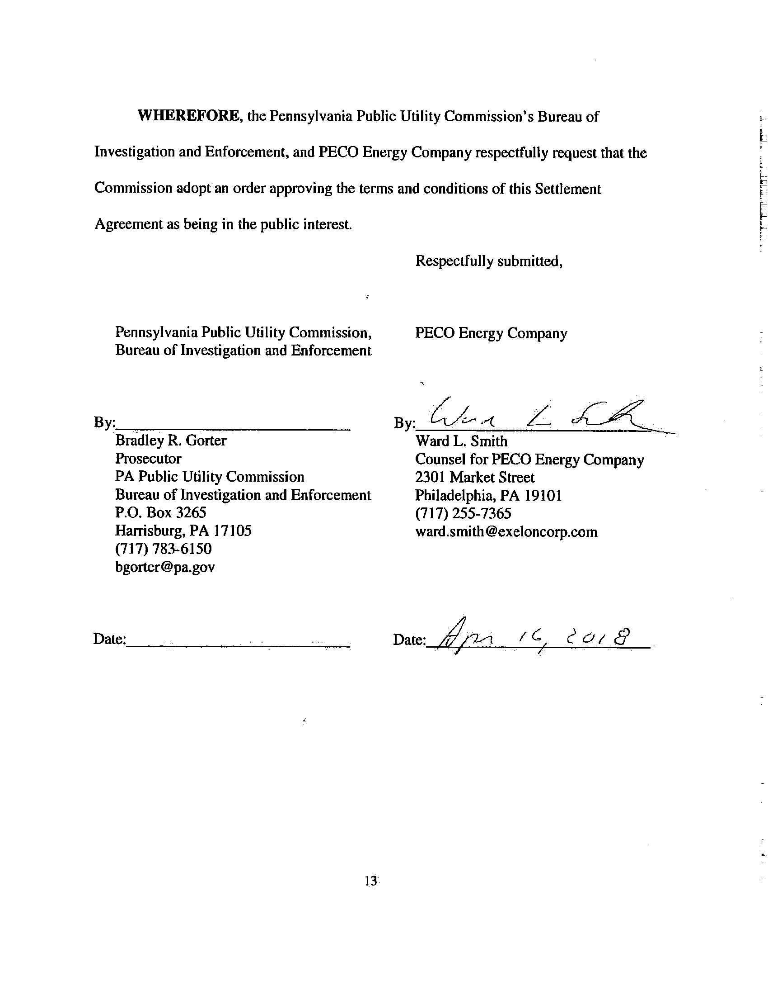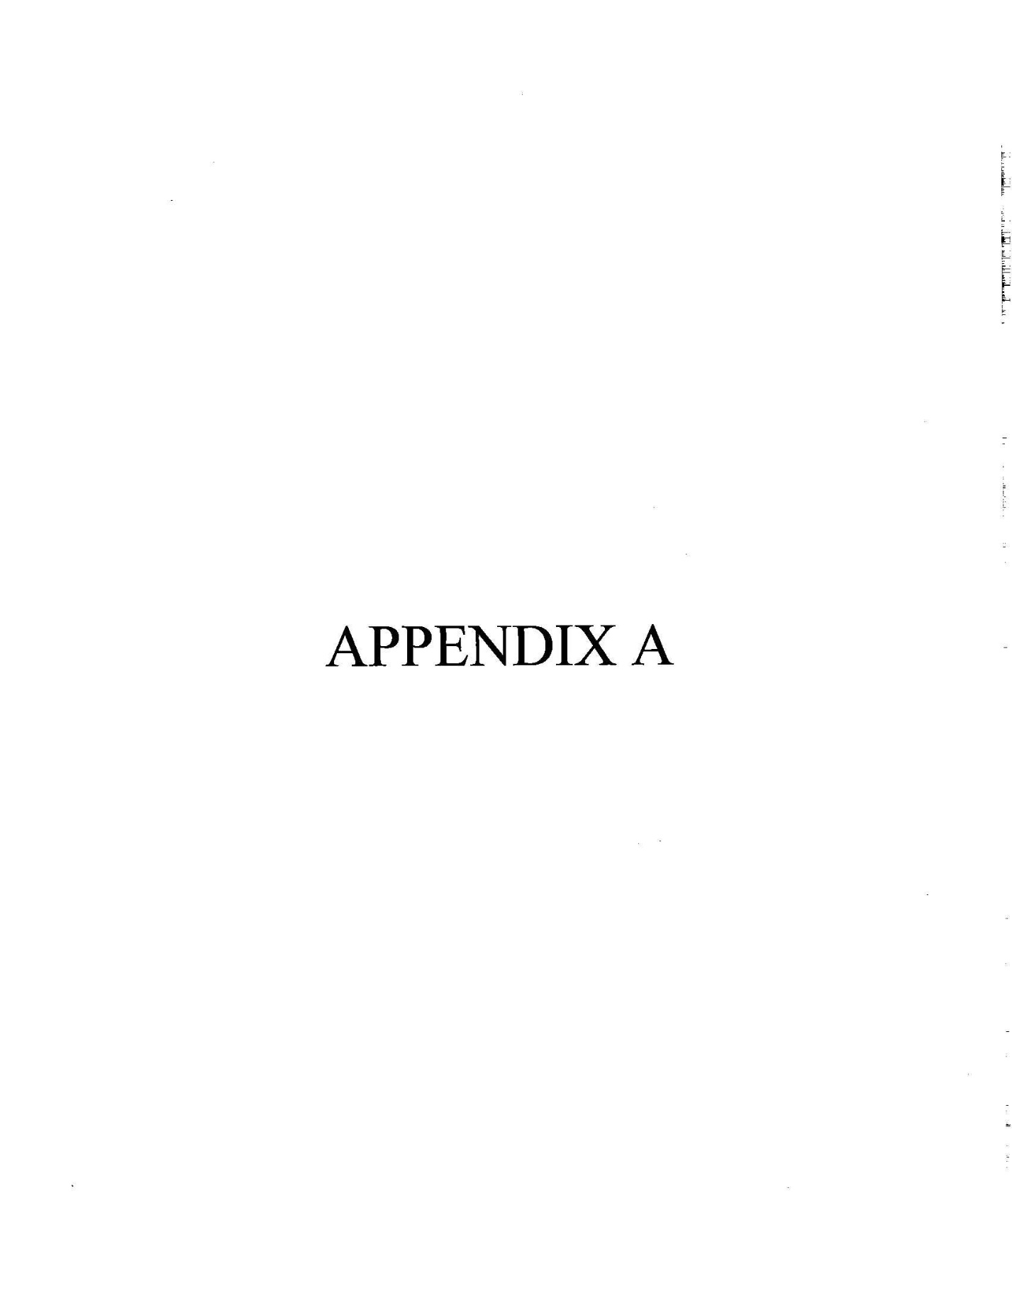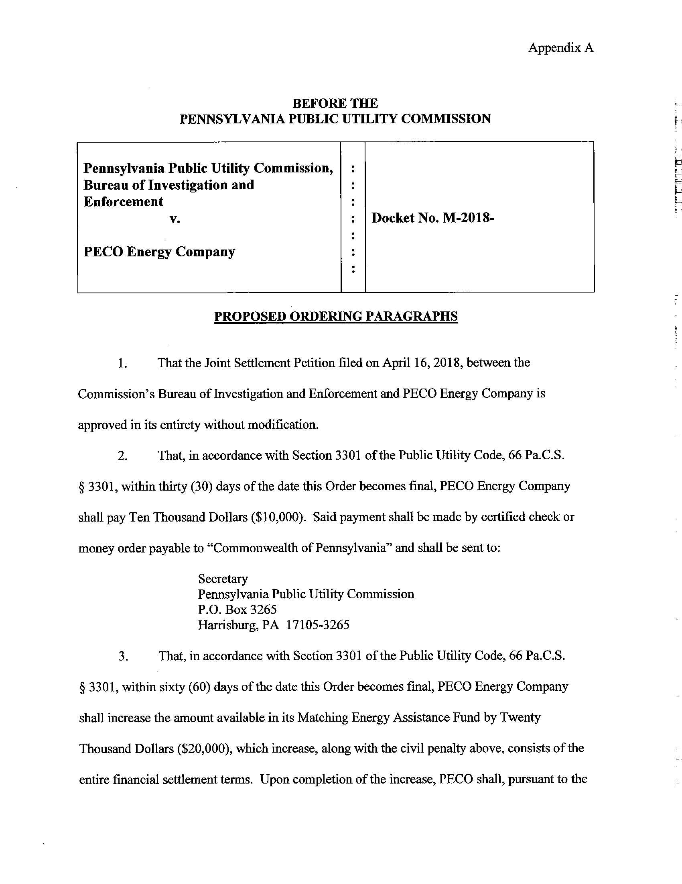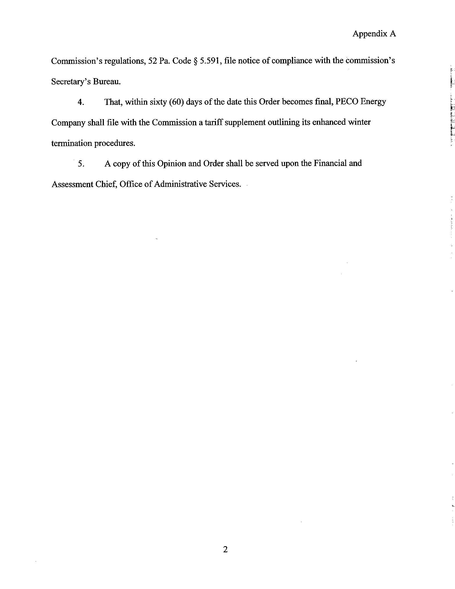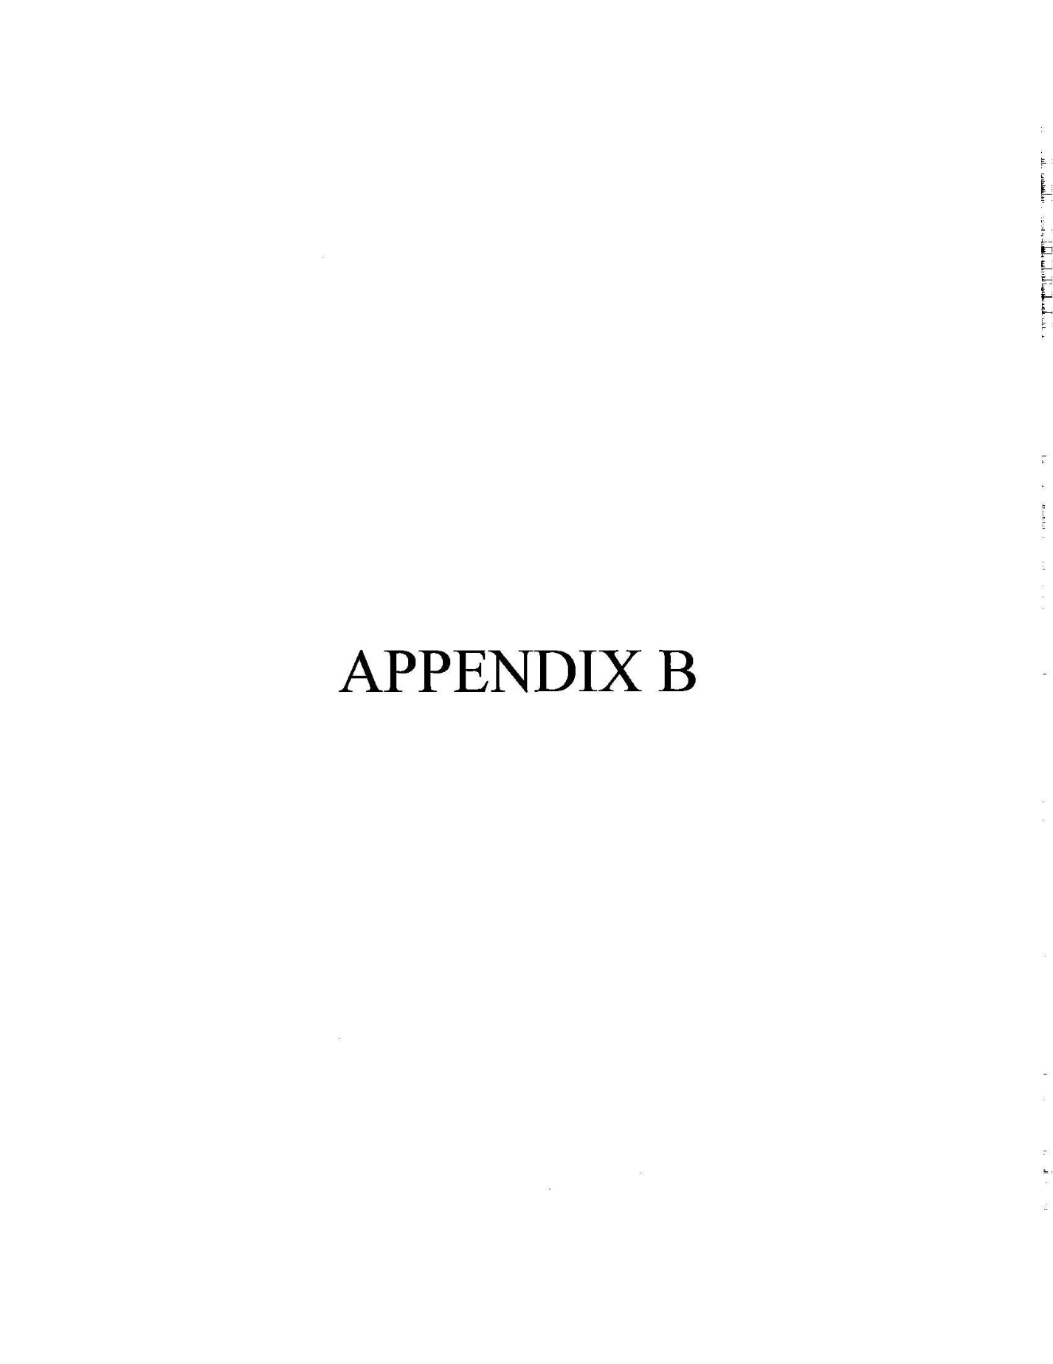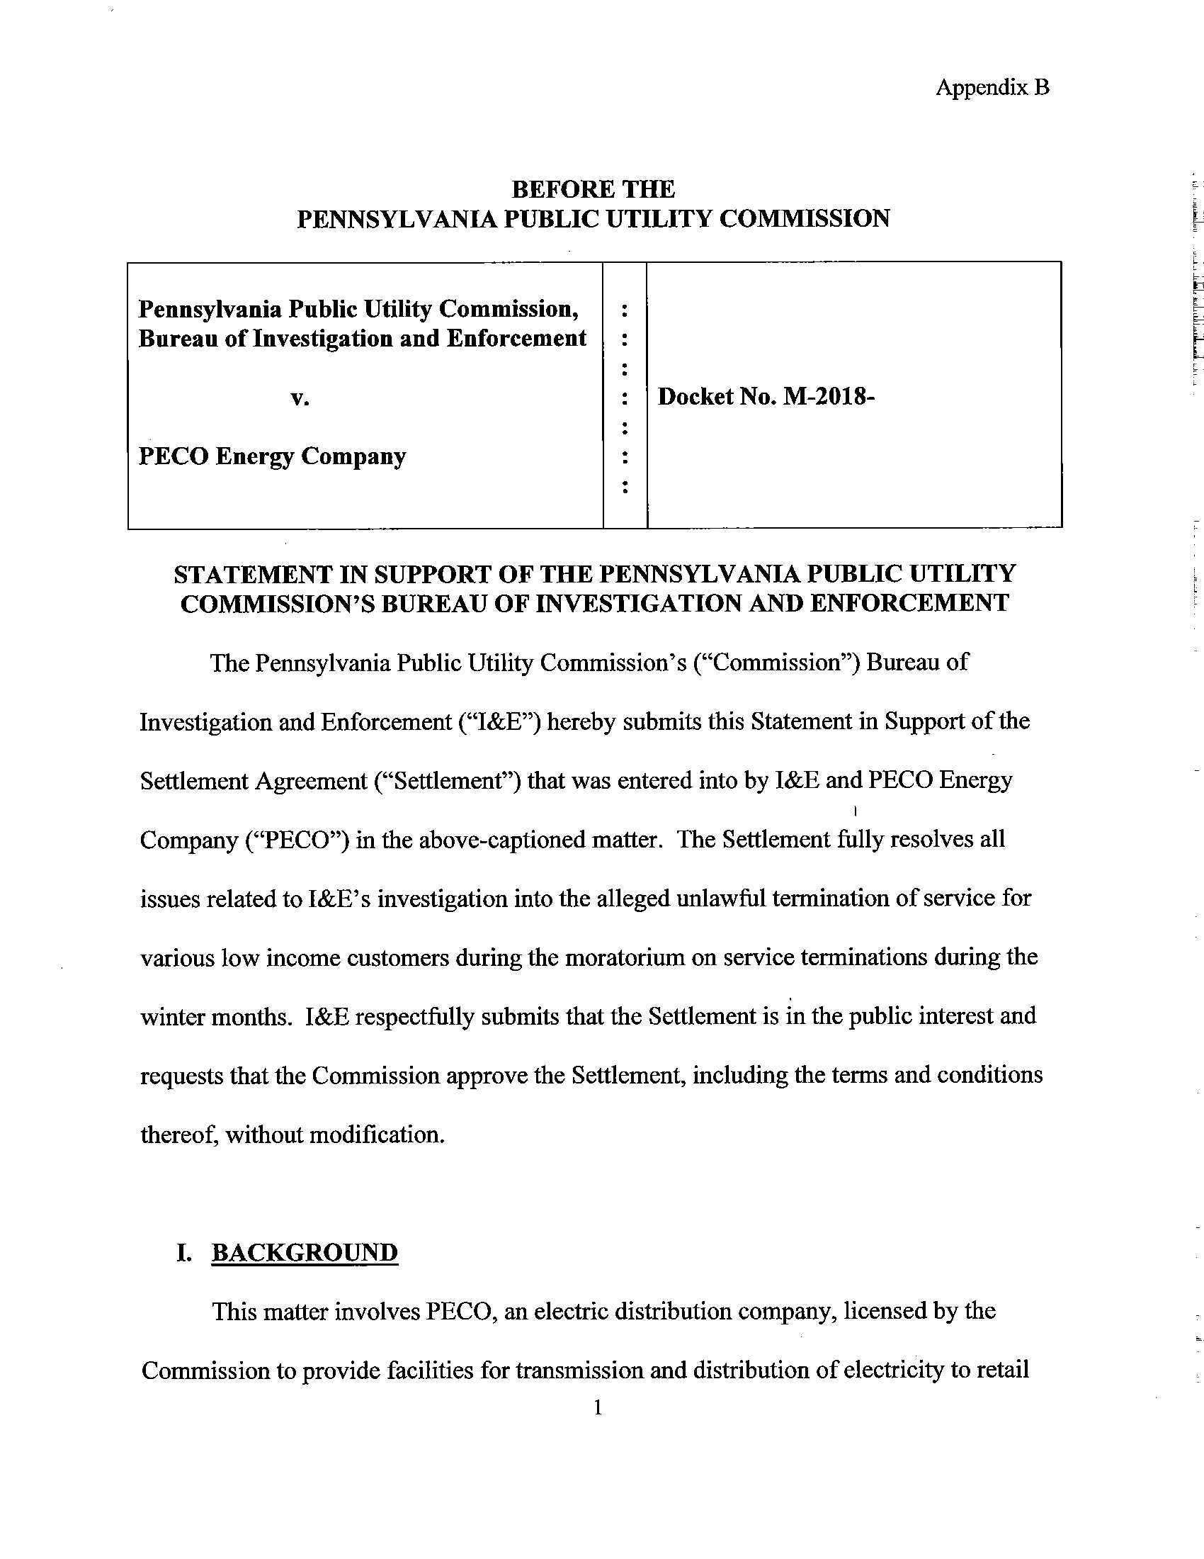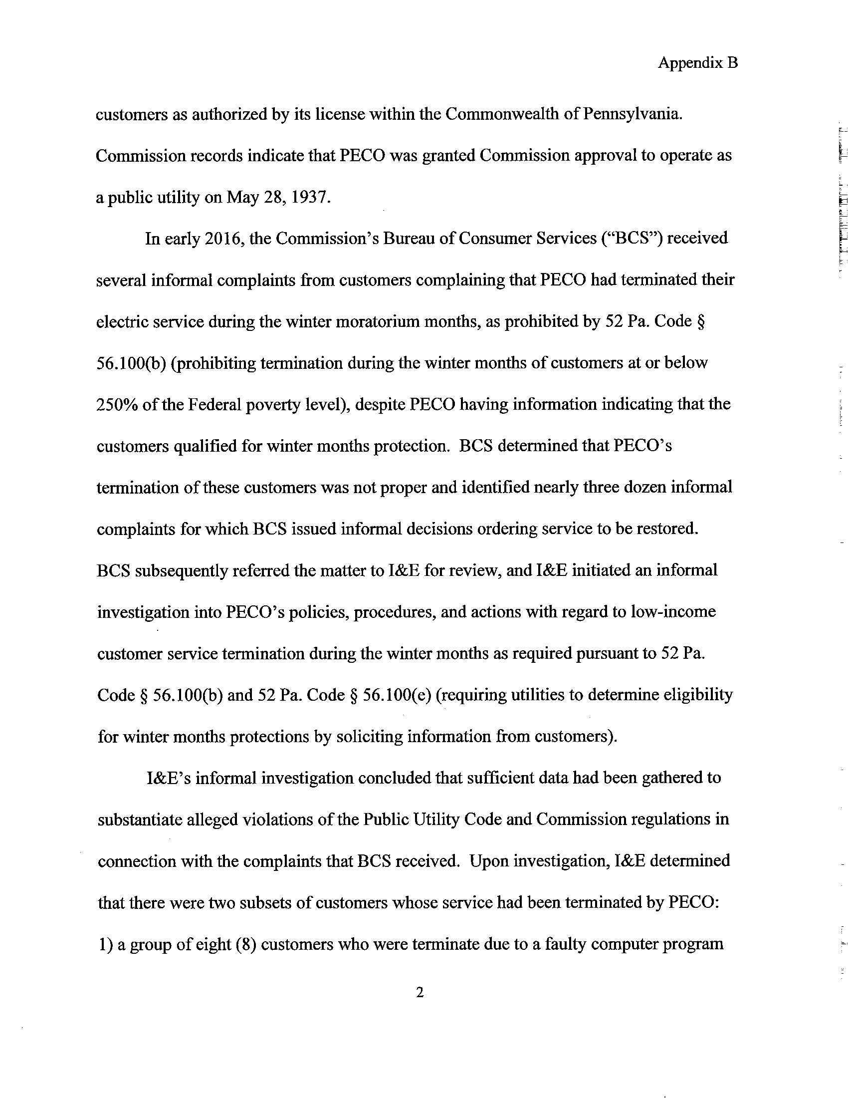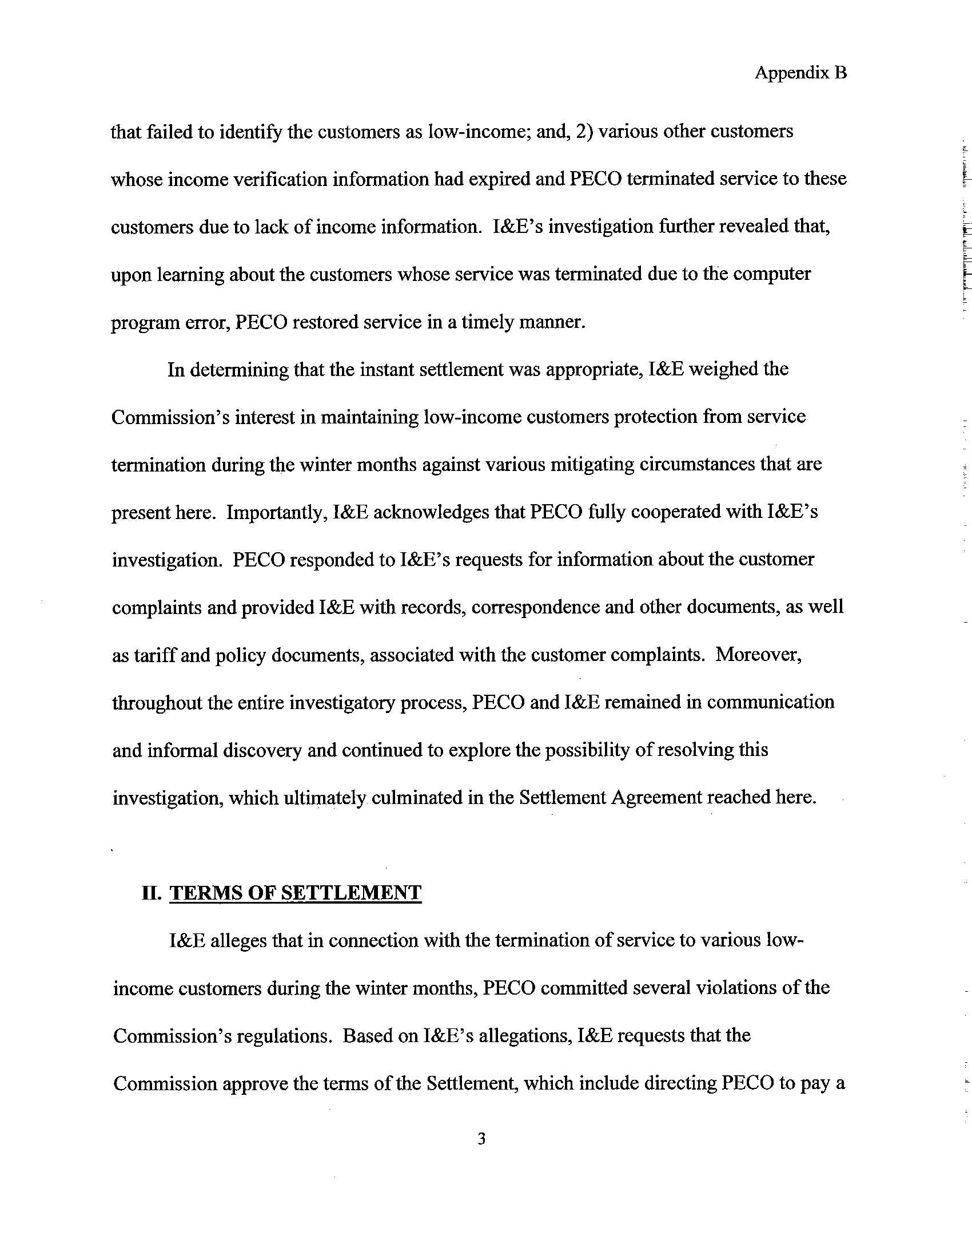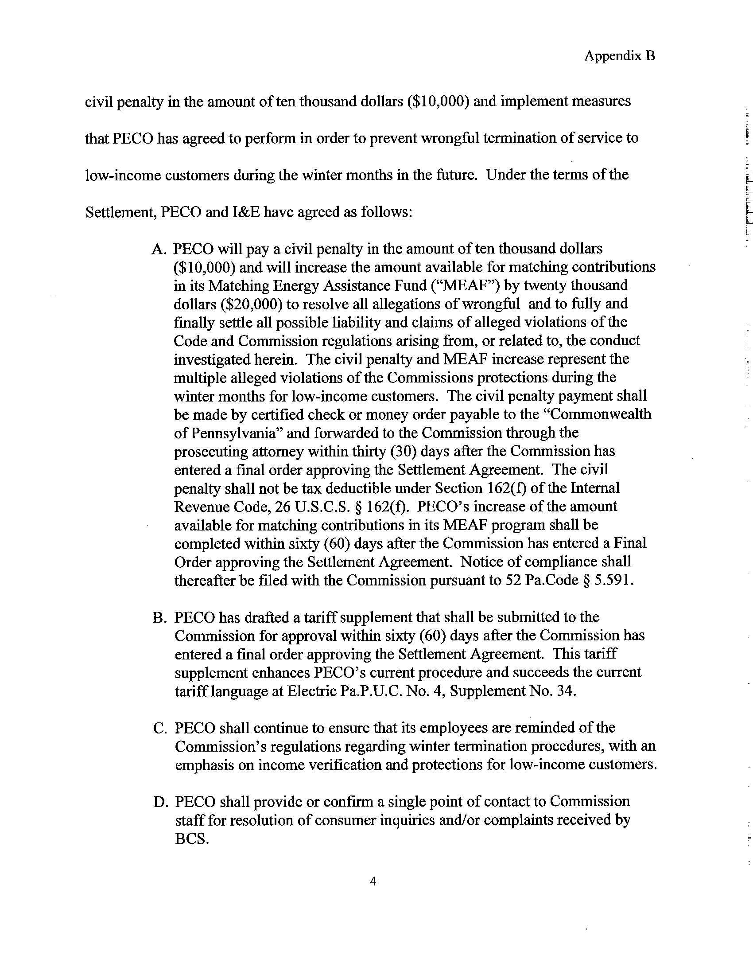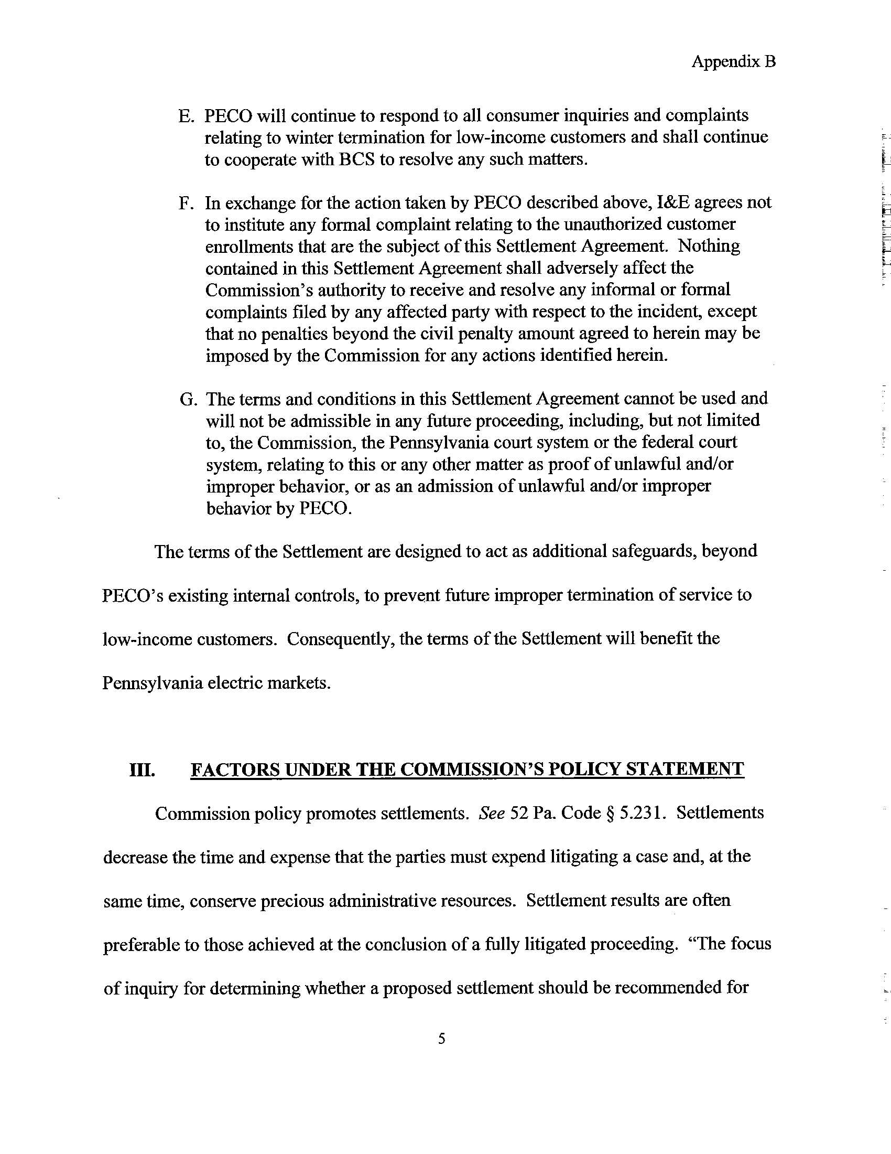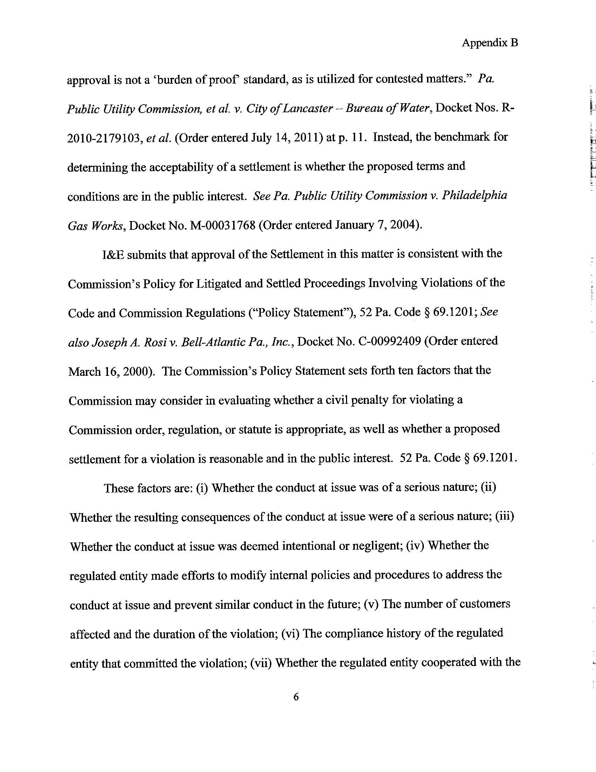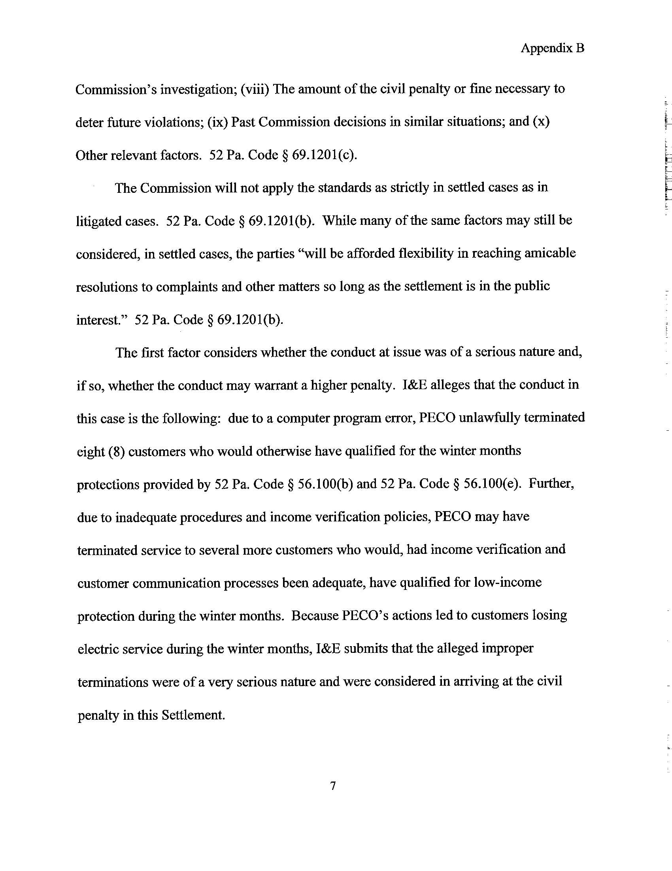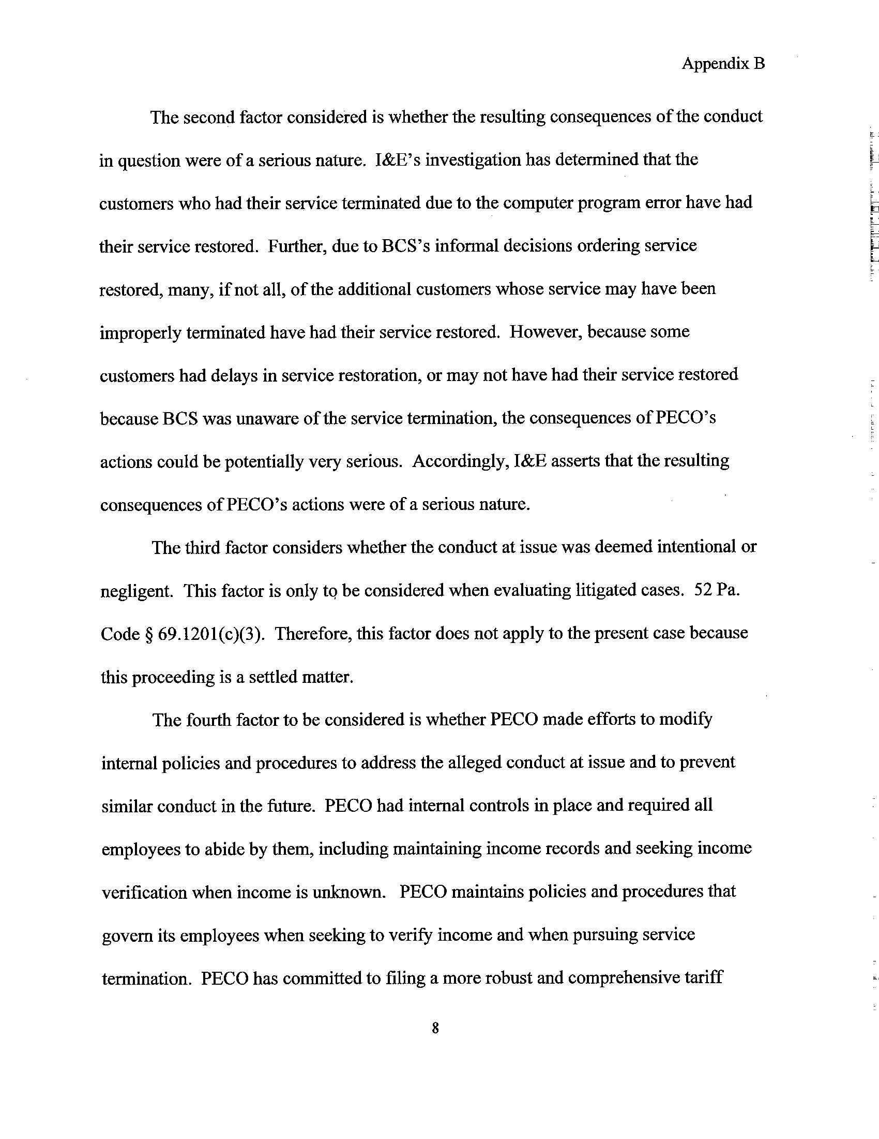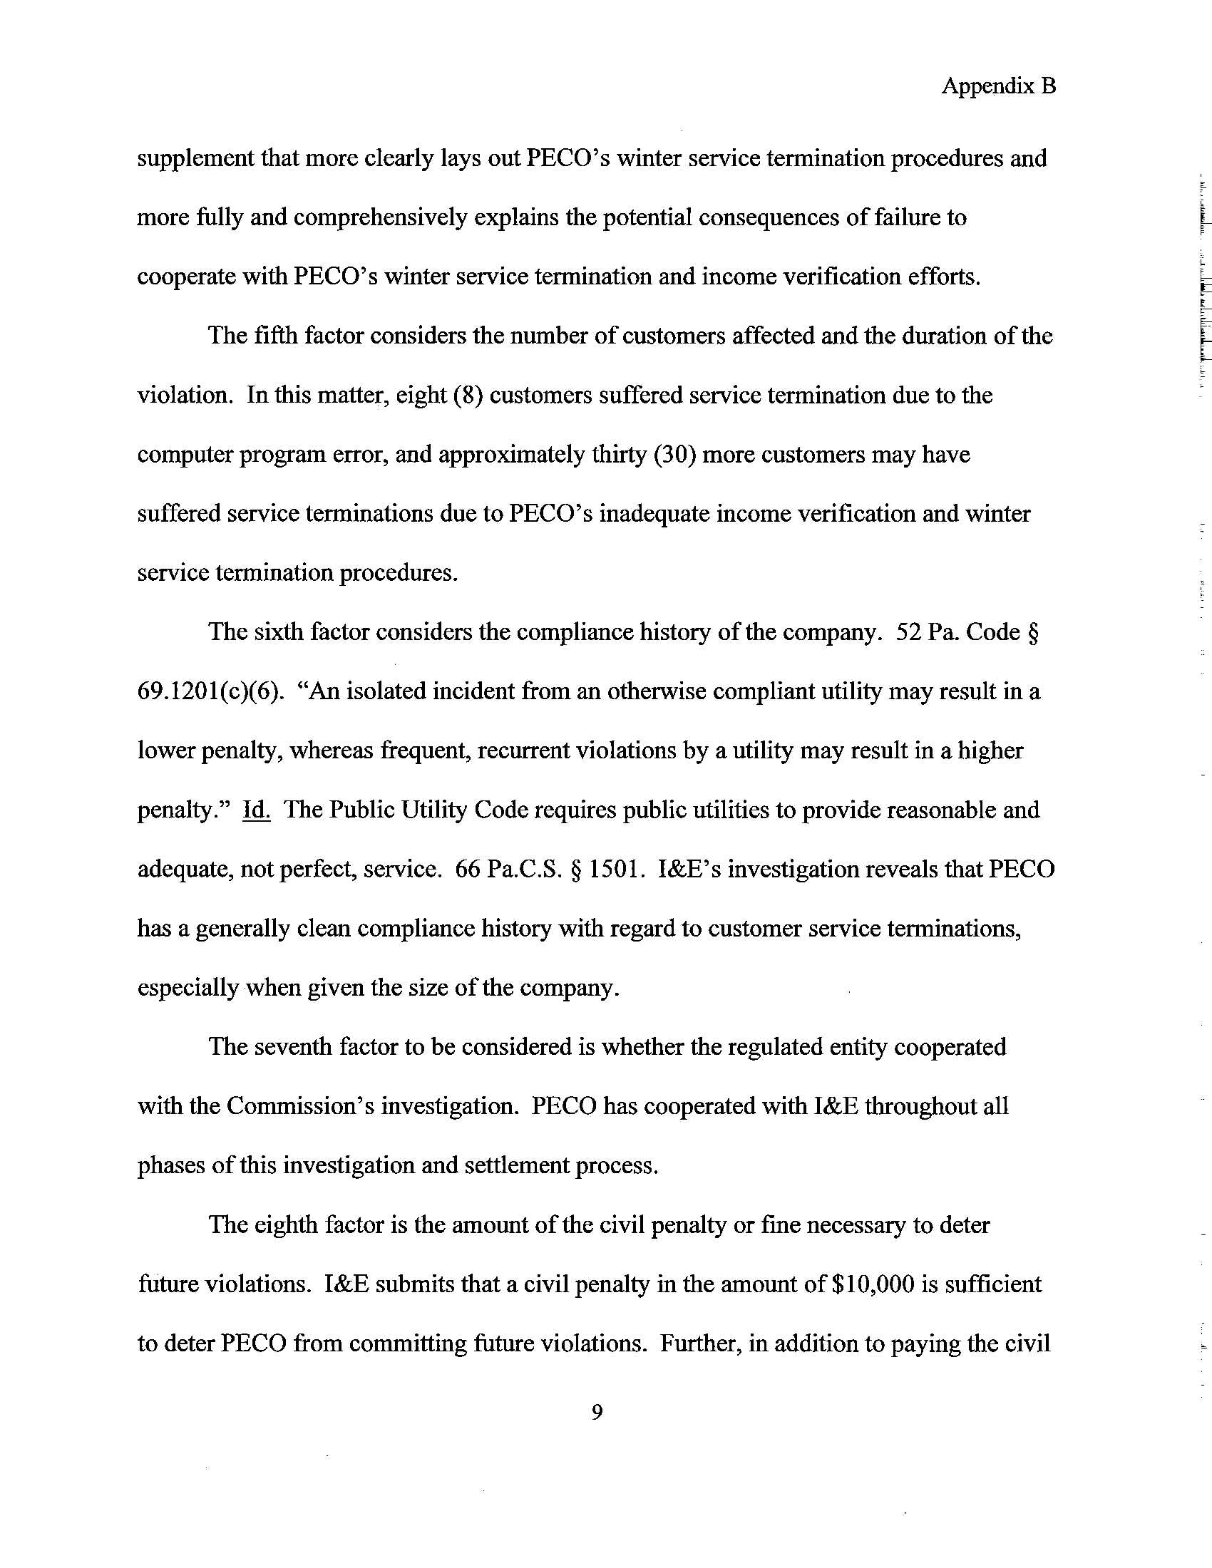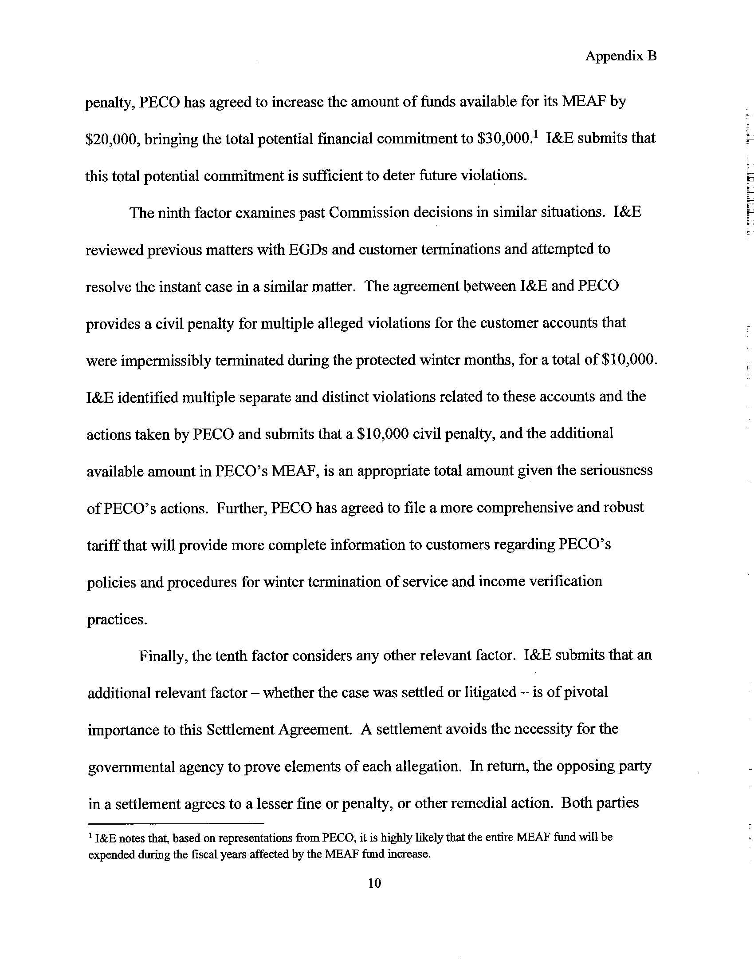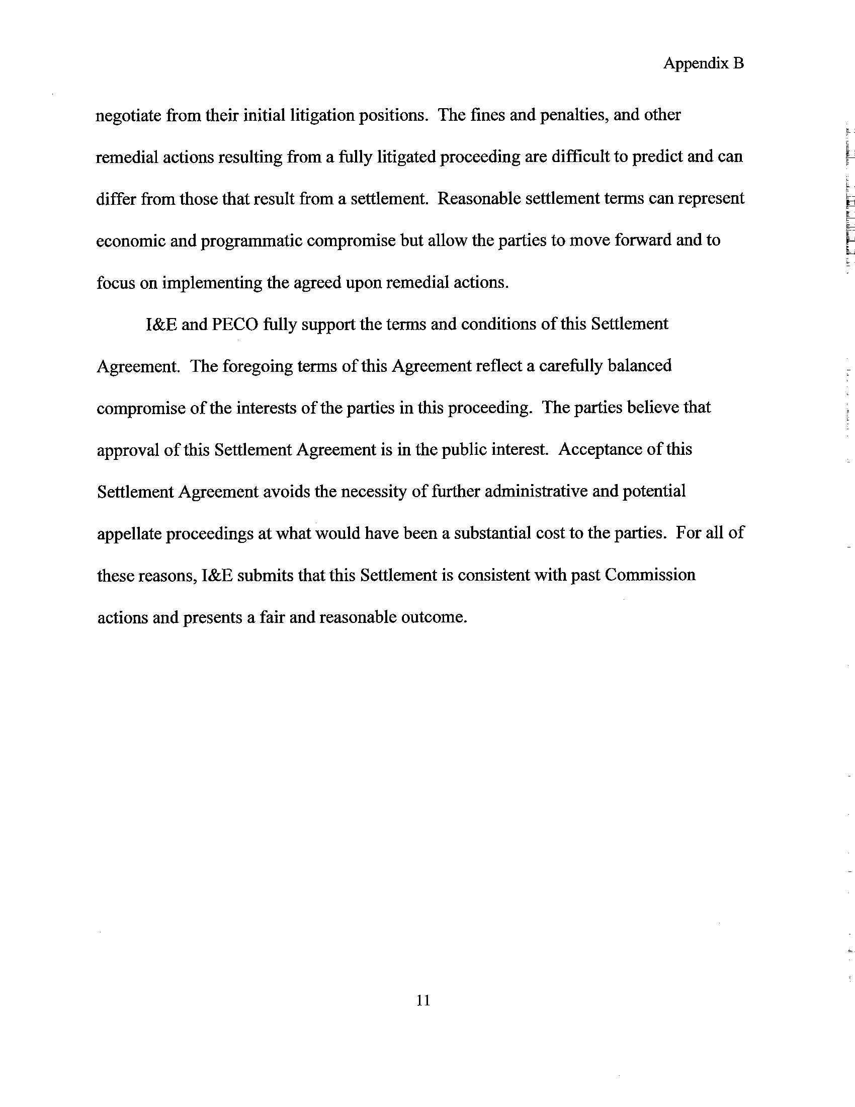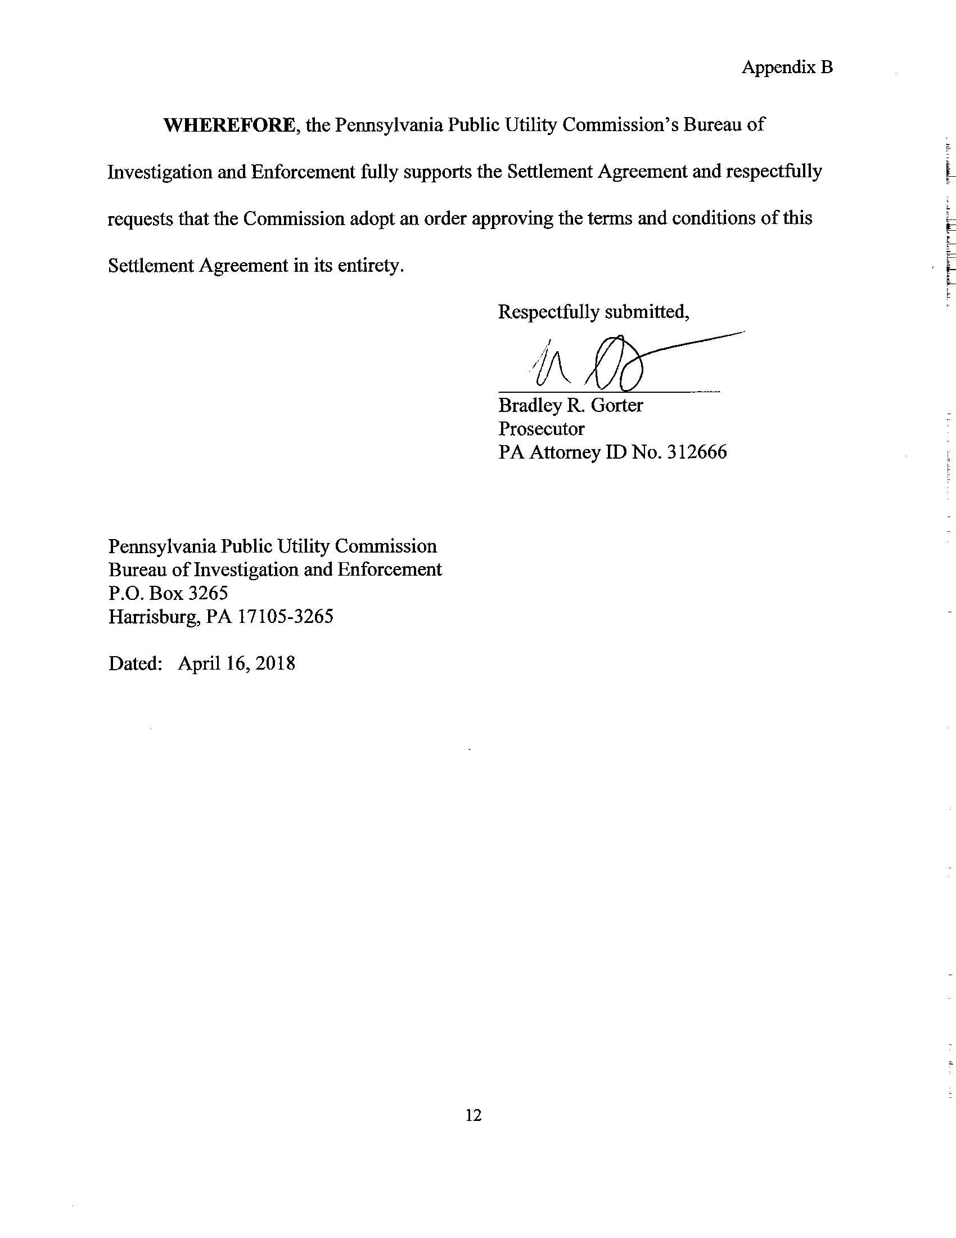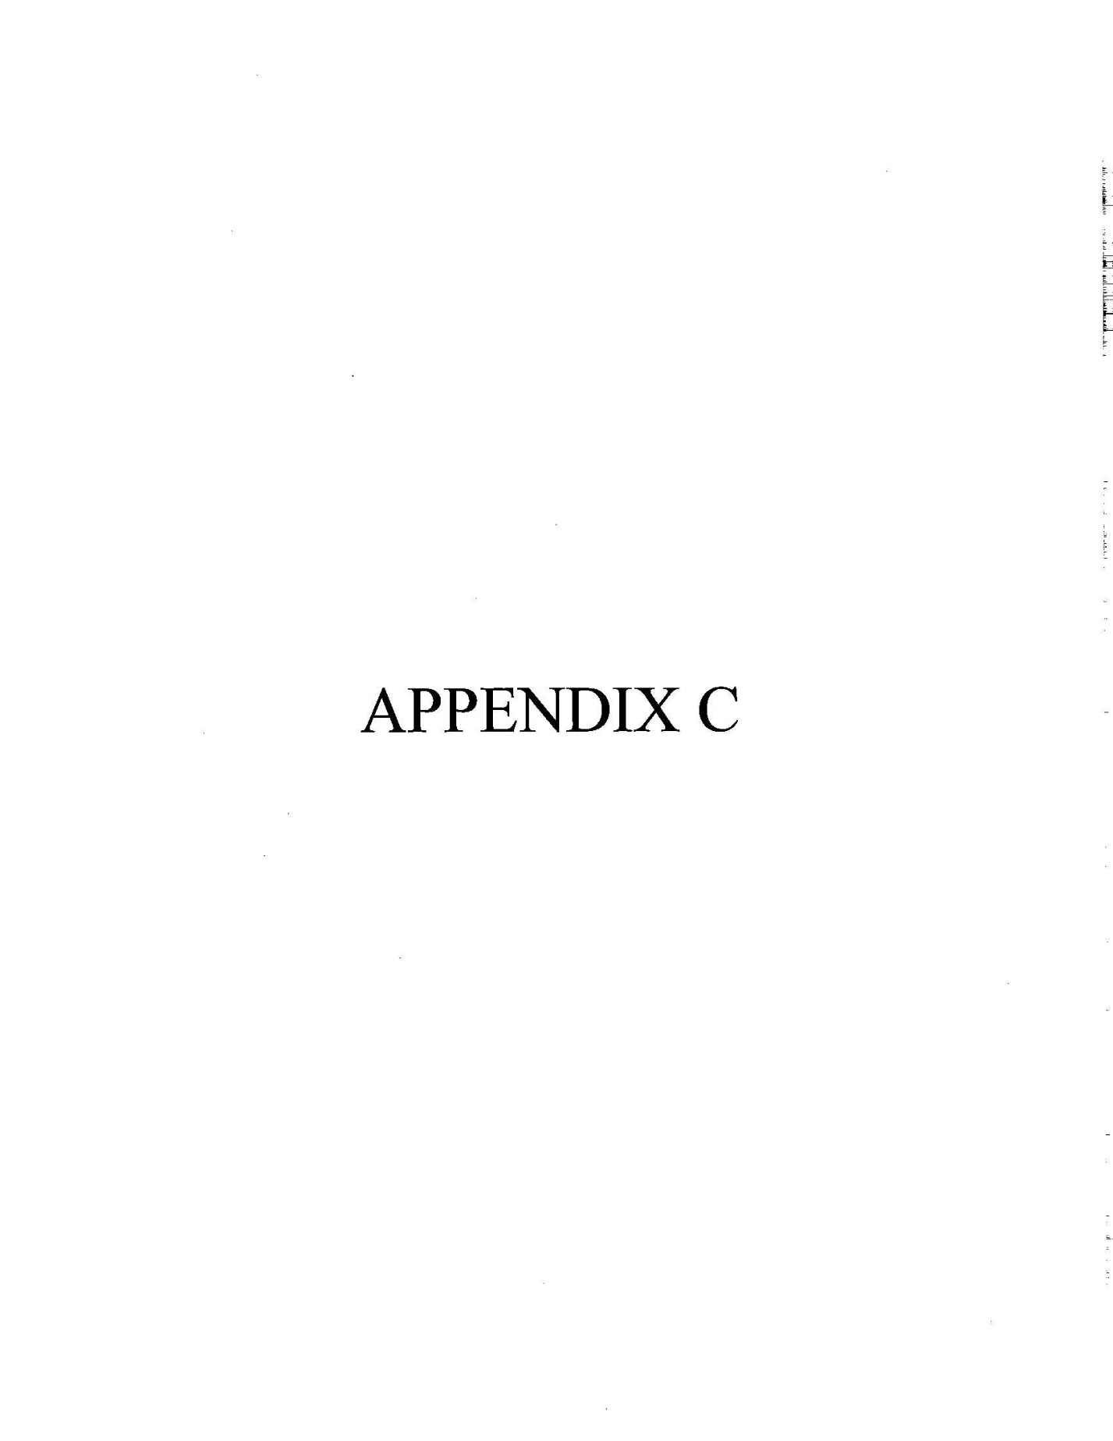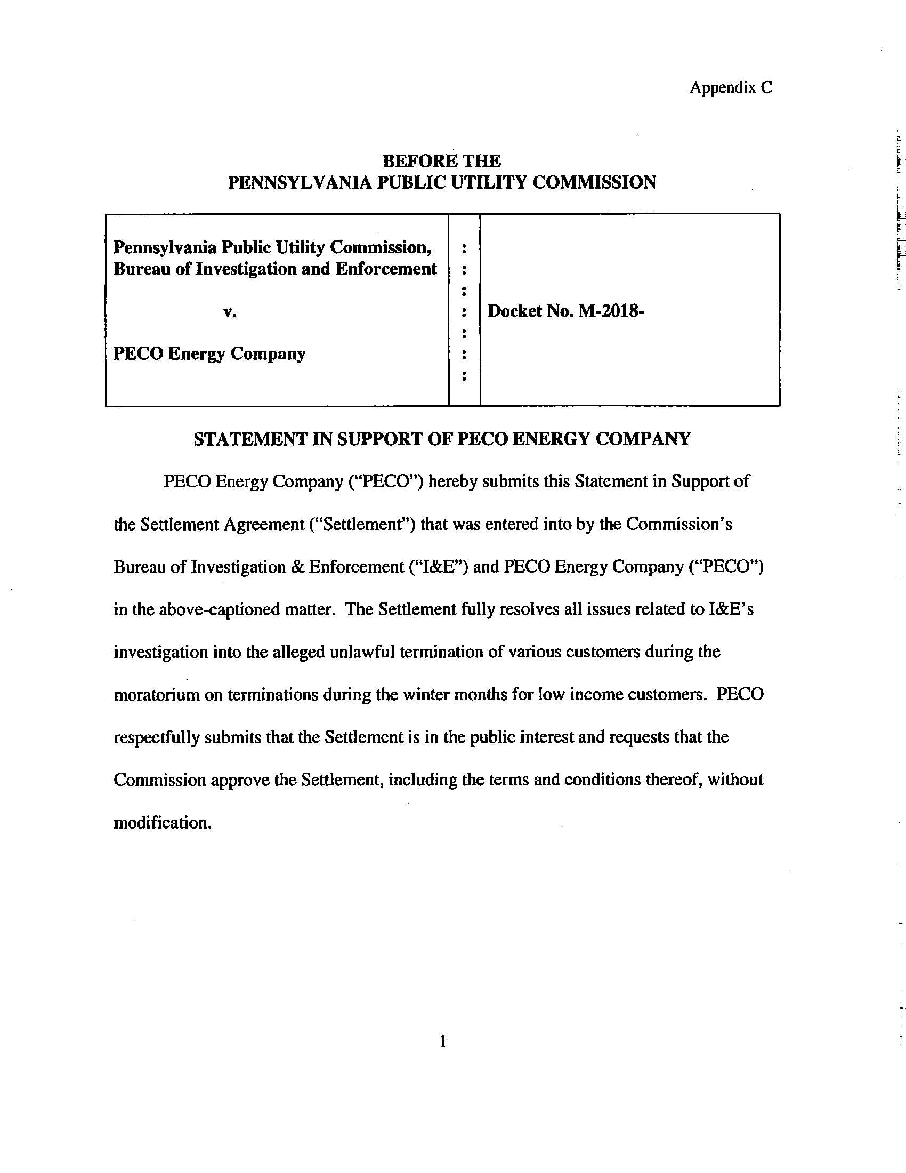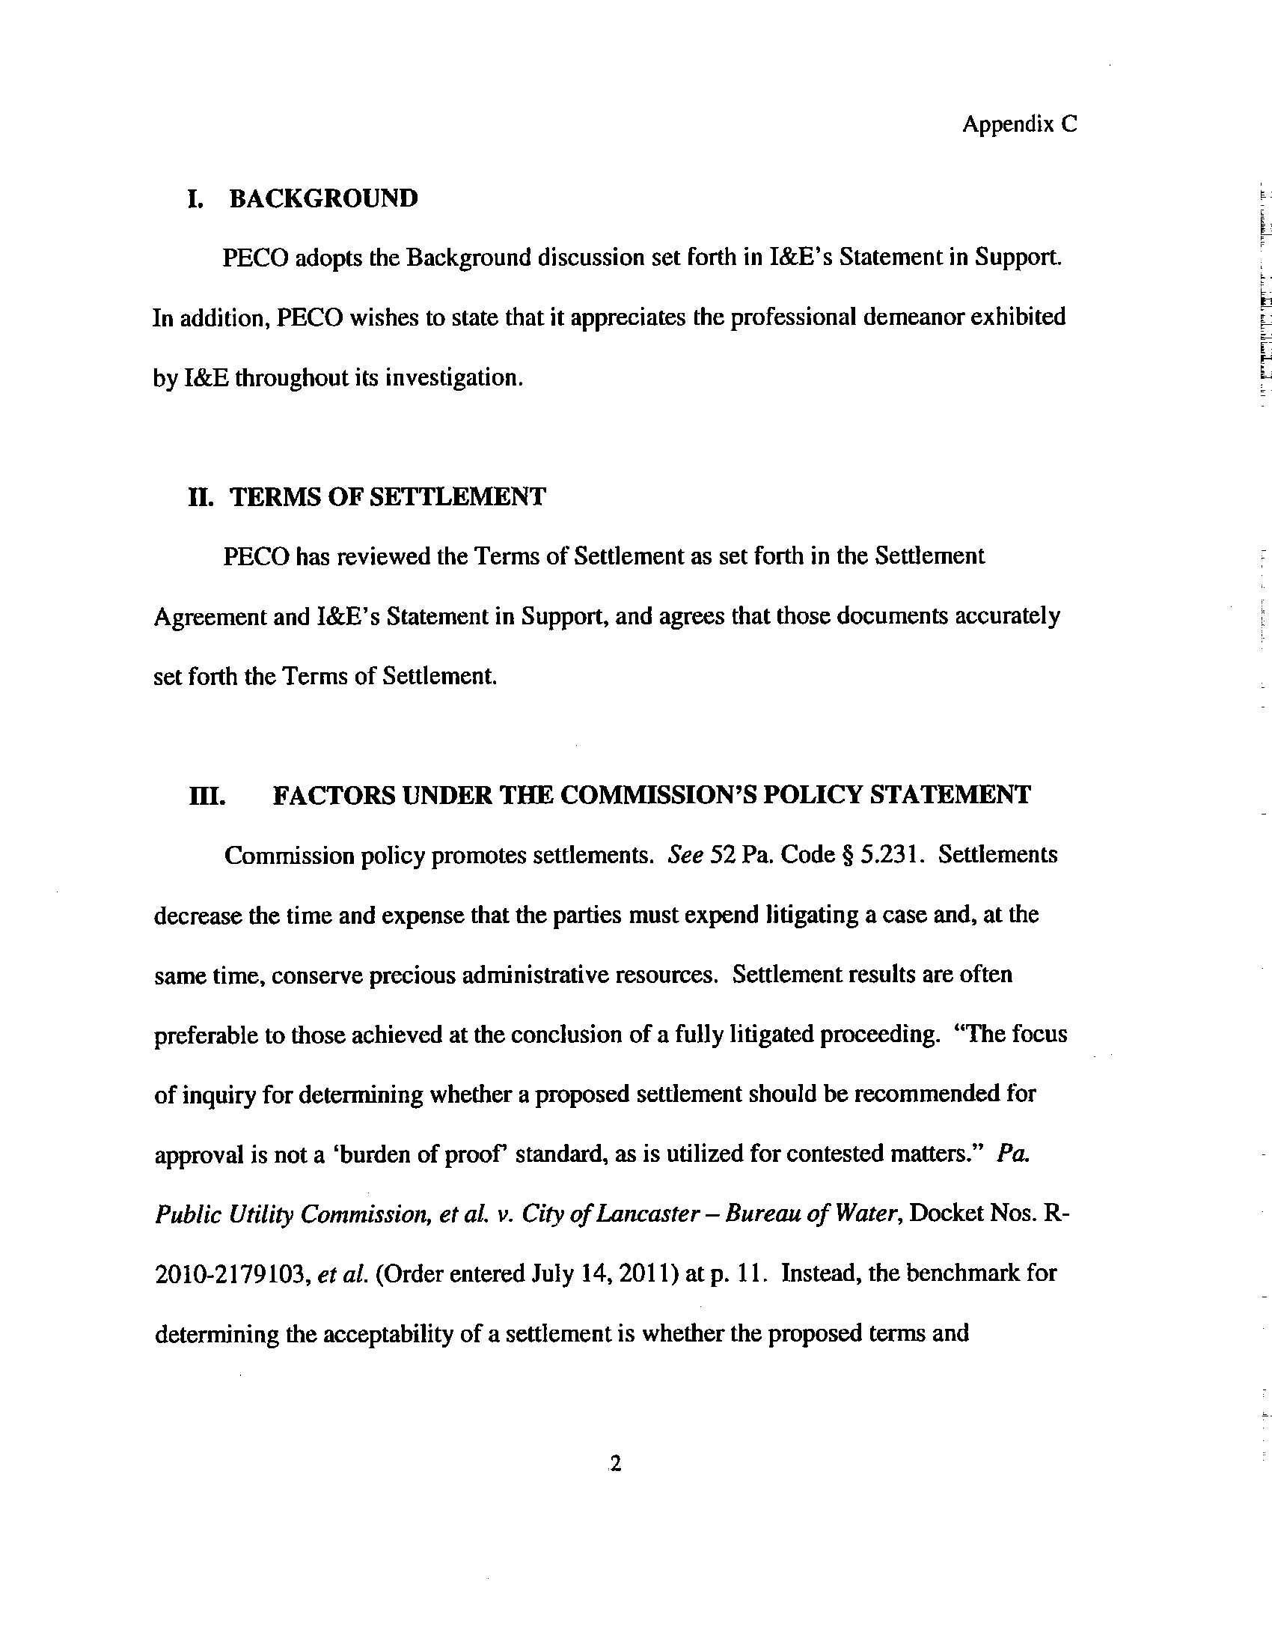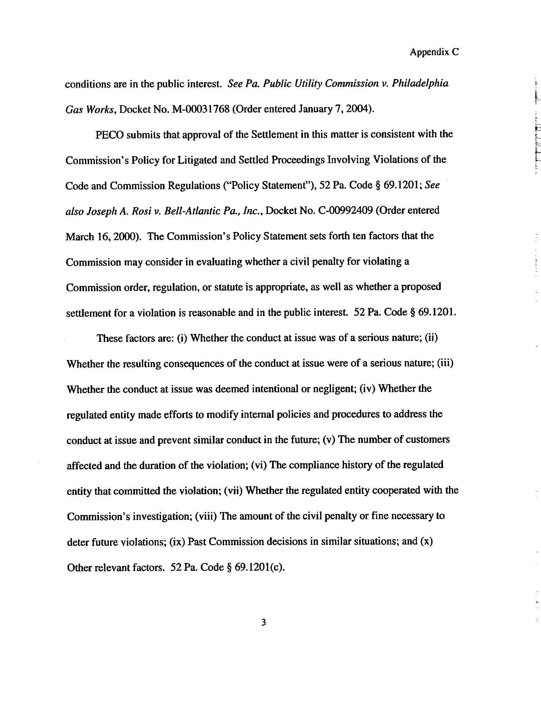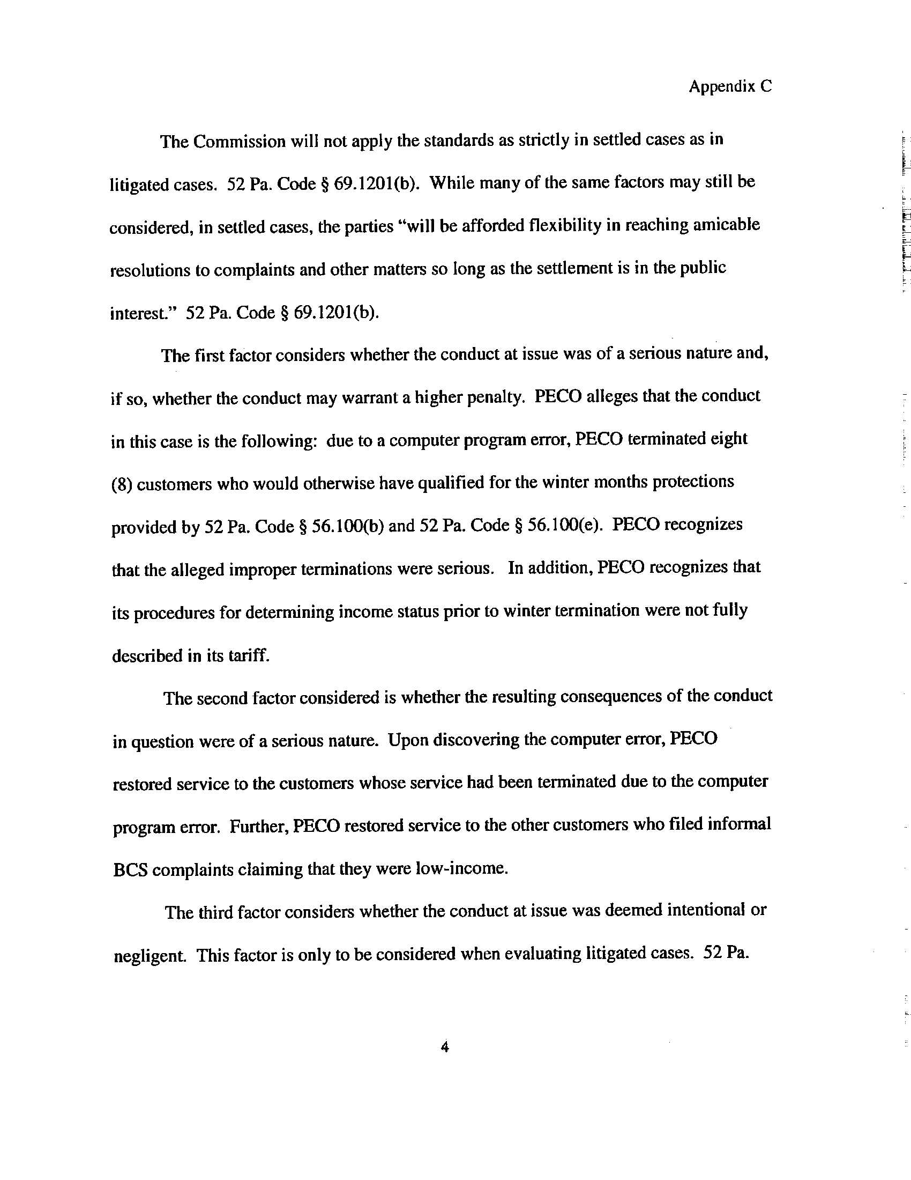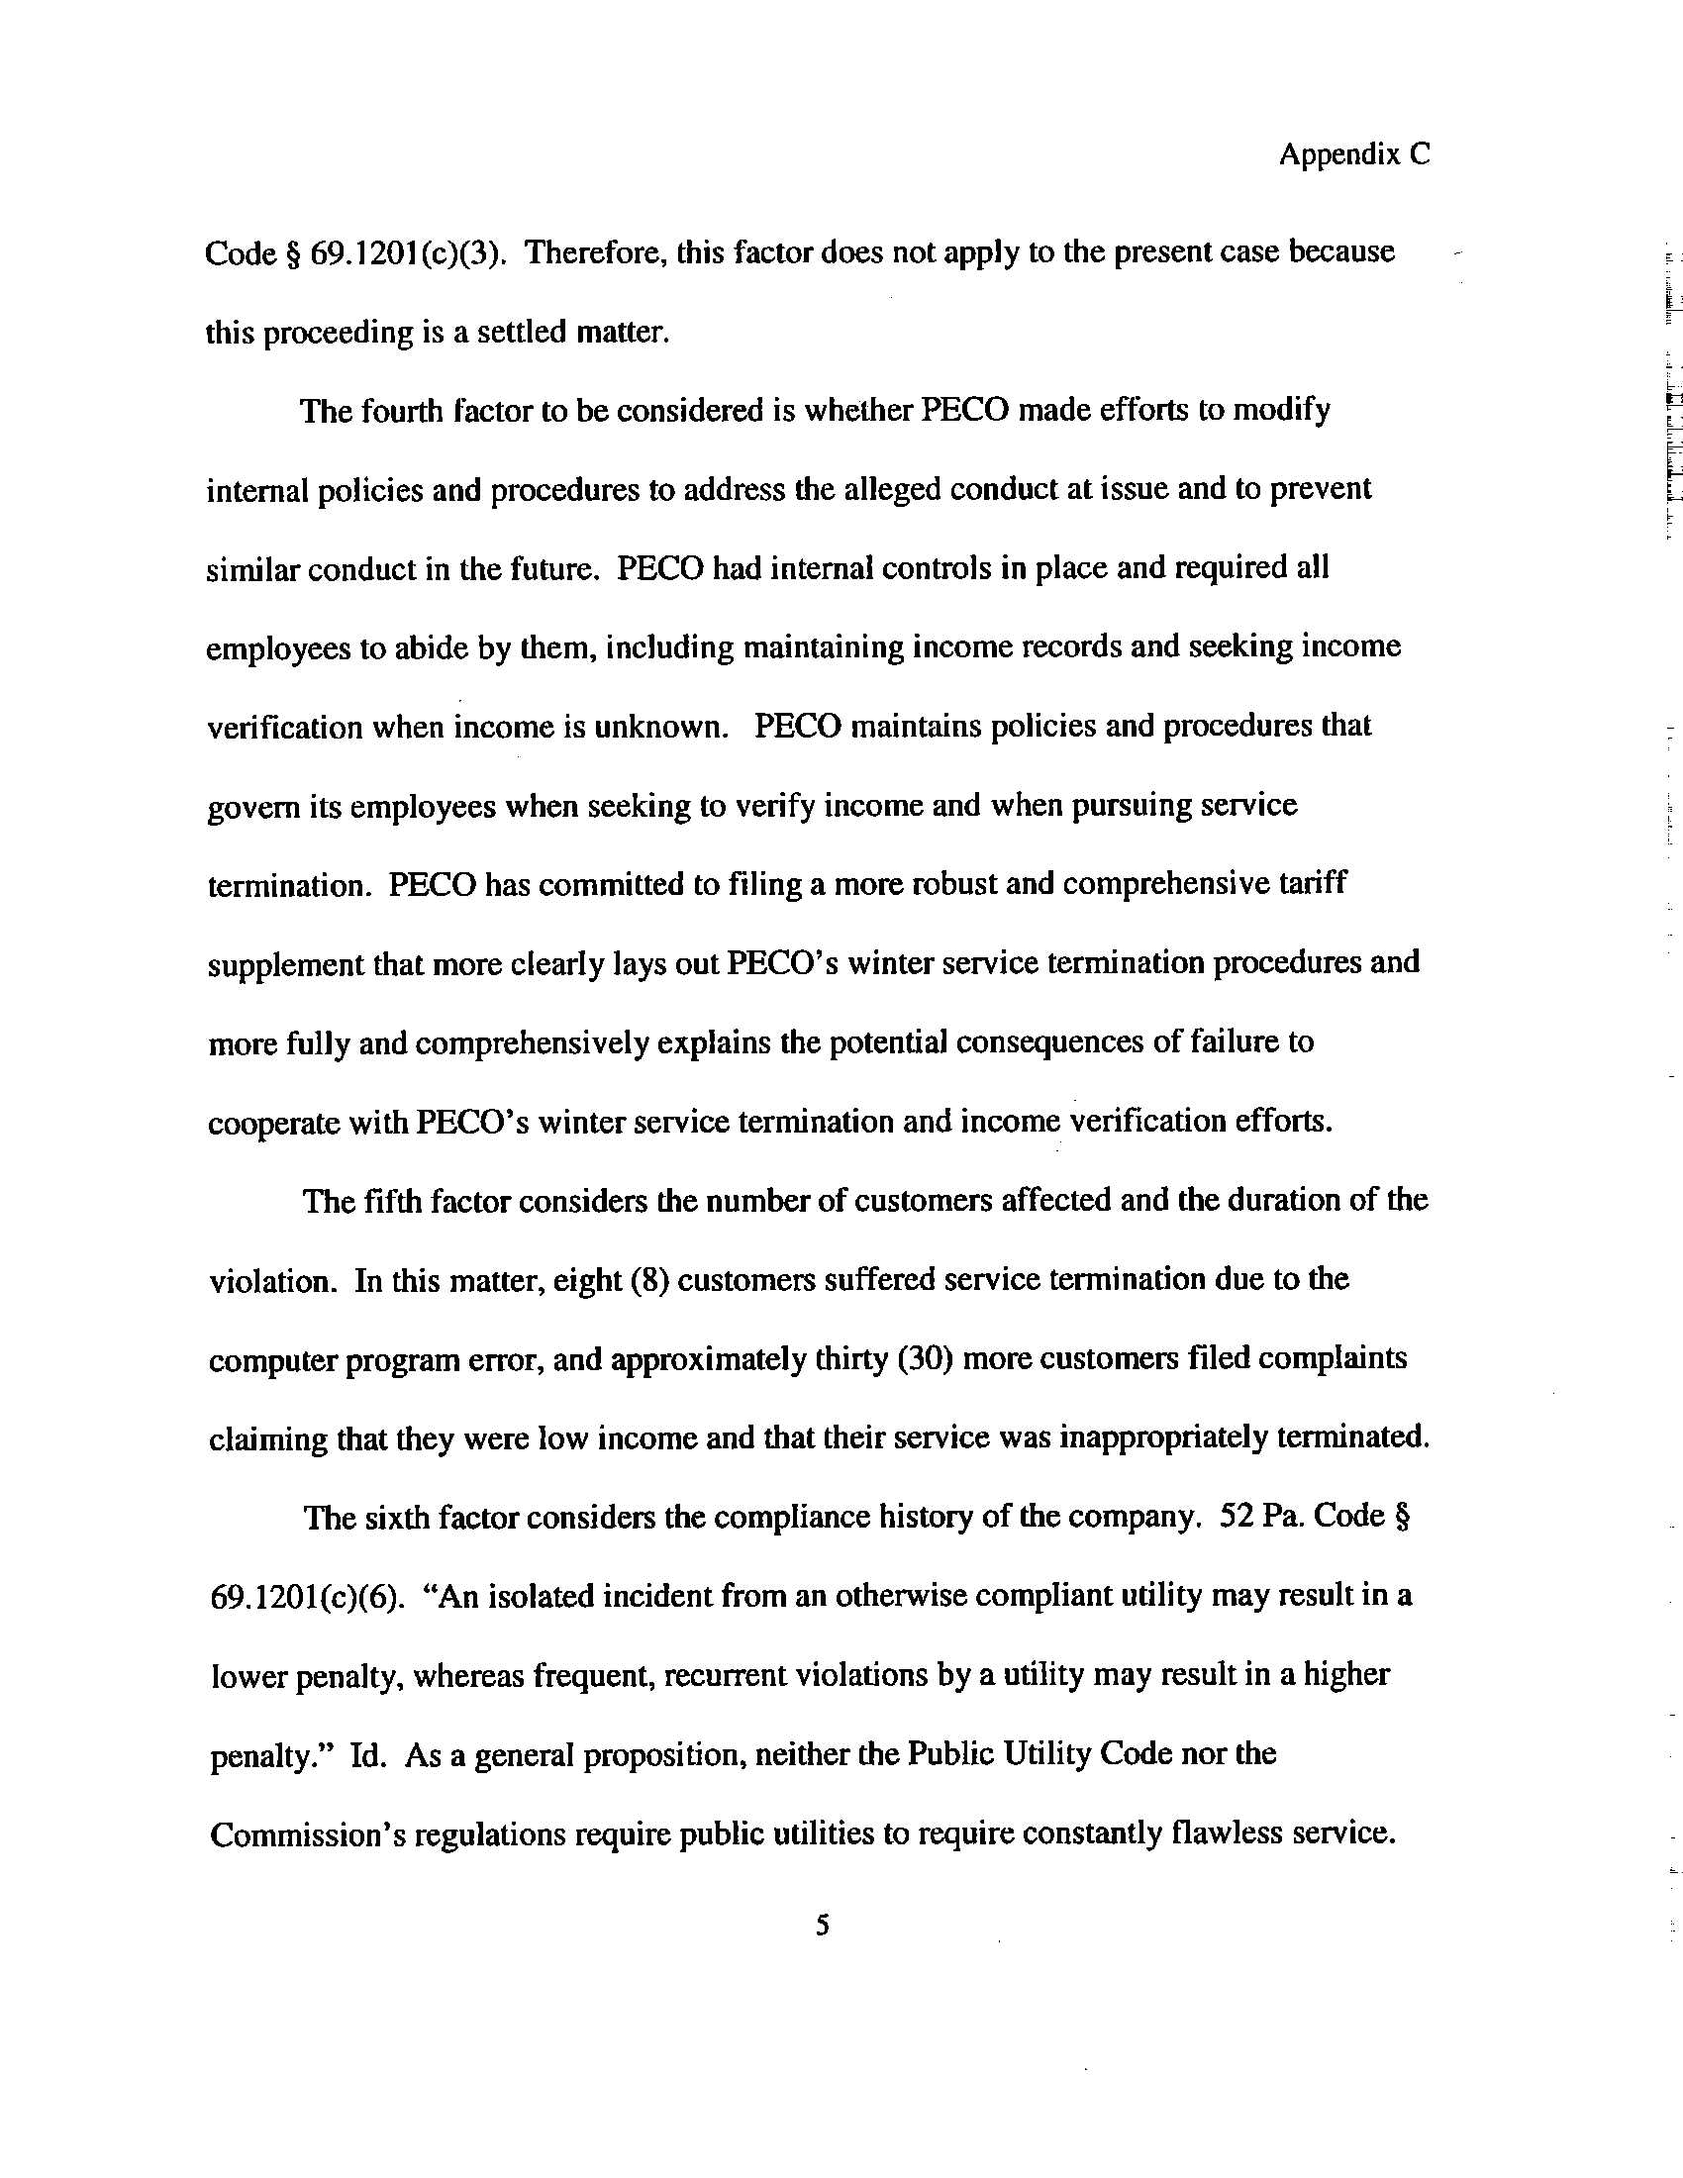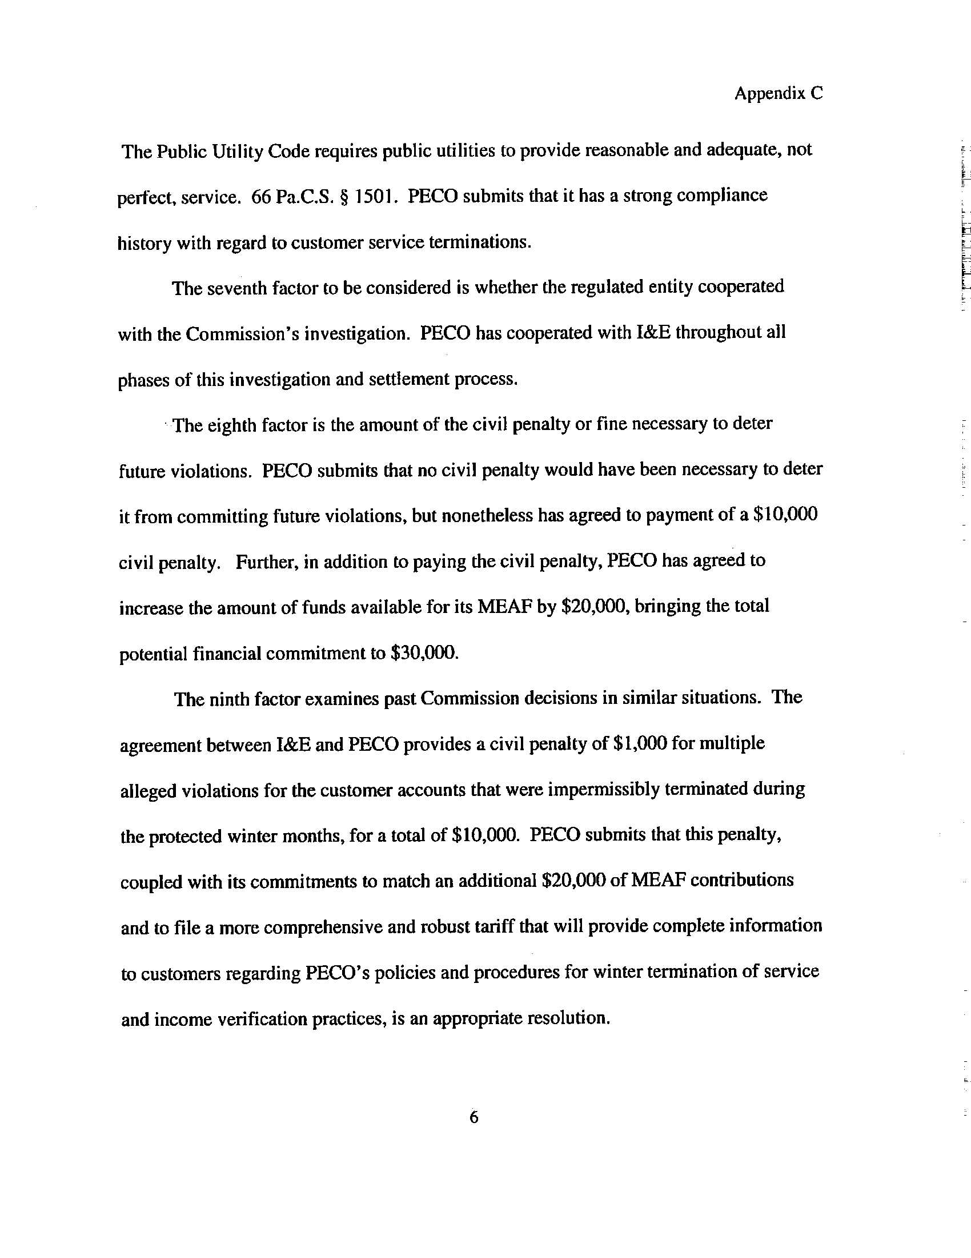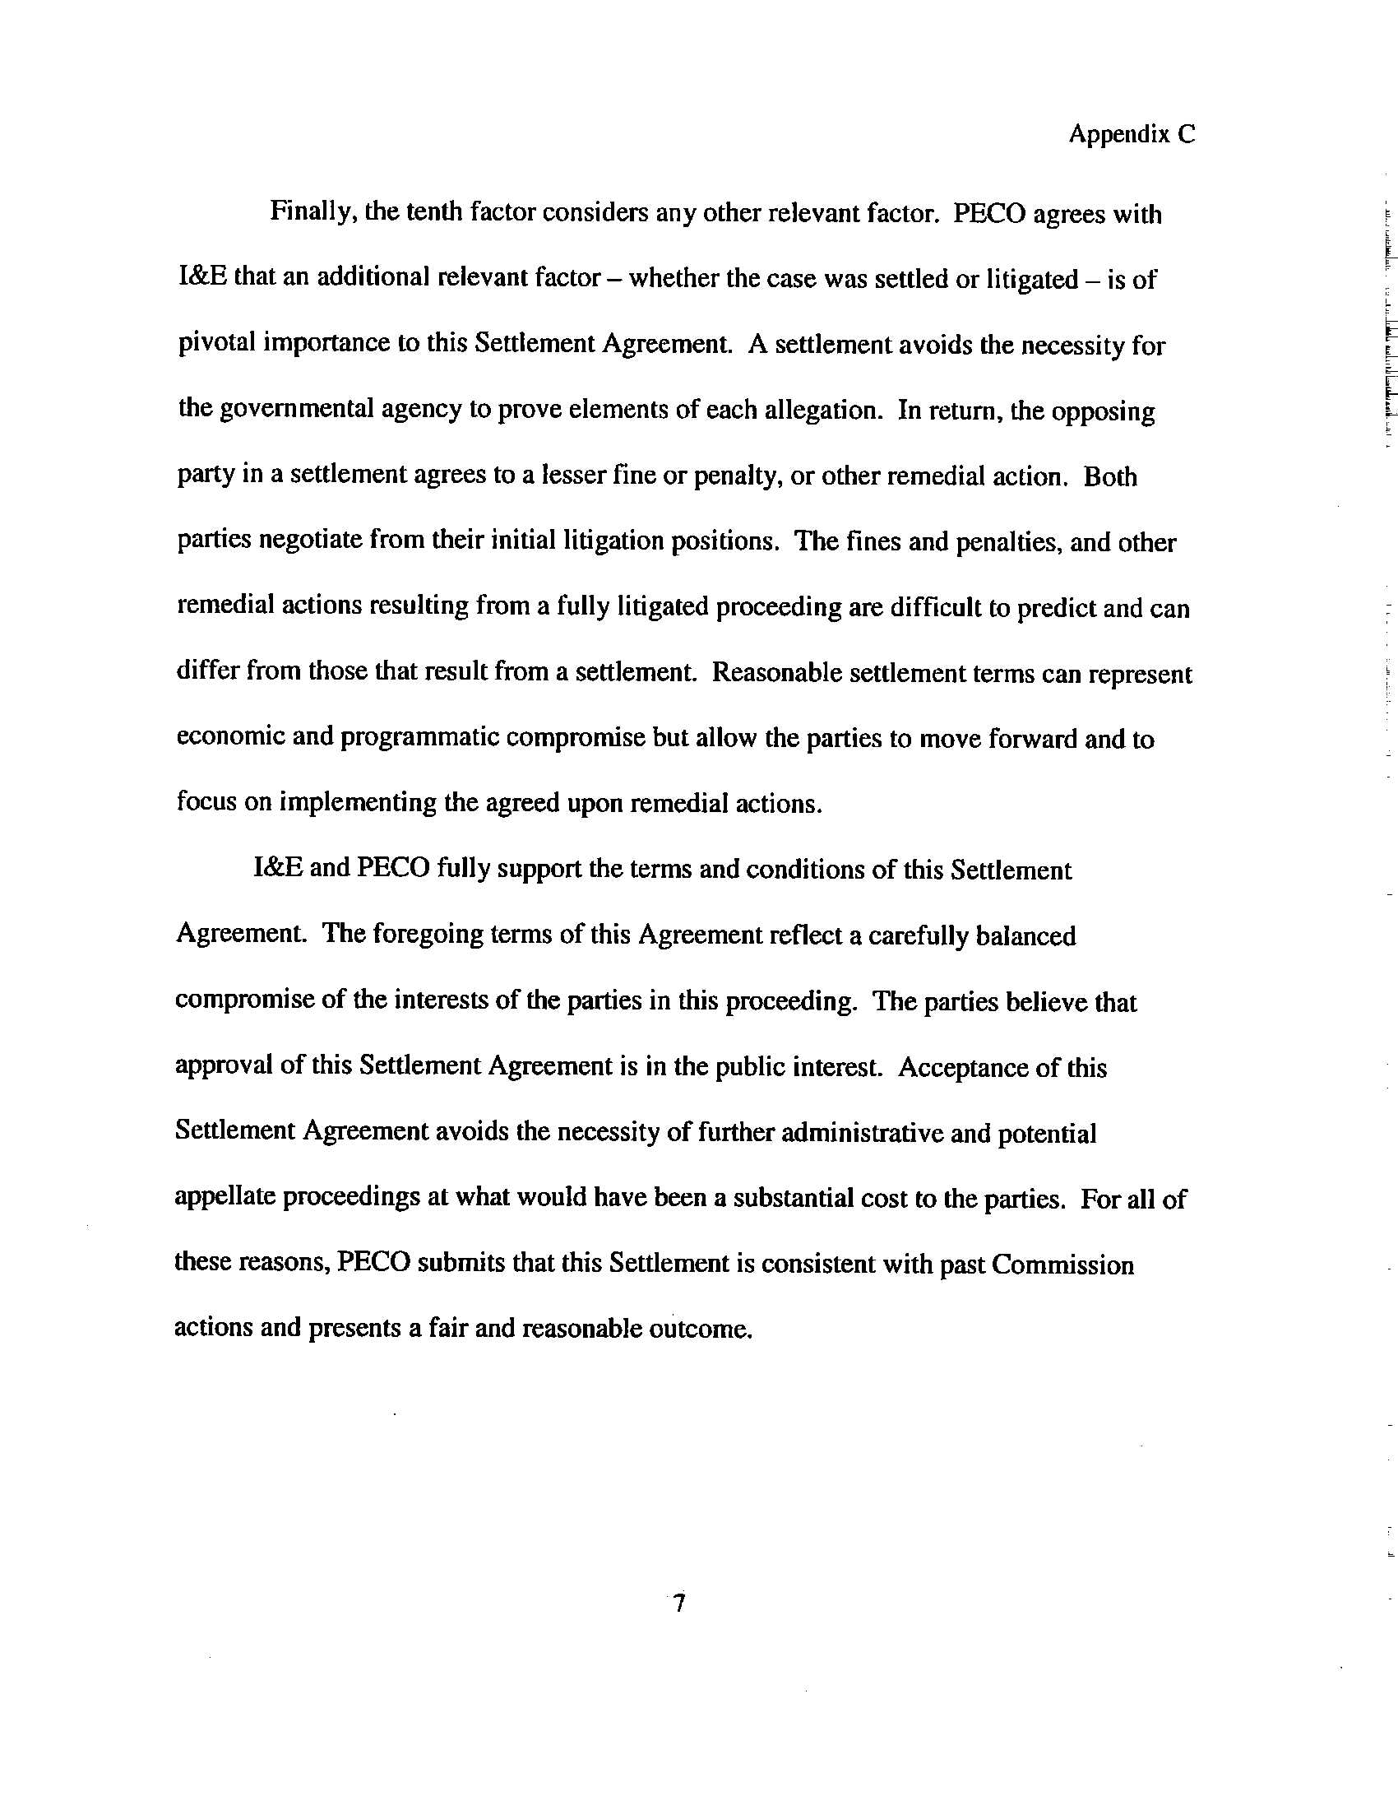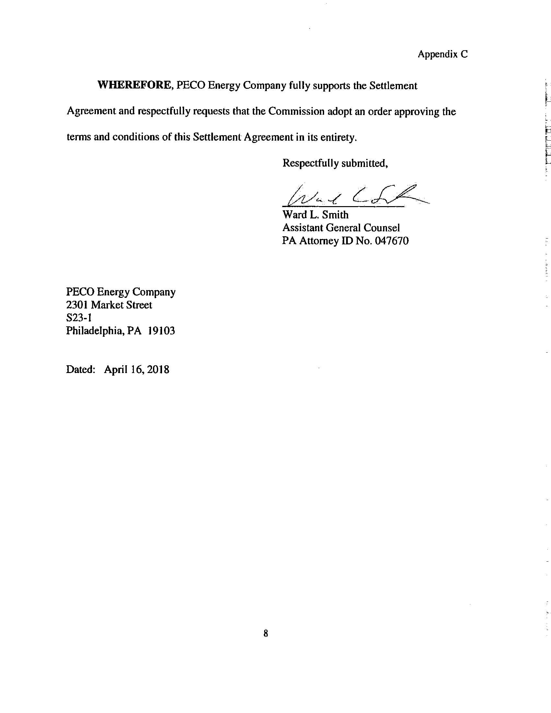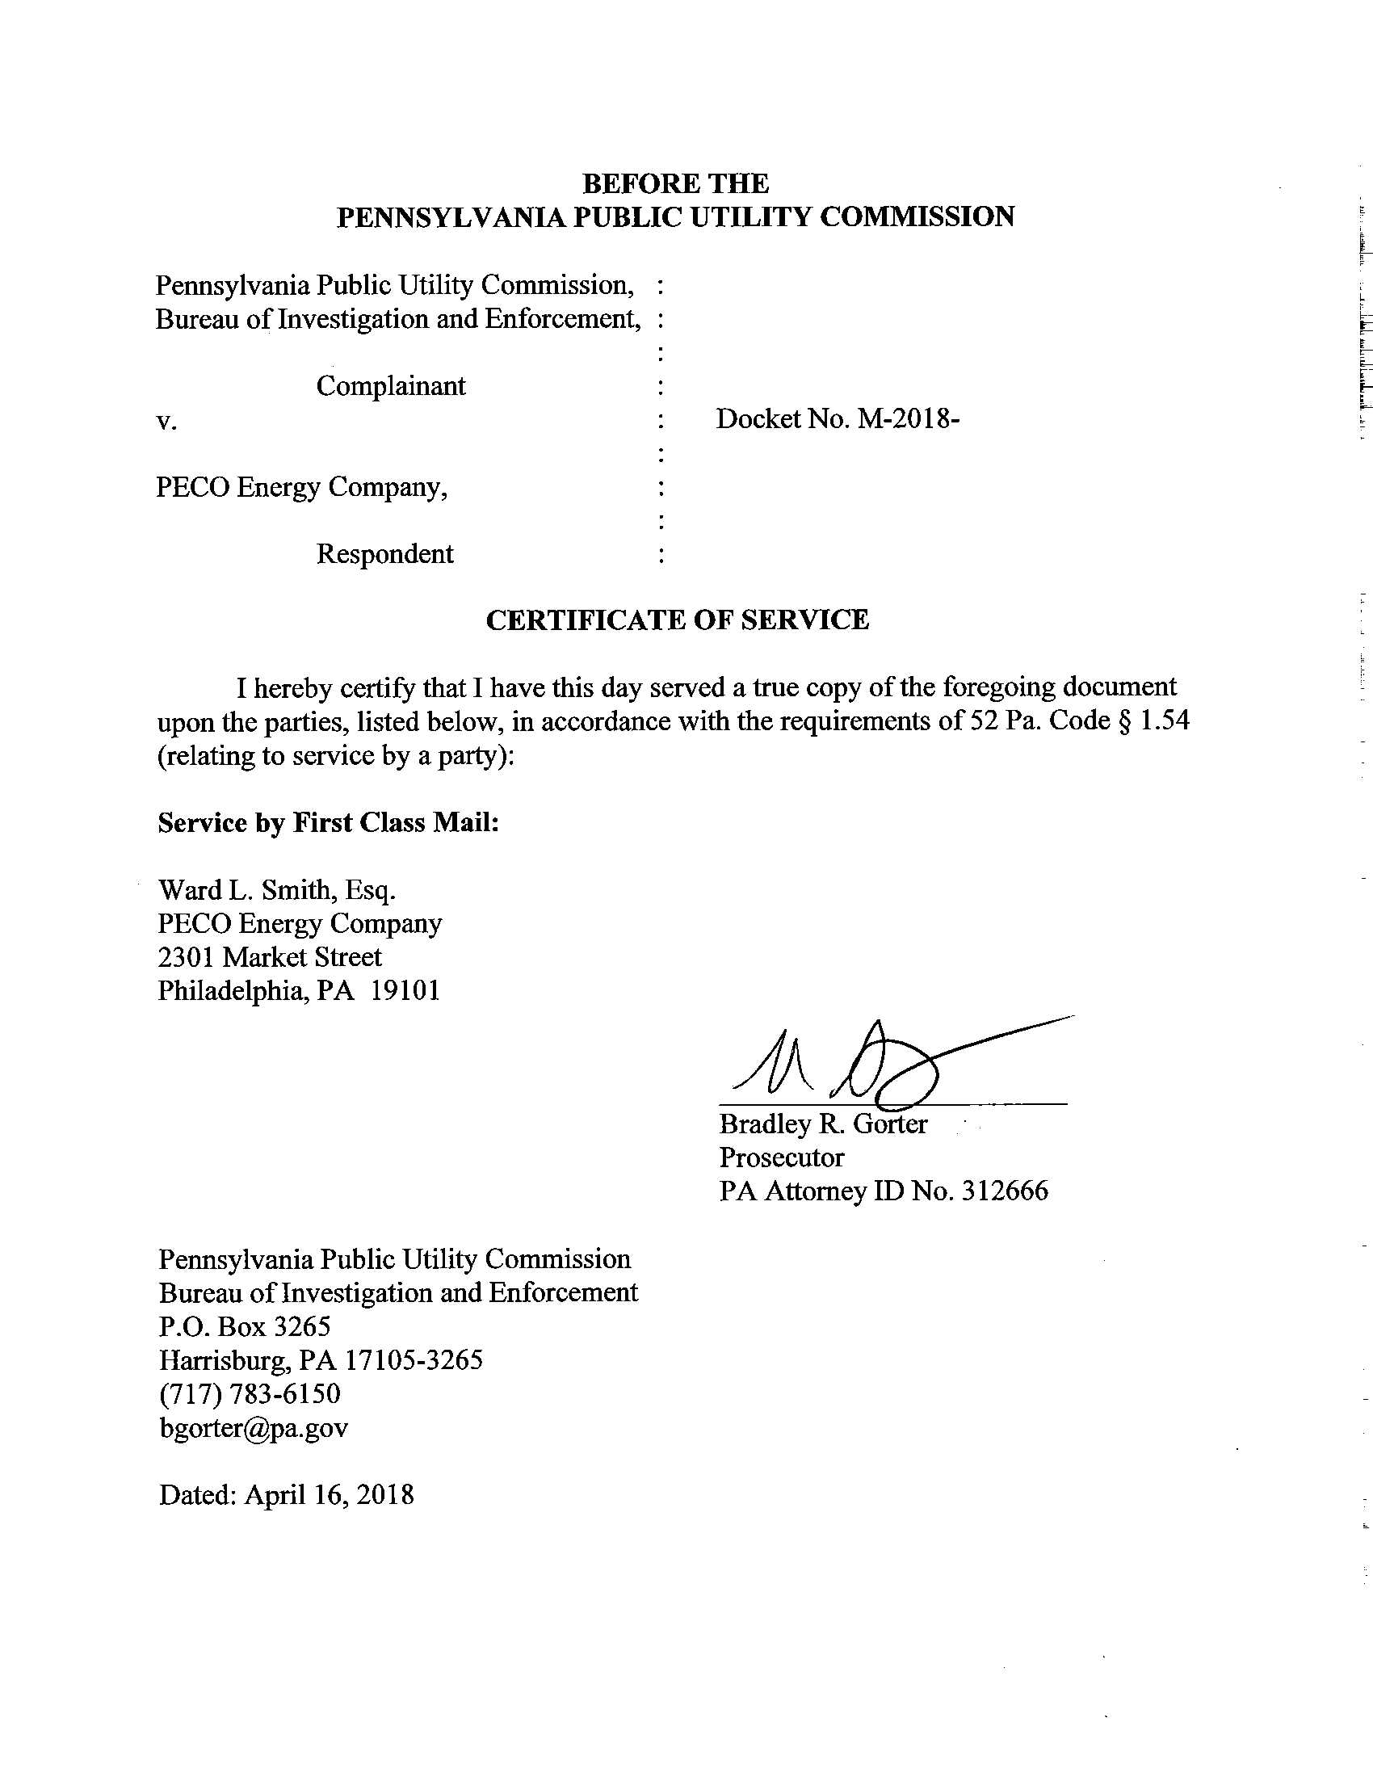

PECO is an electric distribution company licensed by the Commission engaged in providing facilities for transmission and distribution of electricity to retail customers as authorized by its license within the Commonwealth of Pennsylvania. Commission records indicate that PECO was granted Commission approval to operate as a public utility on May 28, 1937.
The Settlement also states that the allegations if proven would constitute a violation of 52 Pa. Code § 56.100(d). Settlement at 6-7. However, this regulatory provision pertains to “City natural gas distribution utility notice to the Commission” and does not appear to be relevant to the allegations pertaining to this Settlement.

