 |  | COMMONWEALTH OF PENNSYLVANIA  PENNSYLVANIA PUBLIC UTILITY COMMISSION  400 North Street, HARRISBURG, PA 17120 |  | IN REPLY PLEASE REFER TO OUR FILE  Phone: 717-772-7777

December 21, 2018
C-2018-3006116

CURTIS STAMBAUGH, ASSISTANT GENERAL COUNSEL
SUNOCO PIPELINE, L.P.
212 NORTH THIRD STREET, SUITE 201
HARRISBURG, PA 17101

Meghan Flynn, Rosemary Fuller, Michael Walsh, Nancy Harkins, Gerald McMullen, Caroline Hughes, and Melissa Haines
v.
Sunoco Pipeline, L.P.

Dear Sir/Madam:

Attached is a copy of an amended complaint filed on behalf of the complainants in the above titled proceeding.

Such answer as you desire to make to the amended complaint should be filed in this Office and served upon the complainant within twenty days from receipt of this letter.

Very truly yours,
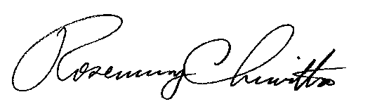
Rosemary Chiavetta
Secretary

cc: File

RC:AEL

