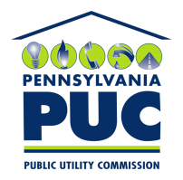 | COMMONWEALTH OF PENNSYLVANIA  PENNSYLVANIA PUBLIC UTILITY COMMISSION  400 NORTH STREET, KEYSTONE BUILDING, SECOND FLOOR  HARRISBURG, PENNSYLVANIA 17120 | IN REPLY PLEASE REFER TO OUR FILE

February 7, 2019

Via Certified Mail

KEVIN MCSPADDEN, EXECUTIVE DIRECTOR
CHARITY+POWER INC
2801 BELDEN DRIVE
LOS ANGELES CA 90068

RE: Continuous Bond
Charity+Power Inc
A-2017-2587808

Dear Sir/Madam:

Please find under cover of this letter the financial instrument filed with the Commission on behalf of Charity+Power Inc.

The Commission requires a supplier to file an original bond, letter of credit, continuation certificate, amendment, or other financial instrument as part of a supplier’s licensing requirements under Section 2809(c) of the Pennsylvania Public Utility Code.

The enclosed financial instrument does not have a "wet ink" original signature for the Principal Company. Please sign in ink and return original financial instrument with my office within 20 days of the date of this letter, preferably by overnight delivery to my office address listed above.

Sincerely,

Rosemary Chiavetta
Secretary of the Commission

RC:jbs
Enclosures

