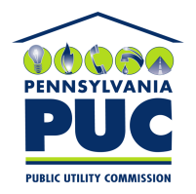 | COMMONWEALTH OF PENNSYLVANIA  PENNSYLVANIA PUBLIC UTILITY COMMISSION  400 NORTH STREET, HARRISBURG, PA 17120 | IN REPLY PLEASE REFER TO OUR FILE
February 4, 2019

RICHARD SOULTANIAN, CO-PRESIDENT
NATIONAL UTILITY SERVICE, INC.
ONE MAYNARD DRIVE
PARK RIDGE, NJ 07656-0712

Dear Mr. Soultanian:

On January 24, 2019, the Commission received the Application of National Utility Service, Inc., for approval to supply natural gas services to the public in the Commonwealth of PA. Upon initial review, the Application has been determined to be missing information for the following reason:

- No Bonding Letters.

Pursuant to 52 Pa. Code §1.4, you are being advised of this missing information and are required to file a correction. Failure to correct the foregoing missing information within 20 days of the date of this letter will result in the Application being returned unfiled.
Please return your item to the above listed address and address to the attention of the Office of the Secretary.
If you have any question in regards to this letter, please contact our bureau at (717) 772-7777. Thank you
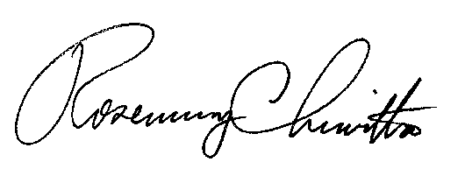
Sincerely,

Rosemary Chiavetta
Secretary

RC:AEL

