BEFORE THE
PENNSYLVANIA PUBLIC UTILITY COMMISSION

Larry Salone :
:
v. : C-2018-3001805
:
Aqua Pennsylvania, Inc. :

FIRST INTERIM ORDER
CONFIRMING THE GRANTING OF THE PARTIES’
JOINT REQUEST FOR A HEARING CONTINUANCE

An initial telephonic hearing in this proceeding was held on Thursday, August 16, 2018. By Notice dated August 21, 2018, a further hearing was scheduled for Tuesday, January 22, 2019. By electronic mail dated January 15, 2019, the parties jointly requested a continuance of the further hearing in order to attempt to resolve some if not all disputed issues. Counsel for the respective parties further represented, “The parties are engaged in active discussions in an attempt to resolve some if not all disputed issues and are exchanging documents requested in discovery.”

Pursuant to Section 1.15(b) of the Pennsylvania Public Utility Commission’s (Commission) regulations, 52 Pa.Code § 1.15(b), a request for a change of the scheduled hearing date may be submitted by motion in writing and filed no later than five (5) days prior to the hearing with the Commission. The motion must state the facts upon which the request rests. Only for good cause shown will requests for continuance be considered. Id.

After due consideration, I treated the electronic mail requesting a continuance of the further hearing as a motion, found that the motion stated good cause to warrant a continuance, and informed the parties by electronic mail on January 16, 2019, that an order granting the continuance would issue shortly. This interim order confirms the granting of the continuance request. A notice rescheduling the further telephonic hearing for the next available date after March 4, 2019, will be issued to the parties.

The parties are encouraged to talk with each other to resolve this matter or some
portion thereof. It is the Commission’s policy to encourage settlements. 52 Pa.Code § 5.231.

THEREFORE,

IT IS CONFIRMED:

- That the joint motion of Complainant Larry Salone and Respondent Aqua Pennsylvania, Inc. for a continuance of the Further Telephonic Hearing scheduled in this proceeding for January 22, 2019, was granted on January 16, 2019.

- That the Scheduling Staff of the Office of Administrative Law Judge shall reschedule the Further Telephonic Hearing in the case of Larry Salon v. Aqua Pennsylvania, Inc. at Docket No. C-2018-3001805 for the next available date after March 4, 2019, and so notify the parties in writing.
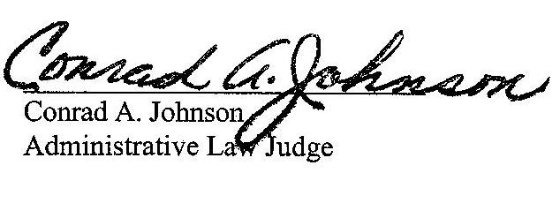

Date: February 20, 2019

C-2018-3001805 - LARRY SALONE v. AQUA PENNSYLVANIA INC
LARRY SALONE
1562 TREASURE LAKE
99 DAVY COURT
DUBOIS PA 15801
Complainant
CJ ZWICK ESQUIRE*
MATTHEW R ZWICK ESQUIRE
ZWICK & ZWICK LLP
171 Beaver Drive
DUBOIS PA 15801
814-371-6400
*Accepts E-service
Representing Complainant
MARGARET A MORRIS ESQUIRE
REGER RIZZO & DARNALL
2929 ARCH STREET 13TH FLOOR
PHILADELPHIA PA 19104
215.495.6524
Accepts E-service
Representing Aqua Pennsylvania, Inc.

