 | COMMONWEALTH OF PENNSYLVANIA  PENNSYLVANIA PUBLIC UTILITY COMMISSION  400 NORTH STREET, HARRISBURG, PA 17120 | IN REPLY PLEASE REFER TO OUR FILE
March 29, 2019

IAN J. DELANEY-LAZAR, MANAGING MEMBER
NE ENERGY LLC
280 SAINT JOHN DRIVE
CAMP HILL, PA 17011

KRISTEN SNYDER, ESQUIRE
JACKSON LAW FIRM
1215 MANOR DRIVE, SUITE 202
MECHANICSBURG, PA 17055

Dear Sir/Madam:

On March 26, 2019, the Commission received the Application of NE Energy LLC for approval to supply natural gas services to the public in the Commonwealth of PA. Upon initial review, the Application has been determined to be missing information for the following reason:

- The Proofs of Publication must be in their original form because it is required for us to have notarized original affidavits with original signatures. Copies of Proofs of Publication will not be accepted.

Pursuant to 52 Pa. Code §1.4, you are being advised of this missing information and are required to file a correction. Failure to correct the foregoing missing information within 20 days of the date of this letter will result in the Application being returned unfiled.
Please return your item to the above listed address and address to the attention of the Office of the Secretary.
If you have any question in regards to this letter, please contact our bureau at (717) 772-7777. Thank you
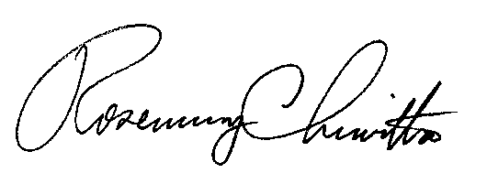
Sincerely,

Rosemary Chiavetta
Secretary

RC:AEL

Enclosures

