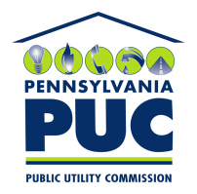 | COMMONWEALTH OF PENNSYLVANIA  PENNSYLVANIA PUBLIC UTILITY COMMISSION  400 NORTH STREET, KEYSTONE BUILDING, SECOND FLOOR  HARRISBURG, PENNSYLVANIA 17120 | IN REPLY PLEASE REFER TO OUR FILE

May 8, 2019

Via Certified Mail

MARTHA LOPEZ
VERDE ENERGY USA, INC
12140 WICKCHESTER LN. SUITE 100
HOUSTON TX 77079

RE: Continuous Bond
Verde Energy USA Inc.
A-2010-2151038

Dear Sir/Madam:

Please find under cover of this letter the financial instrument filed with the Commission on behalf of Verde Energy USA, Inc because it is not acceptable.

The Commission requires a supplier to file an original bond, letter of credit, continuation certificate, amendment, or other financial instrument as part of a supplier’s licensing requirements under Section 2809(c) of the Pennsylvania Public Utility Code.

The enclosed financial instrument does not have a "wet ink" original signature for the Principal Company. Please sign in ink and return original financial instrument with my office within 20 days of the date of this letter, preferably by overnight delivery to my office address listed above.

Sincerely,

Rosemary Chiavetta
Secretary of the Commission

RC:jbs
Enclosures

