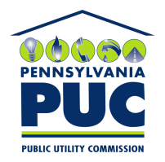 | COMMONWEALTH OF PENNSYLVANIA  PENNSYLVANIA PUBLIC UTILITY COMMISSION  400 NORTH STREET, KEYSTONE BUILDING, SECOND FLOOR  HARRISBURG, PENNSYLVANIA 17120 | IN REPLY PLEASE REFER TO OUR FILE

May 8, 2019

Via Certified Mail

Patricia Shields
IFIC Surety
2570 Boulevard of the Generals, Suite 125
Norristown PA 19403

RE: Cancellation Notice
MC Squared Energy Services LLC
A-2011-2256602

Dear Sir/Madam:

Please find under cover of this letter the Cancellation Notice filed with the Commission on behalf of MC Squared Energy Services LLC because it is not acceptable.

In all locations where the name of the Principal appears, please note that this must match exactly with the license issued by the Commission. Please include the Letter ‘C’ in LLC.

Please return the Cancellation Notice with my office within 20 days of the date of this letter, preferably by overnight delivery to my office address listed above.

Sincerely,

Rosemary Chiavetta
Secretary of the Commission

RC:jbs
CC: Sharon M Hillman Mc Squared Energy Services LLC 175 W Jackson Blvd Suite 240 Chicago IL 60604 ( letter only )

