COMMONWEALTH OF PENNSYLVANIA
PENNSYLVANIA PUBLIC UTILITY COMMISSION
COMMONWESLTH KEYSTONE BUILDING 400 NORTH STREET SECOND FLOOR
HARRISBURG PA 17120

May 9, 2019
IN REPLY PLEASE
REFER TO OUR FILE

A-2019-3009782

JASON SHARP, CHIEF COUNSEL
PENNSYLVANIA DEPARTMENT OF TRANSPORTATION
OFFICE OF CHIEF COUNSEL
PO BOX 8212
HARRISBURG PA 17105-8212

Application of the Department of Transportation of the Commonwealth of Pennsylvania for approval to alter the public below grade crossing by widening State Route 0051 which crosses under the track of Wheeling & Lake Erie Railway Company
(DOT Number 472 722 J) in Rostraver Township, Westmoreland County and the allocation of costs incident thereto.

Dear Mr. Sharp:

Receipt is acknowledged of the application of the Commonwealth of Pennsylvania Department of Transportation which has been captioned and docketed to the above number.

We note that you have served copies of the application upon the parties involved.

The matter will receive the Commission's attention, and you will be advised of any further procedure.

Very truly yours,
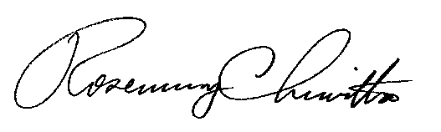

Rosemary Chiavetta
Secretary

RC:mm

