BEFORE THE
PENNSYLVANIA PUBLIC UTILITY COMMISSION

Application of Three Rivers Transportation, LLC : A-2019-3007048
t/a Transport VIP for approval to expand its :
territory as a small passenger carrier in the :
Commonwealth of Pennsylvania. :

PREHEARING ORDER

The above-captioned matter is scheduled for a hearing on Thursday, July 25, 2019, at 10:00 a.m., in an available 2nd Floor Hearing Room, Piatt Place, Suite 220, 301 Fifth Avenue, Pittsburgh, PA 15222. The parties are directed to comply with the following:

- If you are a partnership, limited liability company, corporation, trust, association or governmental agency or subdivision, you must have an attorney represent you in this proceeding. Unless you are an attorney, you may not represent someone. Pursuant to 52 Pa.Code §§ 1.21 and 1.22, you may represent yourself, if you are an individual, or you may have an attorney represent you.

- If you wish to offer into evidence at the hearing material in the form of documents (letters, bills, cancelled checks and the like), you should bring with you the required number of copies (an original and two copies for the Commission, one copy for every other party in the case, and a copy for yourself). 52 Pa.Code § 5.409. Documents should be properly pre-marked for identification.

- Be aware that there often is a delay in my receiving documents filed in Harrisburg. Therefore, serve me directly with any documents that you file in this proceeding.

- In order to facilitate the conduct of the hearing, on or before June 28, 2019, counsel for Applicant and for Protestant(s) are directed to confer in person or by telephone and to exchange in writing the names, addresses, and telephone numbers of all witnesses they intend to have testify. In the course of conferring, counsel also shall informally request copies of any documents deemed relevant so that any such document(s) may be reviewed prior to, rather than during, the hearing.

- If you need to subpoena witnesses for the hearing, you should review 52 Pa.Code § 5.421. You should submit your written application for subpoenas sufficiently in advance of the hearing so that the other parties will have the requisite ten days’ notice to answer your application, and so that you will have enough time to receive the subpoenas and serve them.

- Protestants should be prepared to begin presentation of their direct case immediately upon the conclusion of the presentation of the Applicant’s direct case.

- A request for a change of the scheduled hearing date must be submitted in writing no later than five (5) work days prior to hearing. Requests for changes of initial hearings must be sent to the undersigned Administrative Law Judge, Piatt Place, Suite 220, 301 Fifth Avenue, Pittsburgh, PA 15222. Only the undersigned Administrative Law Judge or Office of Administrative Law Judge Scheduling Staff may grant a request for a change of an initial hearing. Such changes are granted only in rare situations where sufficient cause exists. Requests for changes of subsequent hearings, if any, should also be served directly on me.

- It is the Commission’s policy to encourage settlement. 52 Pa.Code § 5.231(a). You are urged to discuss among yourselves the possible settlement of this case at
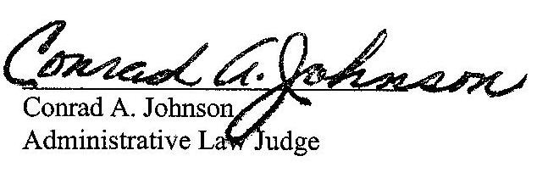
least one week before the hearing. If you are unable to settle this case, you may still resolve as many questions or issues as possible during your informal discussion.
Date: June 7, 2019

A-2019-3007048 - APPLICATION OF THREE RIVERS TRANSPORTATION LLC T/A TRANSPORT VIP FOR APPROVAL TO EXPAND ITS TERRITORY AS A SMALL PASSENGER CARRIER IN THE COMMONWEALTH OF PENNSYLVANIA.
BRAD SOMMER ESQUIRE
SOMMER LAW GROUP
6 MARKET SQUARE
PITTTSBURGH PA 15222
412.471.1266
ACCEPTS E-SERVICE
Applicant
CHARLES E THOMAS III ESQUIRE
THOMAS T NIESEN ESQUIRE
THOMAS NIESEN & THOMAS LLC
212 LOCUST STREET SUITE 302
HARRISBURG PA 17101
717.255.7611
717.255.7600
ACCEPTS E-SERVICE
Representing Protestant Rover Community Transportation, Inc.

