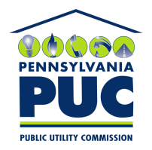 | COMMONWEALTH OF PENNSYLVANIA  PENNSYLVANIA PUBLIC UTILITY COMMISSION  400 NORTH STREET, KEYSTONE BUILDING, SECOND FLOOR  HARRISBURG, PENNSYLVANIA 17120 | IN REPLY PLEASE REFER TO OUR FILE
June 21, 2019

Via Certified Mail

MARTHA LOPEZ
SPARK ENERGY LLC
12140 WICKCHESTER LN. SUITE 100
HOUSTON TX 77079

RE: Bond
Spark Energy LLC
Docket Number A-2009-2145787

Dear Sir/Madam:

Please find under cover of this letter the financial instrument ( Bond number 105406553 ) filed by Spark Energy LLC because it is no longer required. We have the originals of new Bond # 106574684 and its renewals on file.

Thank you for your attention to this matter.

Sincerely,

Rosemary Chiavetta
Secretary of the Commission

Enclosures
RC:jbs

