 | COMMONWEALTH OF PENNSYLVANIA  PENNSYLVANIA PUBLIC UTILITY COMMISSION  400 NORTH STREET, HARRISBURG, PA 17120 | IN REPLY PLEASE REFER TO OUR FILE
June 26, 2019

Docket No. A-110164
Utility Code: 110164
CERTIFIED

SARAH C STONER ESQ
ECKERT SEAMANS CHERIN & MELLOTT LLC
213 MARKET STREET 8TH FLOOR
HARRISBURG PA 17101

RE: Financial Security Reduction Petition Data Request

Dear Ms. Stoner:
On June 17, 2019, Direct Energy Services LLC (Direct Energy Services) filed a petition to reduce its bonding level from 10% to 5% of its most recent 4 quarters of revenue subject to the minimum of $250,000, per the Commission’s Order entered July 24, 2014, at Docket No. M-2013-2393141. The petition was incomplete. In order for us to complete our analysis of your petition, the Energy Industry Group requires answers to the attached question(s).

Please be advised that you are directed to forward the requested information to the Commission within 45 days from the date of this letter. Failure to respond may result in the petition being denied. As well, if Direct Energy Services has decided to withdraw its petition, please reply notifying the Commission of such a decision.

Please forward the information to the Secretary of the Commission at the address listed below. When submitting documents, all documents requiring notary stamps must have original signatures. Please note that some responses may be e-filed to your case, http://www.puc.pa.gov/efiling/default.aspx. A list of document types allowed to be e-filed can be found at http://www.puc.pa.gov/efiling/DocTypes.aspx.

Rosemary Chiavetta, Secretary
Pennsylvania Public Utility Commission
400 North Street
Harrisburg, PA 17120

Your answers should be verified per 52 Pa Code § 1.36. Accordingly, you must provide the following statement with your responses:

I, ________________, hereby state that the facts above set forth are true and correct to the best of my knowledge, information and belief, and that I expect to be able to prove the same at a hearing held in this matter. I understand that the statements herein are made subject to the penalties of 18 Pa. C.S. § 4904 (relating to unsworn falsification to authorities).
The blank should be filled in with the name of the appropriate company representative, and the signature of that representative should follow the statement.

Please direct any questions to Stephen Jakab, Bureau of Technical Utility Services, at sjakab@pa.gov (preferred) or call (717) 783-6174.

Sincerely,

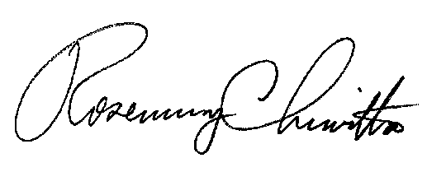
Rosemary Chiavetta
Secretary

Enclosure
Docket No. A-110164
Direct Energy Services LLC
Data Request

- Reference Financial Security Reduction Petition - Applicant failed to provide a Tax Status Letter of Good Standing from the Department of Revenue. Please file a Tax Status Letter of Good Standing. Below is a link to the referenced letter.

https://revenue-pa.custhelp.com/app/answers/detail/a_id/2212/~/how-do-i-request-a-letter-for-tax-status%3F

