 |  | COMMONWEALTH OF PENNSYLVANIA  PENNSYLVANIA PUBLIC UTILITY COMMISSION  400 North Street, HARRISBURG, PA 17120 |  | IN REPLY PLEASE REFER TO OUR FILE  Phone: 717-772-7777
June 27, 2019
A-2019-3011201

JASON SHARP CHIEF COUNSEL
PENNDOT DISTRICT 3-0
OFFICE OF CHIEF COUNSEL
PO BOX 8212
HARRISBURG PA 17105-8212

Application of the Department of Transportation of the Commonwealth of Pennsylvania for approval to alter eight public at-grade crossings by the installation of new active traffic control devices and one concrete tub crossing surface where various state and local roadways cross the tracks of SEDA-COG Joint Rail Authority, operated on by North Shore Railroad Company in various municipalities in Northumberland, Montour and Columbia Counties all in accordance with the Federal Grade Crossing Program and the allocation of costs incident thereto.

Dear Sir/Madam:

Receipt is acknowledged of the application of PennDOT which has been captioned and docketed to the above number.

We note that you have served copies of the application upon the parties involved.

The matter will receive the Commission's attention, and you will be advised of any further procedure.

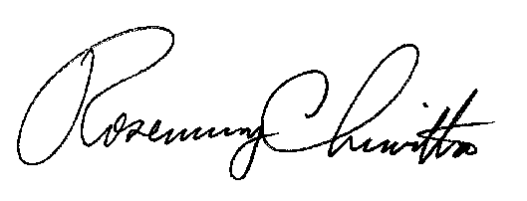
Very truly yours,

Rosemary Chiavetta
Secretary

DJ

