 | PENNSYLVANIA PUBLIC UTILITY COMMISSION  COMMONWEALTH KEYSTONE BUILDING  400 NORTH STREET, HARRISBURG, PA 17120 | IN REPLY PLEASE REFER TO OUR FILE

June 28, 2019
KIMBERLY A KLOCK
SENIOR COUNSEL
PPL ELECTRIC UTILITIES CORPORATION
TWO NORTH NINTH STREET
ALLENTOWN PA 18101-1179

RE: PPL Electric Utilities Corporation
Smart Meter Rider – Phase 2
Effective July 1, 2019
M-2019-3011018

Dear Ms. Klock:

The Bureau of Audits has reviewed PPL Electric Utilities Corporation’s proposed Supplement No. 277 to Tariff Electric - Pa. P.U.C. No. 201 and the supporting rate computations submitted on June 20, 2019 to become effective on July 1, 2019.

Based upon staff review, it appears that the Smart Meter Rider – Phase 2 (SMR-2) rates for the three-month period of July 1, 2019 through September 30, 2019 are consistent with the tariff and, accordingly, are permitted to become effective as filed.

The SMR-2 is subject to continuous Commission review and audit as well as reconciliation reports in accordance with Section 1307(e) of the Public Utility Code, 66 Pa.C.S. § 1307(e).

Any subsequent submissions to the Commission related to this docketed case should reference Docket No. M-2019-3011018.

Sincerely,

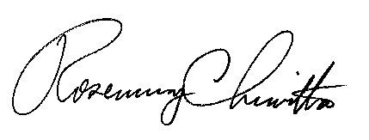
Rosemary Chiavetta Secretary

Contact Person: Ryan Trafecanty
(717) 772-0302

