 | COMMONWEALTH OF PENNSYLVANIA  PENNSYLVANIA PUBLIC UTILITY COMMISSION  400 NORTH STREET, HARRISBURG, PA 17120 | IN REPLY PLEASE REFER TO OUR FILE
Date Served: July 17, 2019

VIA CERTIFIED MAIL
TEMPSCO LLC
T/A JCI TRANSPORTATION
5050 CENTRAL HWY
PENNSAUKEN NJ 08109

RE: Tempsco, LLC. t/a JCI Transportation
C-2019-3008790

TO WHOM IT MAY CONCERN:

Please know we are returning the enclosed check(s) because the Commission cannot accept either personal or checks drawn from a corporate account. This will not affect the timeliness of your filing or in answering a complaint.

You may void the check(s) to avoid incurring any cancellation fees from your bank. Please send us a replacement check for the amount of the fee or civil penalty in the form of a CERTIFIED CHECK OR MONEY ORDER MADE PAYABLE TO THE “COMMONWEALTH OF PENNSYLVANIA.”

Sincerely,

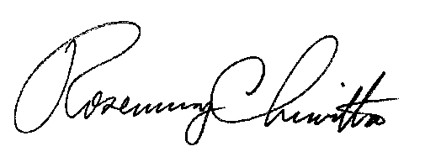
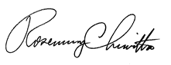

Rosemary Chiavetta
Secretary of the Commission
RC:ane

Enclosure: Corporate Check #205494

