 | COMMONWEALTH OF PENNSYLVANIA  PENNSYLVANIA PUBLIC UTILITY COMMISSION  400 NORTH STREET, HARRISBURG, PA 17120 | IN REPLY PLEASE REFER TO OUR FILE
Date Served: July 18, 2019

VIA CERTIFIED MAIL
B JOHN BEDROSSIAN
ATTORNEY AT LAW
900 MAPLE ST OFFICE STE A
CONSHOHOCKEN PA 19428

RE: John F. Fluehr, Jr.; John F Fluehr, III. and Theodore Fluehr t/a John F. Fluehr & Sons
C-2019-3008807

TO WHOM IT MAY CONCERN:

Please know we are returning the enclosed $10.00 check, #1976 because the Commission no longer requires a filing fee for abandonment/discontinuance applications.

Your Petition for Reconsideration from Staff Action/Abandonment or Discontinuance Application has been processed at the above docket number. Feel free to contact us with any questions you may have.

Sincerely,

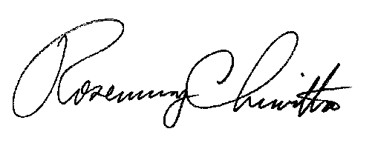
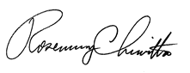

Rosemary Chiavetta
Secretary of the Commission

Enclosure

ane

