 | COMMONWEALTH OF PENNSYLVANIA  PENNSYLVANIA PUBLIC UTILITY COMMISSION  400 NORTH STREET, HARRISBURG, PA 17120 | IN REPLY PLEASE REFER TO OUR FILE
Date Served: August 5, 2019

STERLING TRANSPORT CO INC VIA CERTIFIED MAIL
PO BOX 456
LAKEVIEW NC 28350

RE: Sterling Transport Co., Inc.
C-2019-3011532

TO WHOM IT MAY CONCERN:

Please know we are returning the enclosed check(s) because the Commission cannot accept either personal or checks drawn from a corporate account. This will not affect the timeliness of your filing or in answering a complaint.

You may void the check(s) to avoid incurring any cancellation fees from your bank. Please send us a replacement check for the amount of the fee or civil penalty in the form of a CERTIFIED CHECK OR MONEY ORDER MADE PAYABLE TO THE “COMMONWEALTH OF PENNSYLVANIA.”

Sincerely,

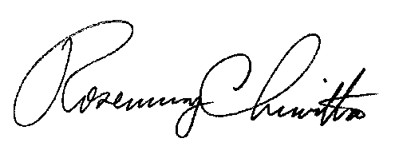
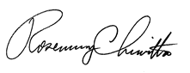

Rosemary Chiavetta
Secretary of the Commission

RC:ane

Enclosure

