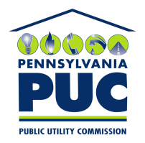 | COMMONWEALTH OF PENNSYLVANIA  PENNSYLVANIA PUBLIC UTILITY COMMISSION  400 NORTH STREET, KEYSTONE BUILDING, SECOND FLOOR  HARRISBURG, PENNSYLVANIA 17120 | IN REPLY PLEASE REFER TO OUR FILE

August 6, 2019

Via Certified Mail

SOMPO INTERNATIONAL
12890 LEBANON RD
MT JULIET TN 37122-2870

RE: Cancellation Notice
Energy CX LLC
A-2019-3011963

Dear Sir/Madam:

Please find under cover of this letter Cancellation Notice filed with the Commission on behalf of Energy CX LLC because it is not acceptable.

Upon review of Energy CX LLC ’s file folder, it appears that the Commission does not hold the Original Bond associated with the enclosed Cancellation Notice(Bond number LICX1165235).

Sincerely,

Rosemary Chiavetta
Secretary of the Commission

rc:jbs
cc: Energy CX LLC, 3501 Woodhead Drive , Northbrook IL 60062 ( letter only )

