BEFORE THE
PENNSYLVANIA PUBLIC UTILITY COMMISSION

Georgiana Freidel :
:
v. : C-2019-3010893
:
Columbia Gas of Pennsylvania, Inc. :

FIRST INTERIM ORDER
GRANTING RESPONDENT’S
MOTION FOR HEARING CONTINUANCE

By Notice dated July 5, 2019, the parties were informed that a telephone hearing was scheduled before me for this proceeding on Friday, August 16, 2019, at 10:00 a.m. On August 8, 2019, I received a letter from counsel for Respondent Columbia Gas of Pennsylvania, Inc., (Columbia Gas), Larry R. Crayne, Esquire, requesting a continuance of the hearing. Attorney Crayne represented, “Columbia Gas and Ms. Freidel have been engaged in discussions for possible resolution of the matter. . . . . In order to give the parties time to possibly resolve this matter, a continuance of the hearing for at least one month is necessary.” Attorney Crayne further represented that Complainant Georgiana Freidel has no objection to the continuance request. A copy of the August 8, 2019 letter is attached hereto as Attachment A.

Pursuant to 52 Pa.Code § 1.15(b), a request for a change of the scheduled hearing date shall be submitted by motion in writing, filed no later than five (5) days prior to the hearing with the Pennsylvania Public Utility Commission (Commission). The motion must state the facts upon which the request rests. Only for good cause shown will requests for continuance be considered (52 Pa. Code §1.15(b)). For the purpose of this order, I will treat the August 8, 2019 letter as a motion.

After due consideration, I find the motion states good cause to warrant a continuance: additional time is needed for resolution discussions.
The parties are encouraged to talk with each other to resolve this matter or some portion thereof. It is the Commission’s policy to encourage settlements. 52 Pa.Code § 5.231.

THEREFORE,

IT IS ORDERED:

- That the continuance requested by Respondent Columbia Gas of Pennsylvania, Inc., in the matter of Georgiana Freidel v. Columbia Gas of Pennsylvania, Inc., at Docket No. C-2019-3010893 is granted.

- That the Scheduling Staff of the Office of Administrative Law Judge shall reschedule this matter for an in-person hearing for the next date available at least thirty days after the date of the within order and so notify the parties in writing.

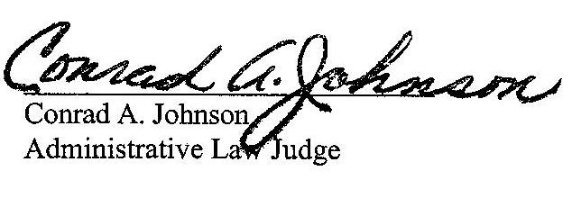

Date: August 8, 2019

ATTACHMENT A

C-2019-3010893 - GEORGIANA FREIDEL v. COLUMBIA GAS OF PA INC
GEORGIANA FREIDEL
933 BALDWIN STREET
PITTSBURGH PA 15234
412.339.6740
LARRY R CRAYNE ESQUIRE
238 JOHNSTON ROAD
PITTSBURGH PA 15241-2556
412.831.5462
ACCEPTS ESERVICE

