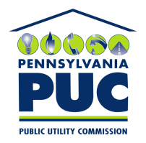 | COMMONWEALTH OF PENNSYLVANIA  PENNSYLVANIA PUBLIC UTILITY COMMISSION  400 NORTH STREET, KEYSTONE BUILDING, SECOND FLOOR  HARRISBURG, PENNSYLVANIA 17120 | IN REPLY PLEASE REFER TO OUR FILE

August 13, 2019

Via Certified Mail

Vaughn Kaizer
Energy Procurement Partners Inc.
4 White Fawn Lane
Pittsburgh PA 15238

RE: Continuous Bond
Energy Procurement Partners Inc.
A-2012-2329987

Dear Mr. Kaizer:

Please find under cover of this letter the updated financial instrument filed with the Commission on behalf of Energy Procurement Partners Inc. because it is not acceptable.

The Commission requires a supplier to file an original bond, letter of credit, continuation certificate, amendment, or other financial instrument as part of a supplier’s licensing requirements under Section 2809(c) of the Pennsylvania Public Utility Code.

The line indicating the date on which the instrument was signed and sealed is September 27, 2019. This future date is not acceptable and must reflect the actual date the bond is signed and sealed by the principal and issuer.

Please file the corrected, originally signed and sealed security instrument with my office within 20 days of the date of this letter, preferably by overnight delivery.

Sincerely,

Rosemary Chiavetta
Secretary of the Commission

RC: jbs
Enclosures

