BEFORE THE
PENNSYLVANIA PUBLIC UTILITY COMMISSION

Justin Namie :
:
v. : C-2019-3008486
:
West Penn Power Company :

INTERIM ORDER
CLOSING THE RECORD

AND NOW, the transcript of the July 2, 2019, initial hearing in this case having been filed with the Commission’s Secretary’s Bureau in Harrisburg on August 6, 2019; and a copy of the transcript having been received by the undersigned in Pittsburgh on August 15, 2018; and Complainant having been given 60 days from the date of the hearing to submit information on the receipt of unemployment compensation benefits by his fiancée, an occupant at the service address; and subject to the receipt of additional information as to the monthly household income at the service address, no further hearings in this matter are to be scheduled or held,

THEREFORE,

IT IS ORDERED:

- That the record at Docket No. C-2019-3008486 shall close as of September 3, 2019.

2. That the Initial Decision in this case shall be prepared and issued after September 3, 2019.
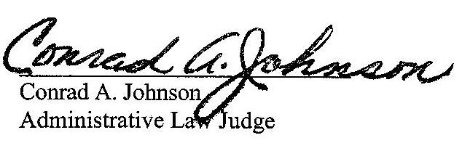

Dated: August 15, 2019
C-2019-3008486 - JUSTIN NAMIE v. WEST PENN POWER COMPANY
JUSTIN NAMIE
123 EMERALD DR
NEW KENSINGTON PA 15068
412.980.1353
ACCEPTS E-SERVICE
MARGARET A MORRIS ESQUIRE
REGER RIZZO & DARNALL
CIRA CENTRE 13th FL
2929 ARCH STREET
PHILADELPHIA PA 19104
215.495.6524
ACCEPTS E-SERVICE

