 |  | COMMONWEALTH OF PENNSYLVANIA  PENNSYLVANIA PUBLIC UTILITY COMMISSION  400 North Street, HARRISBURG, PA 17120 |  | IN REPLY PLEASE REFER TO OUR FILE  Phone: 717-772-7777
AUGUST 21, 2019 A-2019-3012304

PPL ELECTRIC UTILITIES CORP
JESSICA R ROGERS ATTY
POST & SCHELL PC
17 NORTH SECOND STREET 12TH FL
HARRISBURG PA 17101-1601

Dear Ms. Rogers:

Receipt is acknowledged of the Letter of Notification of PPL Electric Utilities Corporation which has been captioned and docketed to the above number.

This matter will receive the attention of the Commission and you will be advised of any further necessary procedure.

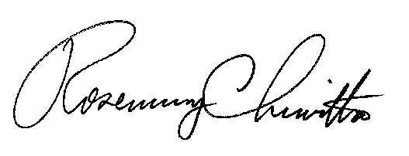
Very truly yours,

Rosemary Chiavetta
Secretary

DJ

