 | COMMONWEALTH OF PENNSYLVANIA  PENNSYLVANIA PUBLIC UTILITY COMMISSION  COMMONWEALTH KEYSTONE BUILDING  400 NORTH STREET, HARRISBURG, PA 17120 | IN REPLY PLEASE REFER TO OUR FILE

September 4, 2019

A-8921917

A-2019-3008201
USDOT #2926018

AMERICAN TWIN MOVERS INC
PO BOX 4482
COLUMBUS GA 31914

Re: ANSWER TO PETITION FOR EXTENSION OF TIME

Dear Mr. Israel:

On August 28, 2019, I received correspondence on your behalf from Micki B. Sanders requesting an extension of time to file insurance. As in accordance with PUC regulation, the Applicant, you, must file the request for an extension of time. The Commission does not accept correspondence from processing services for carriers, except to file an application; therefore, the request from Micki B. Sanders is hereby denied.

As per our conversation on August 27, 2019, and as per our emails of August 27 and 28, 2019, I told you to request an extension of time to file your tariff and insurance. You submitted a tariff on August 27, 2019, and on August 28, 2019, I told you by email that the tariff was unacceptable as it is an Interstate tariff not Intrastate tariff. You need to provide an Intrastate Tariff for your company. Also, you must contact your insurance company and tell them to send in an Insurance Form E (bodily injury liability insurance), and an Insurance Form H (cargo liability insurance). The insurance forms must come directly from the insurance company. There are no exceptions to this policy.

After further consideration and per our conversations of August 27 and 28, 2019, I will grant a thirty (30) day extension of time from the date of this email to file your tariff and insurance forms. Your tariff and insurance forms will now be due October 4, 2019, no exceptions. Please be advised that no further extensions will be granted. If you fail to provide the requested information on or before the due date, your application will be dismissed for noncompliance. Thank you.

Very Truly Yours,

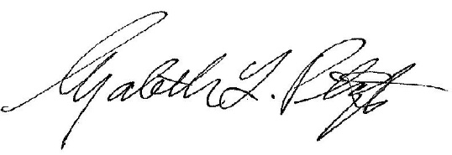

Elizabeth L. Plantz, Compliance Specialist 2
Technical Utility Services

