 | COMMONWEALTH OF PENNSYLVANIA  PENNSYLVANIA PUBLIC UTILITY COMMISSION  400 NORTH STREET, HARRISBURG, PA 17120 | IN REPLY PLEASE REFER TO OUR FILE
Date Served: September 6, 2019

VIA CERTIFIED MAIL

MARC SALLACK
MARC A SALLACK INC
304 HIDDEN HOLLOW LN
PO BOX 637
PUNXSUTAWNEY PA 15767

RE: Marc A. Sallack, Inc.
C-2019-3009832

TO WHOM IT MAY CONCERN:

Please know we are returning the enclosed check(s) because the Commission cannot accept either personal or checks drawn from a corporate account. This will not affect the timeliness of your filing or in answering a complaint.

You may void the check(s) to avoid incurring any cancellation fees from your bank. Please send us a replacement check for the amount of the civil penalty in the form of a CERTIFIED CHECK OR MONEY ORDER MADE PAYABLE TO THE “COMMONWEALTH OF PENNSYLVANIA.”

Sincerely,

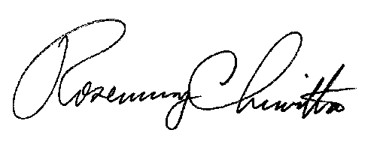
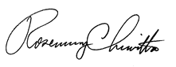

Rosemary Chiavetta
Secretary of the Commission
RC:ane

Enclosure

