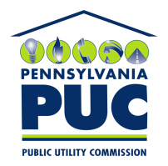 | COMMONWEALTH OF PENNSYLVANIA  PENNSYLVANIA PUBLIC UTILITY COMMISSION  400 NORTH STREET, KEYSTONE BUILDING, SECOND FLOOR  HARRISBURG, PENNSYLVANIA 17120 | IN REPLY PLEASE REFER TO OUR FILE

September 13, 2019

Via Certified Mail

NRGING LLC DBA NETGAIN ENERGY ADVISORS
MICHAEL BEACH
6176 GROVEDALE COURT SUITE 200
ALEXANDRIA VA 22310

RE: Bond Continuation
Nrging LLC dba NetGain Energy Advisors
A-2010-2202885

Dear Sir/Madam:

Please find under cover of this letter the financial instrument filed with the Commission on behalf of Nrging LLC dba NetGain Energy Advisors because it is not acceptable.

The Commission requires a supplier to file an original bond, letter of credit, continuation certificate, amendment, or other financial instrument as part of a supplier’s licensing requirements under Section 2809(c) of the Pennsylvania Public Utility Code.

The enclosed financial instrument does not have a "wet ink" original signature or raised seal for the surety company

Please file the corrected, originally signed and sealed security instrument with my office within 20 days of the date of this letter, preferably by overnight delivery.

Sincerely,

Rosemary Chiavetta
Secretary of the Commission

RC:jbs

