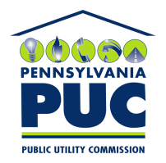 | COMMONWEALTH OF PENNSYLVANIA  PENNSYLVANIA PUBLIC UTILITY COMMISSION  400 NORTH STREET, KEYSTONE BUILDING, SECOND FLOOR  HARRISBURG, PENNSYLVANIA 17120 | IN REPLY PLEASE REFER TO OUR FILE

September 16,2019

Via Certified Mail

MARYLAND ENERGY ADVISORS LLC
PHIL E CROSKEY
509 SOUTH EXETER STREET SUITE 320
BALTIMORE MD 21202

RE: Bond Continuation Certificate
Maryland Energy Advisors LLC A-2015-2472201

Dear Sir/Madam:

Please find under cover of this letter the financial instrument filed with the Commission on behalf of Maryland Energy Advisors LLC because it is a photocopy, and not acceptable.

The Commission requires a supplier to file an original bond, letter of credit, continuation certificate, amendment, or other financial instrument as part of a supplier’s licensing requirements under Section 2809(c) of the Pennsylvania Public Utility Code.

- The enclosed financial instrument does not have a "wet ink" original signature for the Principal Company
- The enclosed financial instrument does not have a "wet ink" original signature or raised seal for the surety company.

Please file the originally signed and sealed security instrument with my office within 20 days of the date of this letter, preferably by overnight delivery to my office address listed above.

Sincerely,

Rosemary Chiavetta
Secretary of the Commission

RC:jbs
Enclosures

