BEFORE THE
PENNSYLVANIA PUBLIC UTILITY COMMISSION

Alisa Stroud :
:
v. : C-2019-3011476
:
Peoples Natural Gas Company LLC – :
Equitable Division :

FIRST INTERIM ORDER
GRANTING RESPONDENT’S MOTION FOR CONTINUANCE

By Notice dated August 1, 2019, the Parties were informed that an initial telephonic hearing was scheduled before me for this proceeding on Friday, September 20, 2019, at 10:00 a.m. On September 18, 2019, Respondent Peoples Natural Gas Company LLC - Equitable Division (Equitable Division) filed a Motion for Continuance (Motion) of the scheduled hearing because one of its witnesses was unavailable due to the death of a close family member. By facsimile received on September 19, 2019, Complainant Alisa Stroud requested a hearing continuance due to the death of a family member.

After due consideration, Equitable Division’s Motion for continuance of the telephonic hearing scheduled for Friday, September 20, 2019, will be granted in the ordering paragraphs below. As a result of the granting of Equitable Division’s Motion, a ruling on Complainant’s request for a hearing continuance is unnecessary.

The Parties are encouraged to talk with each other to resolve this matter or some portion thereof. It is the Commission’s policy to encourage settlements. 52 Pa.Code § 5.231.

THEREFORE,

IT IS ORDERED:

- That Peoples Natural Gas Company LLC - Equitable Division’s Motion for Continuance of the Initial Telephonic Hearing scheduled in this matter for Friday, September 20, 2019 in the matter of Alisa Stroud v. People Natural Gas Company LLC – Equitable Division at Docket No. C-2019-3011476 is granted.

- That the Scheduling Staff of the Office of Administrative Law Judge shall reschedule this matter for the next available hearing date and so notify the Parties in writing.

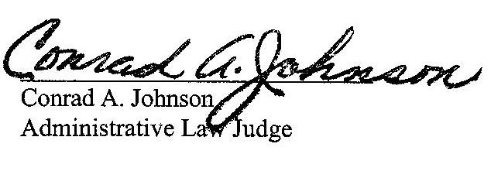
Date: September 19, 2019

C-2019-3011476 - ALISA STROUD v. PEOPLES NATURAL GAS CO LLC - EQUITABLE DIVISION
ALISA STROUD
112 PALACE CT
BALDWIN VILLAGE
PITTSBURGH PA 15227
412.339.7566
JENNIFER PETRISEK ESQUIRE
PEOPLES NATURAL GAS COMPANY LLC - EQUITABLE DIVISION
375 NORTH SHORE DRIVE
PITTSBURGH PA 15212
412.208.6834
ACCEPTS E-SERVICE

