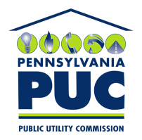 | COMMONWEALTH OF PENNSYLVANIA  PENNSYLVANIA PUBLIC UTILITY COMMISSION  400 NORTH STREET, KEYSTONE BUILDING, SECOND FLOOR  HARRISBURG, PENNSYLVANIA 17120 | IN REPLY PLEASE REFER TO OUR FILE

September 24, 2019

Via Certified Mail

US SURETY SERVICE AGENCY INC
65 BROADWAY SUITE 1104
NEW YORK, NY 10006-2503

RE: Bond Release Letter
Great American Power LLC
A-2010-2205475

Dear Sir/Madam:

Please find under cover of this letter the Bond Release request Letter filed with the Commission on behalf of Great American Power LLC.Upon initial review, the Letter is missing the following items needed in order to accept it as a filing:

It needs an original signature.

Please sign in ink as indicated by the tab stating ‘Sign Here’, then return to the address listed at the top of this letter within 20 days.

Once we receive your Response, we will be able to process as needed. If you do not return within 20 days your filing will be returned and considered unfiled.

Thank you for your attention to this matter.

Sincerely,

Rosemary Chiavetta
Secretary of the Commission

RC:jbs

