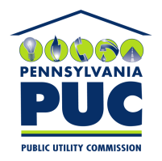 | COMMONWEALTH OF PENNSYLVANIA  PENNSYLVANIA PUBLIC UTILITY COMMISSION  400 NORTH STREET, HARRISBURG, PA 17120 | IN REPLY PLEASE REFER TO OUR FILE
September 11, 2019

KENNETH MATULA, VICE PRESIDENT
USOURCE, L.L.C.
1 LIBERTY LANE, EAST, SUITE 220
HAMPTON, NH 03842

DEANNE O’DELL, ESQUIRE
ECKERT SEAMANS CHERIN & MELLOTT, LLC
213 MARKET STREET, 8TH FLOOR
HARRISBURG, PA 17101

Dear Sir/Madam:

On September 9, 2019, the Commission received the Application of USOURCE, L.L.C., for approval to supply natural gas services to the public in the Commonwealth of PA. Upon initial review, the Application has been determined to be missing information for the following reasons:

- The exhibit headings overlap wording on multiple pages of this application. Unfortunately, this is unacceptable. These pages include for Pages 7 through 9 of Exhibit 2, Pages 11 through 12 of Exhibit 7b,and Pages 15 through 41 of Exhibit 7b.

- No original signatures on Pages 9 and 14 of Exhibit 7b (Confidenital).

Pursuant to 52 Pa. Code §1.4, you are being advised of this missing information and are required to file corrections. Failure to correct the foregoing missing information within 20 days of the date of this letter will result in the Application being returned unfiled.
Please return your items to the above listed address and address to the attention of the Office of the Secretary.

If you have any question in regards to this letter, please contact our bureau at (717) 772-7777. Thank you
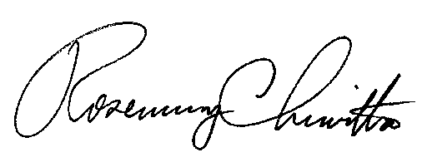
Sincerely,

Rosemary Chiavetta
Secretary

RC:AEL

Enclosures

