 | COMMONWEALTH OF PENNSYLVANIA  PENNSYLVANIA PUBLIC UTILITY COMMISSION  400 NORTH STREET, HARRISBURG, PA 17120 | IN REPLY PLEASE REFER TO OUR FILE
Date Served: July 17, 2019

JEREMY GREEN
130 CARL AVE
BUTLER PA 16001

Dear Mr. Green:

We are in receipt of the formal complaint you filed against Peoples Gas and West Penn Power Company. Please know that you must file a separate complaint for each individual company. Enclosed with this letter, you will find blank formal complaint forms. Please fill this out, sign and date against West Penn Power Company. Once filled out, you may return the forms to the address listed at the top of this letter.

Additionally, the formal complaint for Peoples Gas is also enclosed. Please be more specific on line two (Name of Company). Is your complaint against Peoples Natural Gas Company, LLC.; Peoples Gas Company, LLC. or Peoples Natural Gas Company, LLC.-Equitable Division? Clarification is needed so that we process your complaint against the correct company.

Thank you for your attention in this matter.

Sincerely,

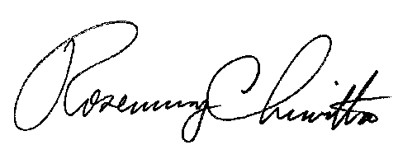
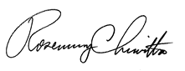

Rosemary Chiavetta
Secretary of the Commission
RC:ane

PLEASE RETURN THIS LETTER WITH YOUR COMPLETED FORMS

