 | COMMONWEALTH OF PENNSYLVANIA  PENNSYLVANIA PUBLIC UTILITY COMMISSION  400 NORTH STREET, HARRISBURG, PA 17120 | IN REPLY PLEASE REFER TO OUR FILE
October 1, 2019

THOMAS WILLIAMS, PRESIDENT
UNITED ENERGY TRADING, LLC
T/A KRATOS GAS & POWER
919 SOUTH 7TH STREET, SUITE 405
BISMARCK, ND 58504

MATTHEW LINDSAY, ESQUIRE
UNITED ENERGY TRADING, LLC
T/A KRATOS GAS & POWER
225 UNION BOULEVARD, SUITE 200
LAKEWOOD, CO 80228

Dear Sirs:

On September 26, 2019, the Commission received the Application of United Energy Trading, LLC, t/a Kratos Gas & Power for approval to supply natural gas services to the public in the Commonwealth of PA. Upon initial review, the Application has been determined to be missing information for the following reason:

- The Proofs of Publication of The Patriot News and The Scranton Times must be in their original form because it is required for us to have notarized original affidavits with original signatures. Copies of Proofs of Publication will not be accepted.

Pursuant to 52 Pa. Code §1.4, you are being advised of this missing information and are required to file a correction. Failure to correct the foregoing missing information within 20 days of the date of this letter will result in the Application being returned unfiled.
Please return your item to the above listed address and address to the attention of the Office of the Secretary.
If you have any question in regards to this letter, please contact our bureau at (717) 772-7777. Thank you
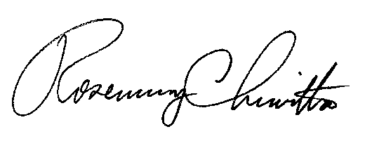
Sincerely,

Rosemary Chiavetta
Secretary

RC:AEL

Enclosures

