BEFORE THE
PENNSYLVANIA PUBLIC UTILITY COMMISSION

John Crawford :
:
v. : C-2019-3011358
:
West Penn Power Company :

INTERIM ORDER
CLOSING THE RECORD

AND NOW, the transcript of the September 13, 2019, initial hearing in this case having been filed with the Commission’s Secretary’s Bureau in Harrisburg on September 24, 2019; and a copy of the transcript having been received by the undersigned in Pittsburgh on October 3, 2019; and no further hearings in this matter are to be scheduled or held,

THEREFORE,

IT IS ORDERED:

- That the record at Docket No. C-2019-3011358 is closed.

2. That the Initial Decision in this case shall be prepared and issued.

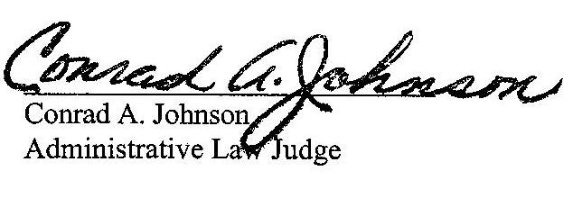
Dated: October 11, 2019

C-2019-3011358 - JOHN CRAWFORD v. WEST PENN POWER COMPANY
Revised 8/28/19
JOHN M CRAWFORD
242 FAIRMOUNT AVENUE
FAIRMOUNT CITY PA 16224
814.316.6031
ACCEPTS E-SERVICE
TERESA HARROLD ESQUIRE
FIRSTENERGY SERVICE CO
2800 POTTSVILLE PIKE
PO BOX 16001
READING PA 19612
610.921.6783
ACCEPTS E-SERVICE

