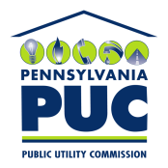 |  | COMMONWEALTH OF PENNSYLVANIA  PENNSYLVANIA PUBLIC UTILITY COMMISSION  400 North Street, HARRISBURG, PA 17120 |  | IN REPLY PLEASE REFER TO OUR FILE  Phone: 717-772-7777
October 18, 2019

A-2019-3013638

ALAN ROSENTHAL
CHEVRON APPALACHIA LLC
700 CHERRINGTON PARKWAY
CORAOPOLIS PA 15108

Application of Chevron Appalachia LLC for approval of the alteration of the crossing (DOT #367 800 C ) by the installation of three Metal Clad multi conductor armored cables where T-305 crosses below grade the tracks of Norfolk Southern Railroad Company, located in Luzerne Township in Fayette County, Pennsylvania.

Dear Sir/Madam:

Receipt is acknowledged of the application of Chevron Appalachia LLC which has been captioned and docketed to the above number.

We note that you have served copies of the application upon the parties involved.

The matter will receive the Commission's attention, and you will be advised of any further procedure.

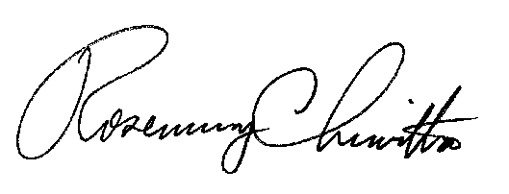
Very truly yours,

Rosemary Chiavetta
Secretary

DJ

