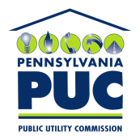 | COMMONWEALTH OF PENNSYLVANIA  PENNSYLVANIA PUBLIC UTILITY COMMISSION  400 NORTH STREET, HARRISBURG, PA 17120 | IN REPLY PLEASE REFER TO OUR FILE

Date of Service: October 21, 2019 Docket Number: C-2019-3013650

ELENA SHERMAN, PRESIDENT
ENTERPRISE LIMOUSINE INC.
672 GRAY CIRCLE
SOUTHAMPTON, PA 18966

Bureau of Investigation and Enforcement
v.
ENTERPRISE LIMOUSINE INC.

Dear Sir/Madam:

The Pennsylvania Public Utility Commission has delegated its authority to initiate prosecutory proceedings to several of its Commission bureaus with enforcement responsibilities. Pursuant to this delegated authority and Section 701 of the Public Utility Code, 66 Pa. C.S. § 701, Bureau of Investigation and Enforcement staff has filed the attached Complaint in the above docketed proceeding.

Very truly yours,


Rosemary Chiavetta
Secretary

RC:AEL

