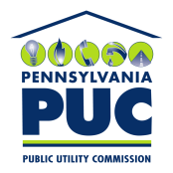 |  | COMMONWEALTH OF PENNSYLVANIA  PENNSYLVANIA PUBLIC UTILITY COMMISSION  400 North Street, HARRISBURG, PA 17120 |  | IN REPLY PLEASE REFER TO OUR FILE  Phone: 717-772-7777
October 8, 2019

CHEVRON APPALACHIA LLC
GABRIEL B ACOSTA
700 CHERRINGTON PARKWAY
CORAOPOLIS PA 15108

Dear Mr. Acosta:

On October 8, 2019, the Commission received your e-filed Application of Chevron Appalachia LLC. Upon initial review, the Application has been determined to be missing the following items:

- Certificate of Service

Pursuant to 52 Pa. Code §1.4, you are required to correct this missing item. Failure to do so within 20 days of the date of this letter will result in the Application being returned unfiled.
Please return your items to the above listed address and address to the attention of Secretary Chiavetta.

Should you have any questions pertaining to your application, please contact our Bureau at 717-772-7777.

Sincerely,

Rosemary Chiavetta
Secretary

DJ

