BEFORE THE
PENNSYLVANIA PUBLIC UTILITY COMMISSION

393 Vanadium Limited Partnership :
:
v. : C-2019-3010281
:
Peoples Natural Gas Company LLC :

FIRST INTERIM ORDER
GRANTING RESPONDENT’S MOTION FOR CONTINUANCE

By Notice dated September 12, 2019, the Parties were informed that an initial telephonic hearing was scheduled before me for this proceeding on Wednesday, October 23, 2019, at 10:00 a.m. On October 18, 2019, Respondent Peoples Natural Gas Company LLC (Peoples) filed a Motion for Continuance of the scheduled hearing because its counsel was unavailable for medical reasons.

After due consideration, Peoples’ Motion for Continuance of the telephonic hearing scheduled for Wednesday, October 23, 2019, will be granted in the ordering paragraphs below.

The Parties are encouraged to talk with each other to resolve this matter or some portion thereof. It is the Commission’s policy to encourage settlements. 52 Pa.Code § 5.231.

THEREFORE,

IT IS ORDERED:

- That Peoples Natural Gas Company LLC’s Motion for Continuance of the Initial Telephonic Hearing scheduled in this matter for Wednesday, October 23, 2019, in the matter of 393 Vanadium Limited Partnership v. Peoples Natural Gas Company LLC at Docket No. C-2019-3010281 is granted.
- That the Scheduling Staff of the Office of Administrative Law Judge shall reschedule this matter for the next available hearing date and so notify the Parties in writing.

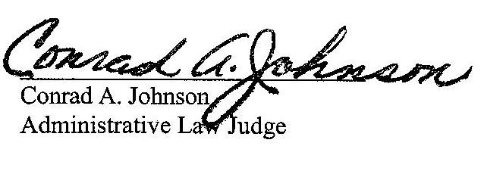
Date: October 22, 2019

C-2019-3010281 - 393 VANADIUM LIMITED PARTNERSHIP v. PEOPLES NATURAL GAS COMPANY LLC
REED J DAVIS, GENERAL PARTNER
393 VANADIUM LIMITED PARTNERSHIP
393 VANADIUM ROAD SUITE 300
PITTSBURGH PA 15243-1427
412.489.1390
ACCEPTS E-SERVICE
JENNIFER PETRISEK ESQUIRE
PEOPLES NATURAL GAS COMPANY LLC
375 NORTH SHORE DRIVE
PITTSBURGH PA 15212
412.208.6834
ACCEPTS E-SERVICE

