 | COMMONWEALTH OF PENNSYLVANIA  PENNSYLVANIA PUBLIC UTILITY COMMISSION  400 NORTH STREET, HARRISBURG, PA 17120 | IN REPLY PLEASE REFER TO OUR FILE
Date Served: November 4, 2019

VIA CERTIFIED MAIL

MICHAEL J LAVISH
T/A M J LAVISH LIMO SERVICE
2031 STOUT DRIVE, UNIT 5
WARMINSTER PA 18974

RE: Pennsylvania Public
Docket #: C-2019-3011497
A: 00105575

TO WHOM IT MAY CONCERN:

Please know we are returning the enclosed check(s) because the Commission cannot accept either personal or checks drawn from a corporate account. This will not affect the timeliness of your filing or in answering a complaint.

You may void the check(s) to avoid incurring any cancellation fees from your bank. Please send us a replacement check for the amount of the fee or civil penalty in the form of a CERTIFIED CHECK OR MONEY ORDER MADE PAYABLE TO THE “COMMONWEALTH OF PENNSYLVANIA.”

Sincerely,

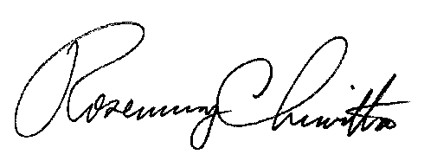
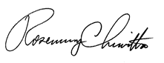

Rosemary Chiavetta
Secretary of the Commission

RC/tjt
Enclosureane

