BEFORE THE
PENNSYLVANIA PUBLIC UTILITY COMMISSION

Alisa Stroud :
:
v. : C-2019-3011476
:
Peoples Natural Gas Company LLC – :
Equitable Division :

SECOND INTERIM ORDER
GRANTING COMPLAINANT’S MOTION FOR CONTINUANCE

By Notice dated August 1, 2019, the Parties were informed that an initial telephonic hearing was scheduled before me for this proceeding on Friday, September 20, 2019, at 10:00 a.m. On September 18, 2019, Respondent Peoples Natural Gas Company LLC - Equitable Division (Equitable Division) filed a Motion for Continuance (Motion) of the scheduled hearing because one of its witnesses was unavailable due to the death of a close family member. By facsimile received on September 19, 2019, Complainant Alisa Stroud requested a hearing continuance due to the death of a family member.

After due consideration, Equitable Division’s Motion for continuance of the telephonic hearing scheduled for Friday, September 20, 2019, was granted by Interim Order entered on September 18, 2019. As a result of the granting of Equitable Division’s Motion, a ruling on Complainant’s September 19, 2019, request for a hearing continuance was unnecessary.

By Notice dated September 20, 2019, the Parties were informed that the initial telephonic hearing was rescheduled before me for on Tuesday, November 5, 2019, at 10:00 a.m.

By facsimile received on October 28, 2019, Complainant requested a continuance of the November 5, 2019, until late December or early January. As reasons for the continuance request, Complainant represented she has started a new job, and she did not wish to jeopardize her new position during her 90-day probationary period. For the purposes of this Interim Order, Complainant facsimile will be treated as Motion for Continuance.

By email dated October 30, 2019, counsel for Respondent represented that Equitable Division did not object to Complainant’s request for a continuance; however, Respondent requested that the rescheduling of the hearing be set in December 2019, as the Formal Complaint was filed in July 2019.

After due consideration, Complainant’s Motion for Continuance will be granted in the ordering paragraphs below, and the telephonic hearing will be rescheduled for an available date in December 2019.

The Parties are encouraged to talk with each other to resolve this matter or some portion thereof. It is the Commission’s policy to encourage settlements. 52 Pa.Code § 5.231.
THEREFORE,

IT IS ORDERED:

- That Complainant Alisa Stroud s Motion for Continuance of the telephonic hearing rescheduled for Tuesday, November 5, 2019, in the matter of Alisa Stroud v. People Natural Gas Company LLC – Equitable Division at Docket No. C-2019-3011476 is granted.

- That the Scheduling Staff of the Office of Administrative Law Judge shall reschedule this matter for the next available hearing date in December 2019 and so notify the Parties in writing.
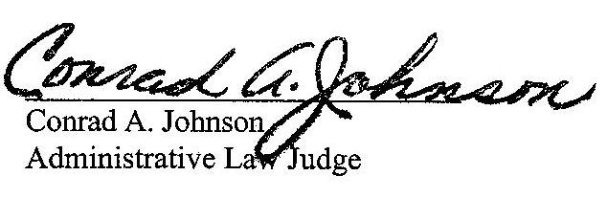

Date: November 4, 2019

C-2019-3011476 - ALISA STROUD v. PEOPLES NATURAL GAS CO LLC - EQUITABLE DIVISION
ALISA STROUD
112 PALACE CT
BALDWIN VILLAGE
PITTSBURGH PA 15227
412.339.7566
JENNIFER PETRISEK ESQUIRE
PEOPLES NATURAL GAS COMPANY LLC - EQUITABLE DIVISION
375 NORTH SHORE DRIVE
PITTSBURGH PA 15212
412.208.6834
ACCEPTS E-SERVICE

