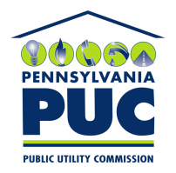 | COMMONWEALTH OF PENNSYLVANIA  PENNSYLVANIA PUBLIC UTILITY COMMISSION  400 NORTH STREET, KEYSTONE BUILDING, SECOND FLOOR  HARRISBURG, PENNSYLVANIA 17120 | IN REPLY PLEASE REFER TO OUR FILE

Date: November 6, 2019

Via Certified Mail

JOYCE MIRANDA
UBS AG ZCVF -MIR
1285 AVENUE OF THE AMERICAS, 8TH FLOOR
NEW YORK, NY 10019

RE: Letter of Credit
Holcim (US) Inc
A-2016-2532829

Dear Sir/Madam:

Please find under cover of this letter the financial instrument filed with the Commission on behalf of Holcim (US) Inc because it is not acceptable.

The Commission requires a supplier to file an original bond, letter of credit, continuation certificate, amendment, or other financial instrument as part of a supplier’s licensing requirements under Section 2809(c) of the Pennsylvania Public Utility Code.

We cannot accept ink stamp of a signature on the Letter of Credit and its amendment. The enclosed financial instruments must have a "wet ink" original signature.

Please file the originally signed security instrument with my office within 20 days of the date of this letter, preferably by overnight delivery to my office address listed above.

Sincerely,

Rosemary Chiavetta
Secretary of the Commission

RC:jbs
Enclosures

