 | COMMONWEALTH OF PENNSYLVANIA  PENNSYLVANIA PUBLIC UTILITY COMMISSION  400 NORTH ST, HARRISBURG, PA 17120 | IN REPLY PLEASE REFER TO OUR FILE

November 12, 2019

A-6922400

A-2019-3011581
(CORRECTED)
MICHELE TAYLOR
T/A TAYLOR-MADE TOURS
PO BOX 570
SEWICKLEY PA 15143

RE: Application of Michele Taylor, t/a Taylor-Made Tours, 203 New England Place, Sewickley, Allegheny County, PA 15143

To Whom It May Concern:

The purpose of this Letter is to advise you that your application has been reviewed and approved by the Pennsylvania Public Utility Commission (Commission). However, before you begin operations, you must file with the Commission all of the information listed in the paragraph below. You cannot operate under the approved motor carrier rights set forth in this Letter until all of the information listed below is filed with, and approved by, the Commission. Once the information listed below is received and approved by the Commission, you will receive a Certificate of Public Convenience, with PUC No. A-6922400, which authorizes you to begin operating under the motor carrier rights set forth in this Letter.

- A surety bond in the amount of $10,000.00 as proof of financial responsibility.

Upon issuance of a Certificate of Public Convenience you are granted the right to operate as follows:

To operate as a broker, to arrange for the transportation of persons, between points in Pennsylvania.

FAILURE TO COMPLY WITH ANY PROVISION OF THIS LETTER WITHIN SIXTY (60) DAYS OF THE DATE OF THIS LETTER WILL RESULT IN THE DISMISSAL OF THE APPLICATION AND REQUIRE THE FILING OF A NEW APPLICATION AND FILING FEE.

You should become familiar with the requirements of 52 Pa. Code as applicable to the operation of a common carrier as authorized by this grant of authority. Any change in address of Application of Michele Taylor, t/a Taylor-Made Tours, must be reported to the Commission by filing a Change of Address Form. This form can be found on the Commission's website at: www.puc.pa.gov/general /onlineforms/pdf/MC_Address_Change.pdf Failure to comply with all applicable requirements may subject the carrier to penalties, including fines, suspension of operating rights or cancellation of authority. Title 52 of the Pennsylvania Code may be accessed at www.pacode.com.

If you are dissatisfied with the resolution of this matter, you may, as set forth in 52 Pa. Code §5.44, file a petition with the Commission within twenty (20) days of the date of this Letter.

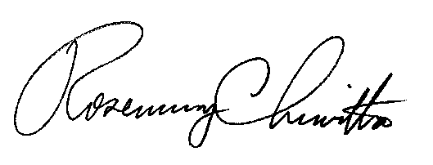
Very truly yours,

Rosemary Chiavetta
Secretary

Contact: Insurance (717-787-1227)
Tariff (717-787-1227)
Safety (717-783-5011)

