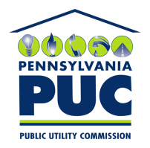 | COMMONWEALTH OF PENNSYLVANIA  PENNSYLVANIA PUBLIC UTILITY COMMISSION  400 NORTH STREET, KEYSTONE BUILDING, SECOND FLOOR  HARRISBURG, PENNSYLVANIA 17120 | IN REPLY PLEASE REFER TO OUR FILE

November 13, 2019

Via Certified Mail

MARYLAND ENERGY ADVISORS LLC
PHIL E CROSKEY
509 SOUTH EXETER STREET SUITE 320
BALTIMORE MD 21202

RE: Bond
Maryland Energy Advisors LLC A-2015-2472201

Dear Sir/Madam:

Please find under cover of this letter the duplicate original financial instrument filed by Maryland Energy Advisors LLC. We are returning it because it is not required, we have the original Bond on file.

Thank you for your attention to this matter

Sincerely,

Rosemary Chiavetta
Secretary of the Commission

RC:jbs
Enclosures

