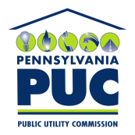 | COMMONWEALTH OF PENNSYLVANIA  PENNSYLVANIA PUBLIC UTILITY COMMISSION  400 NORTH STREET, HARRISBURG, PA 17120 | IN REPLY PLEASE REFER TO OUR FILE

Date of Service: November 13, 2019 Docket Number: C-2019-3009656

POCONO CAB COMPANY LLC
T/A POCONO CAB
431 NORTH COURTLAND STREET
EAST STROUDSBURG, PA 18301

Bureau of Investigation and Enforcement
v.
Pocono Cab Company LLC t/a Pocono Cab

Dear Sir/Madam:

The Pennsylvania Public Utility Commission has delegated its authority to initiate prosecutory proceedings to several of its Commission bureaus with enforcement responsibilities. Pursuant to this delegated authority and Section 701 of the Public Utility Code, 66 Pa. C.S. § 701, Bureau of Investigation and Enforcement staff has filed the attached Amended Complaint in the above docketed proceeding.

Very truly yours,


Rosemary Chiavetta
Secretary

RC:AEL

