 | COMMONWEALTH OF PENNSYLVANIA  PENNSYLVANIA PUBLIC UTILITY COMMISSION  400 North Street, Harrisburg, Pennsylvania 17120 | IN REPLY PLEASE REFER TO OUR FILE
November 26, 2019
Docket No. R-2019-3014209
Utility Code: 310800
LINDA SALDANA
FRONTIER COMMUNICATIONS
341 VIA DE PELLEGRINI
HENDERSON NV 89011

Re: Frontier Communications Commonwealth Telephone Company
Revisions to Informational Tariff for Competitive Services

Dear Ms. Saldaña:

Commission Staff reviewed the tariff revisions, referenced below. Suspension or further investigation does not appear warranted at this time. Therefore, in accordance with 52 Pa. Code, the tariff revisions are effective by operation of law according to the effective dates contained on each page, and the case will be closed. However, this does not constitute a determination that the revisions are just, lawful, and reasonable, but only that suspension or further investigation does not appear warranted at this time, and is without prejudice to any formal complaints timely filed against said tariff revisions.

Supplement | Tariff | Description | Filed | Effective
43 | 500 | Introduces Live Operator Fee when the customer chooses to speak with a live operator. | 11/8/2019 | 11/13/2019

If you are dissatisfied with the resolution of this matter, you may, as set forth in 52 Pa. Code § 5.44, file a petition with the Commission within 20 days of the date of this letter. If you have any questions in this matter, please contact Spencer Nahf, Telco Section, Bureau of Technical Utility Services at (717) 787- 5164 or snahf@pa.gov.

Sincerely,

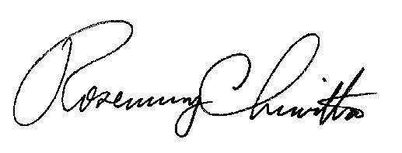

Rosemary Chiavetta

Secretary

cc: Melissa Derr, TUS

