 |  | COMMONWEALTH OF PENNSYLVANIA  PENNSYLVANIA PUBLIC UTILITY COMMISSION  400 North Street, HARRISBURG, PA 17120 |  | IN REPLY PLEASE REFER TO OUR FILE  Phone: 717-772-7777
December 18, 2019

Docket# C-2019-3014395

ENERGY TRANSFER RETAIL POWER LLC
C/O WHITNEY SNYDER, ESQ.
HAWKE MCKEON & SNISCAK LLP
100 NORTH 10TH STREET
HARRISBURG PA 17105

Dear Ms. Snyder:

This is to advise that the Formal Complaint at Docket Number C-2019-3014395, Michelle Lutz vs Energy Transfer, was processed against Energy Transfer Retail Power LLC in error. No other action is required of Energy Transfer Retail Power LLC concerning this matter.

We are sorry for any inconvenience this may have caused you.

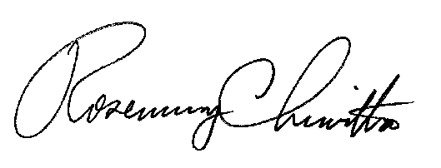
Very truly yours,

Rosemary Chiavetta
Secretary

RC: ss

