 | PENNSYLVANIA PUBLIC UTILITY COMMISSION  COMMONWEALTH KEYSTONE BUILDING  400 NORTH STREET, HARRISBURG, PA 17120 | IN REPLY PLEASE REFER TO OUR FILE
December 30, 2019

KIMBERLY A KLOCK
SENIOR COUNSEL
PPL ELECTRIC UTILITIES CORPORATION
TWO NORTH NINTH STREET
ALLENTOWN PA 18101-1179

RE: Universal Service Rider Rate
Effective January 1, 2020
M-2019-3015011

Dear Ms. Klock:

The Bureau of Audits has reviewed PPL Electric Utilities Corporation’s proposed Supplement No. 288 to Tariff Electric – Pa. P.U.C. No. 201 and the supporting rate computations submitted on December 18, 2019, to become effective on January 1, 2020.

Based upon staff review, it appears that the proposed Universal Service Rider (USR) rate for the twelve-month period of January 1, 2020 through December 31, 2020, is consistent with the tariff and, accordingly, is permitted to become effective as filed.

The USR is subject to continuous Commission review and audit as well as reconciliation reports in accordance with Section 1307(e) of the Public Utility Code, 66 Pa. C.S. § 1307(e).

Any subsequent submissions to the Commission related to this docketed case should reference Docket No. M-2019-3015011.

Sincerely,

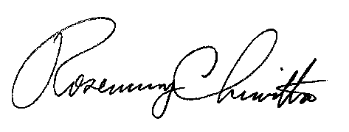

Rosemary Chiavetta
Secretary

Contact Person: David G. Kennerly, CPA
(717) 783-3971

